­­­

CampusNexus

Build Your Own Financial Aid Verification Process

Campus Management Corp.

Web Site

[www.campusmanagement.com](http://www.campusmanagement.com/)

Contact Information

Phone: 1.561.923.2500

Sales/Support: 1.561.999.9904

Toll Free: 1.800.483.9106

Facsimile: 1.561.999.0096

Address

Campus Management Corp.

5201 Congress Ave

Boca Raton, FL 33487 USA

Copyright

© 2018 Campus Management Corp. All rights reserved. Campus Management Corp. and the Campus Management logo are trademarks or service marks of Campus Management Corp. These marks may be registered in the U.S. or other countries. All other registered trademarks and service marks are the properties of their respective owners.

Contents

Introduction 4

Course Objectives 4

Target Audience 4

Course Prerequisites 4

Lesson 1: Create a Student Self-Service Form and Supporting Workflow 5

Lesson Overview 5

Exercise 1: Create a Financial Aid Verification Form and Supporting Workflow 11

Lesson 2: Create Workflows to Automate the Verification Process 108

Lesson Overview 108

Exercise 2: Create a Workflow to Send the Financial Aid Verification Form Link to the Student 108

Exercise 3: Create a Workflow to Send an Email Confirmation to the Student upon Financial Aid Verification Process Completion 124

Lesson 3: Validate the Financial Aid Verification Process 140

Lesson Overview 140

Exercise 4: Validate the Student Self-Service Form and Supporting Workflows for the Financial Aid Verification Process 140

# Introduction

This is an advanced, hands-on session. Participants will learn how to build a student self-service Financial Aid Verification Process utilizing Forms Builder, Workflow, and CampusNexus® Student.

## Course Objectives

At the end of this session, participants will be able to:

* Build a Financial Aid Verification form
* Automate Financial Aid Verification processes utilizing Workflow and CampusNexus Student configurations
* Manage Students who have been selected for Verification

## Target Audience

Technical Business Analysts, System Administrators, Database Programmer, IT staff members

## Course Prerequisites

* Understanding of business processes
* Understanding of CampusNexus Student application and schema and/or CampusNexus CRM application and schema
* Awareness of .NET technologies and understanding of VB.Net
  + Create Variables, assign Data Types, and a basic understanding of development languages
* Awareness of:
  + Windows Workflow Foundation (4.5)
  + CSS Themes
* SQL Knowledge
  + Ability to create SQL jobs, call Stored Procedures and write queries
* General development knowledge of Variables, Arguments, Control Logic, Exception Handling, Debugging

# Lesson 1: Create a Student Self-Service Form and Supporting Workflow

## Lesson Overview

In this lesson, we will create a Financial Aid Verification form for an Independent Student and supporting workflow to facilitate a student self-service Verification Process. In the following exercises, we will create additional supporting workflows. The Verification process flow will be as follows:

* An ISIR is imported into the CampusNexus Student application for an Independent student that is selected for Verification.
* The student is automatically placed into the Verification Hold Group and is sent an email with a link to the Verification form in order to complete the Verification process online.
* The student completes the Verification form and submits the information. The Verification form and supporting documents are uploaded in the student's Document Center and the status of the documents updated to Ready for Review.
* The staff member is notified that the student completed the Verification process.
* The staff member reviews the submitted documents and marks them as On File. The staff member completes Verification for the student and the student is removed from the Verification Hold Group.
* The student is notified that the Verification process is complete.

Let us look at a few configurations that need to occur in CampusNexus Student to ensure the Verification process flow is complete.

* ***View > Student Groups*** – A Group needs to be created for students selected for Verification.

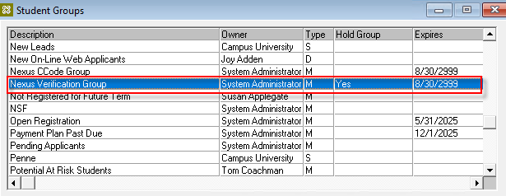

* ***Setup > Financial Aid > Hold Codes tab*** – The Verification group needs to be configured as a **Hold Group** for ***Schedule Financial Aid.***

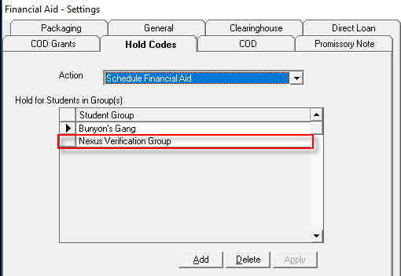

* ***Setup > Campus Locations > Campus Management Institute > Edit > Financial Aid tab*** – The **Verification Group** needs to be configured for the campus.

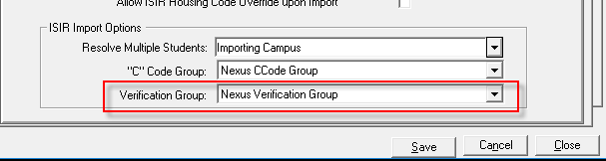

* ***Lists > Contact Manager > Documents*** – A **Verification for Independent** document needs to be configured.

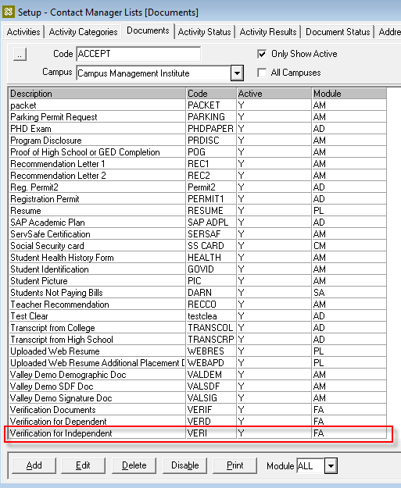

* ***Daily > Contact Manager > Schedule Documents*** – The Verification for Independent document needs to be automatically added to the student's Document Center when the ISIR is imported and the student is an Independent Student and in the V1 Verification Group.

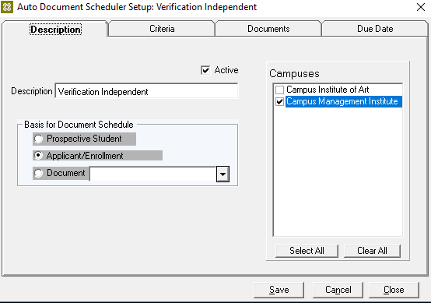

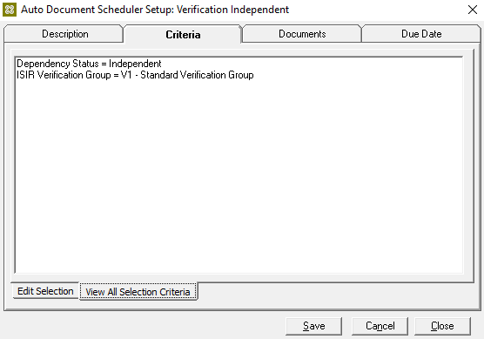

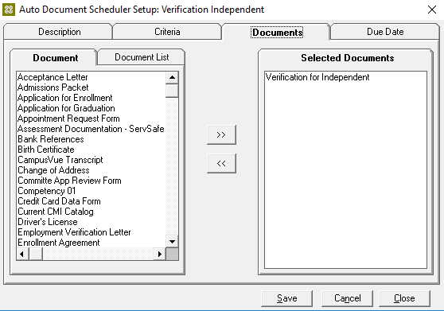

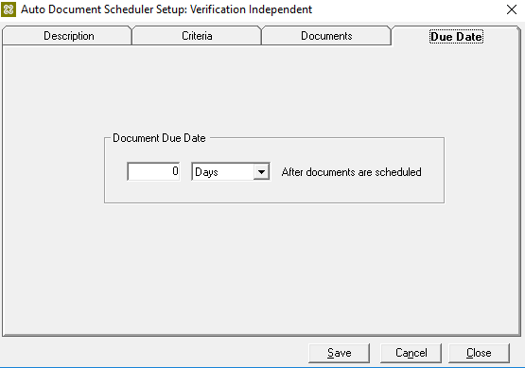

* ***Lists > Contact Manager > Activities*** – Several activities need to be configured to facilitate the process.

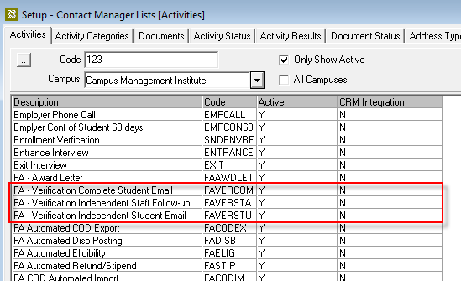

**Note**: We have provided a template for the steps in the exercise below. The template includes a form sequence and supporting workflow. Instead of following the steps in this exercise, you can import the template file and then modify the sequence and workflow as necessary for your environment. The document ***Template – Financial Aid Verification Process*** outlines the steps to import and modify the sequence and workflow.

Once you have completed your modifications based on the template, continue with ***Lesson 2: Create Workflows to Automate the Verification Process*** on **page *108***.

### Exercise 1: Create a Financial Aid Verification Form and Supporting Workflow

1. Navigate to ***Google Chrome*** and Launch ***Designer*** from the ***Bookmarks bar***.



1. ***Sign in*** using the following credentials:

* ***administrator***
* ***testing***

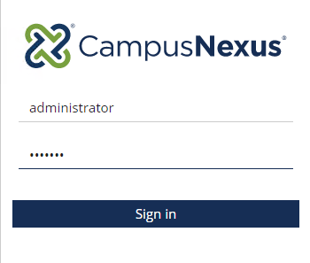

1. Select the ***Form Designer*** to start creating your form.

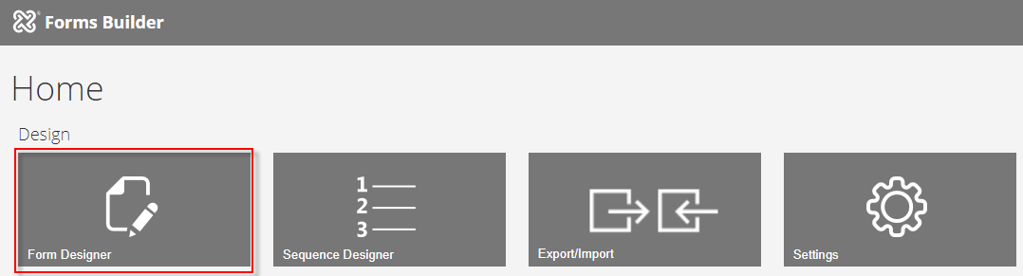

1. Select Provider ***Student*** from the first drop-down list.

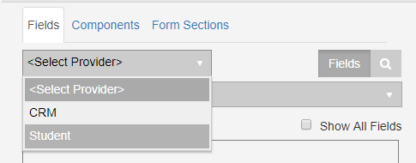

1. Select the ***Student*** entity from the second drop-down list.

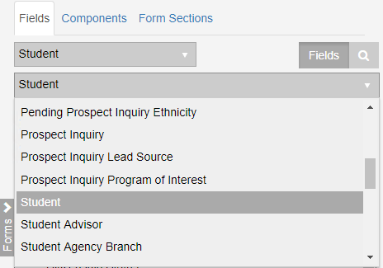

1. Select ***New*.** A 1-column panel is added to the designer.

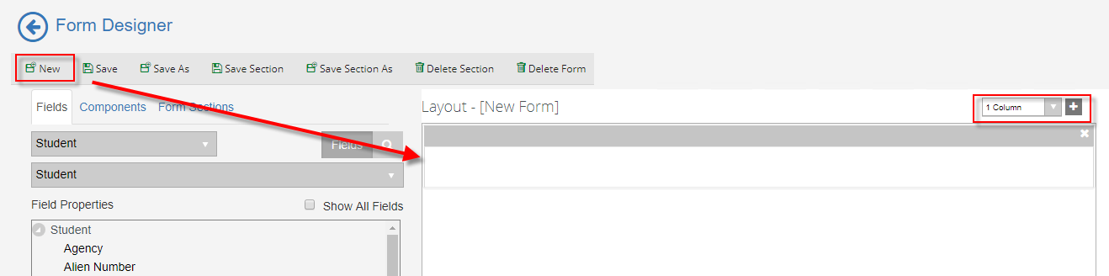

1. Drag an ***HTML*** field into the panel from the ***Components*** fields.

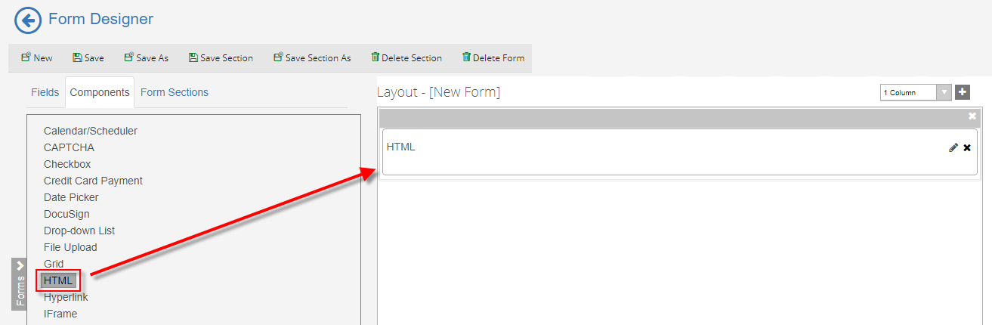

1. Update the ***HTML*** property for the component in the ***Properties Pane*** as follows:

***<div style="width:1600px;height:150px;padding:10px;border:1px dotted black;">***

***<h3>Your 2018–2019 Free Application for Federal Student Aid (FAFSA) was selected for review in a process called Verification. The law***

***states that before awarding Federal Student Aid, we must ask you to confirm the information you reported on your FAFSA. To verify***

***that you provided correct information, the Student Financial Services Office will compare your FAFSA with the information on this***

***worksheet and with any other required documents. If there are differences, your FAFSA information may need to be corrected. </h3>***

***</div>***

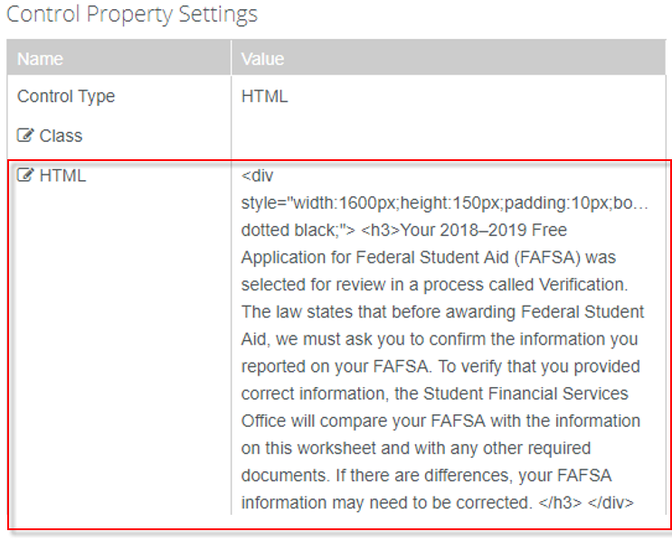

1. In the column drop-down above the designer, select ***1 Column*** and click the ***(+)*** to add a ***1-column*** panel to the designer.

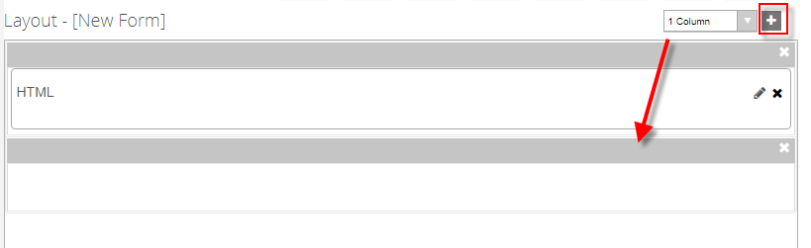

1. Drag an ***HTML*** field into the panel from the ***Components*** fields.

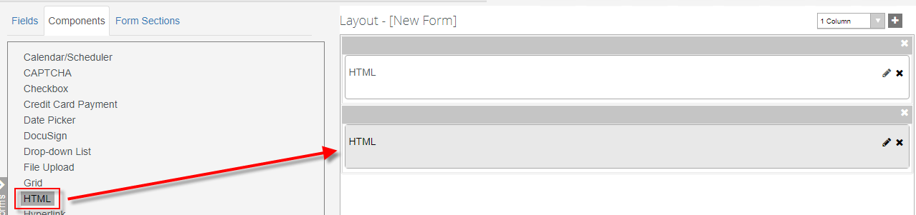

1. Update the ***HTML*** property for the component in the ***Properties Pane*** as follows:

***<b>1. Student Information</b>***

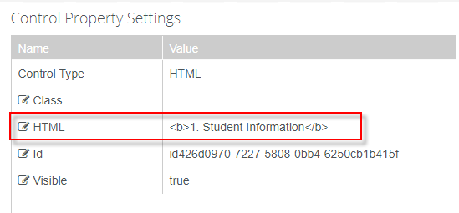

1. In the column drop-down above the designer, select ***3 Columns*** and click the ***(+)*** to add the panel to the designer.

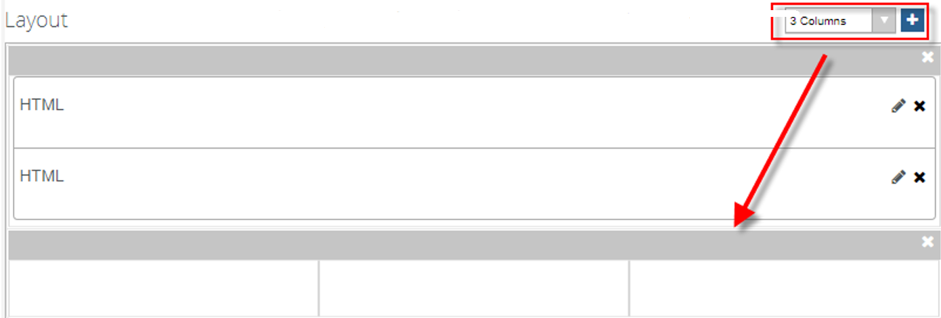

1. Drag the ***First Name, Middle Initial,*** and ***Last Name*** fields from the ***Student*** entity into the panel.

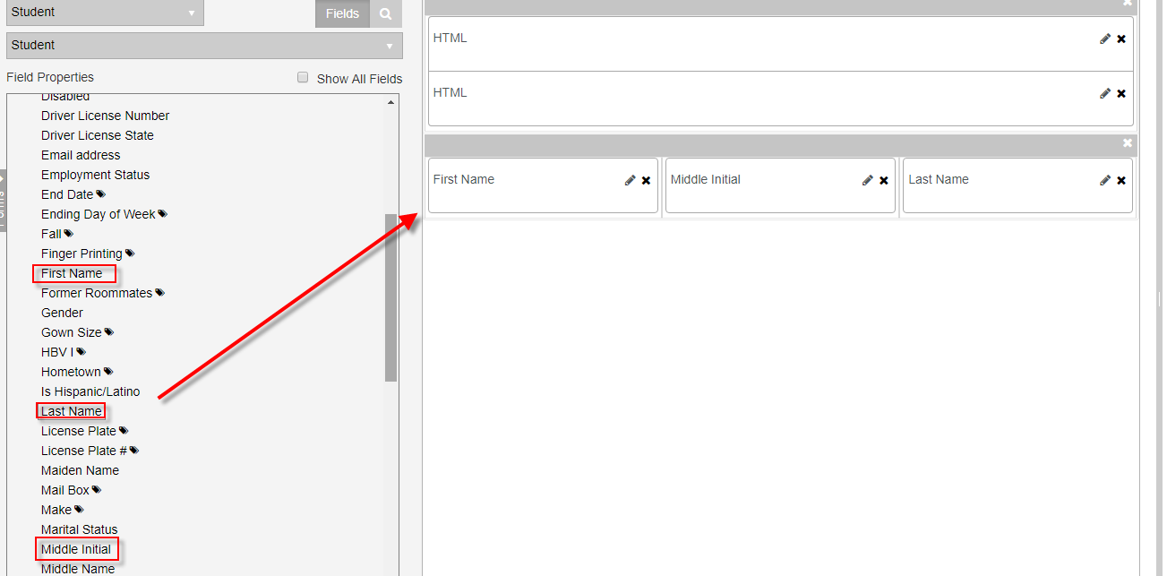

1. Drag a ***Masked Text Box*** from the ***Components*** fields and the ***Date of Birth*** and ***Email Address*** fields from the ***Student*** entity fields into the same panel below the other fields.

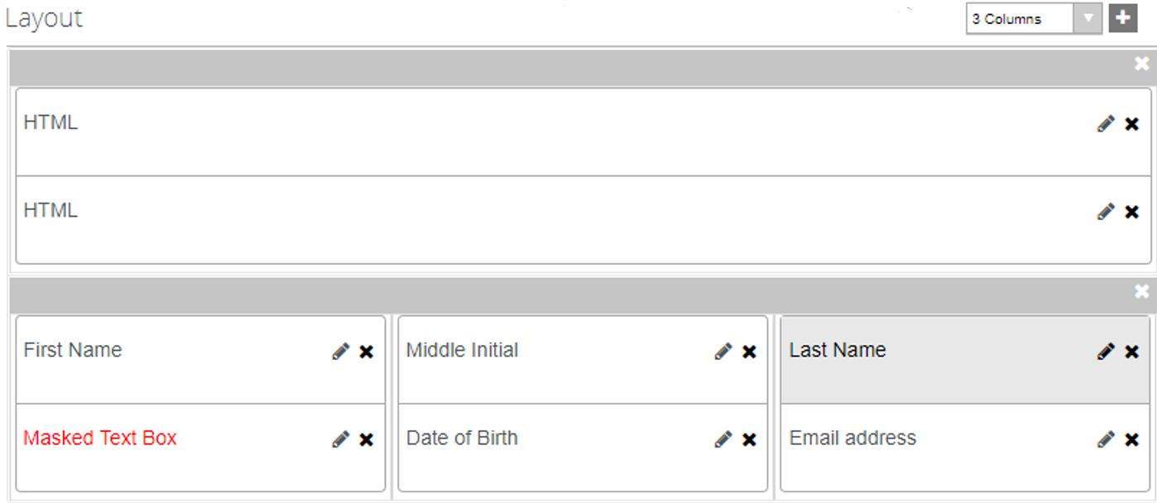

1. Edit the ***Description*** of the ***Masked Text Box*** component to ***SSN*** by selecting the ***pencil icon*** on the Layout pane.

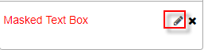

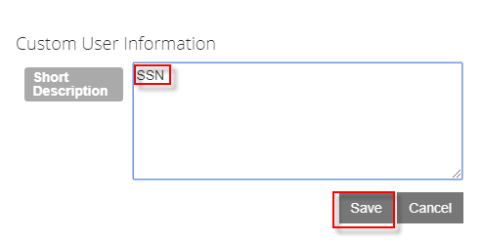

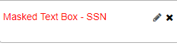

1. Update the properties for the ***Masked Text Box*** in the ***Properties Pane*** as follows:

* Format: ***000-00-0000***
* Label: ***SSN***
* Model: ***vm.models.studentEntity.Ssn*** (This will bind the field to the ***SSN*** field on the ***Student*** entity.)
* Required: ***true***

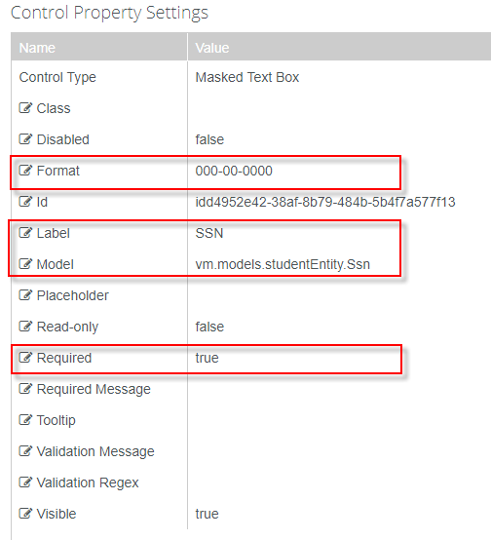

1. Update the ***Required property*** in the ***Properties Pane*** for the ***Date of Birth*** and ***Email Address*** fields to ***true***.

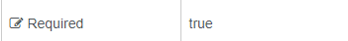

1. Update the ***Type*** property for the ***Email Address*** field in the ***Properties Pane*** to ***email.***

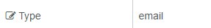

1. In the column drop-down above the designer, select ***1 Column*** and click the ***(+)*** to add the panel to the designer.

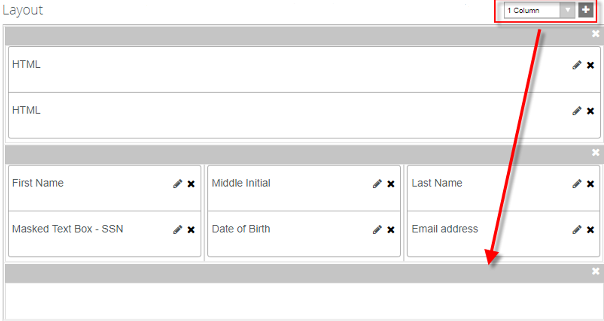

1. Drag the ***Street Address*** field from the ***Student*** entity into the panel.

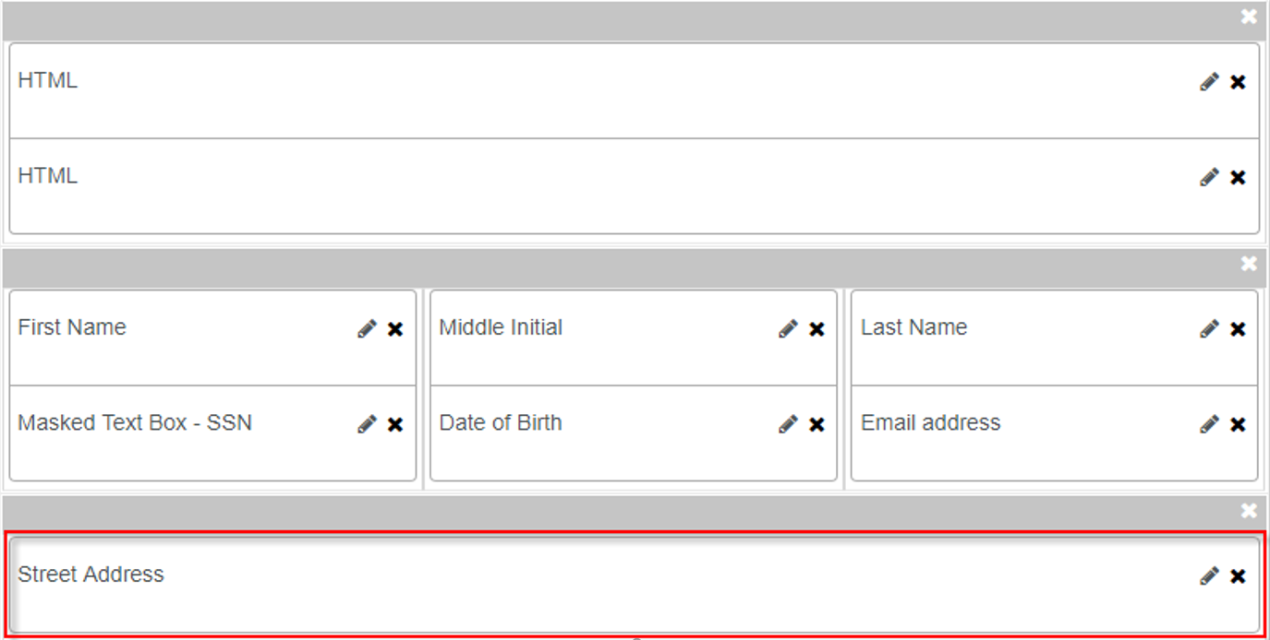

1. Update the ***Required*** property in the ***Properties Pane*** for the ***Street Address*** field to ***true***.



1. In the column drop-down above the designer, select ***3 Columns*** and click the ***(+)*** to add the panel to the designer.

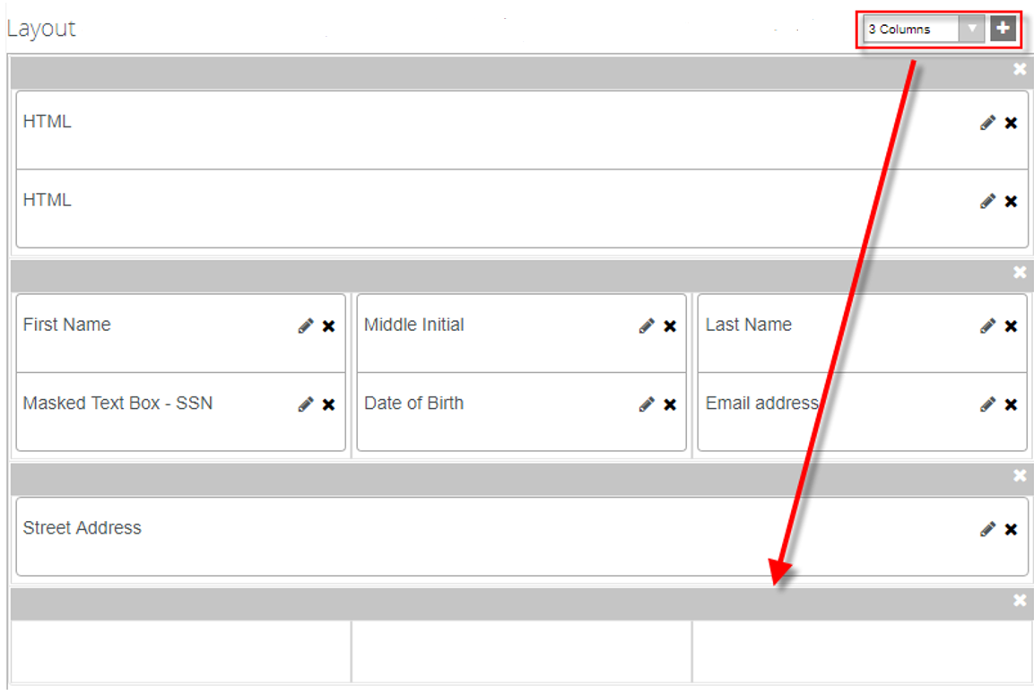

1. Drag the ***City, State,*** and ***Postal Code*** fields from the ***Student*** entity into the panel.

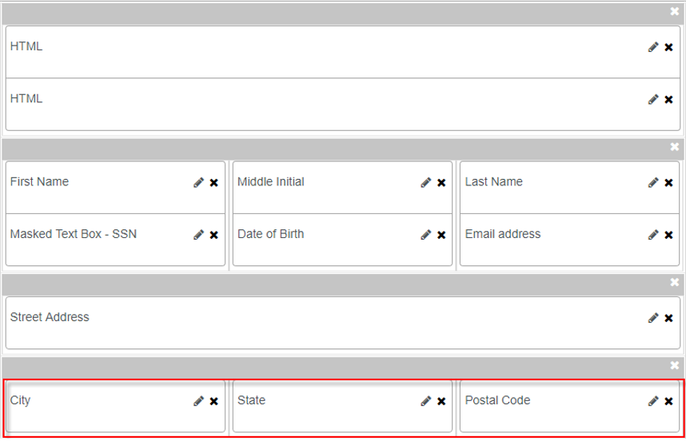

1. Update the ***Required*** property in the ***Properties Pane*** for all threefields to ***true.***



1. Change the ***Lookup Display Member*** property for the ***State*** field to ***Code*** in the ***Properties Pane***.

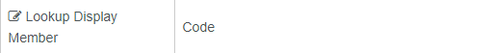

1. In the column drop-down above the designer, select ***2 Columns*** and click the ***(+)*** to add the panel to the designer.

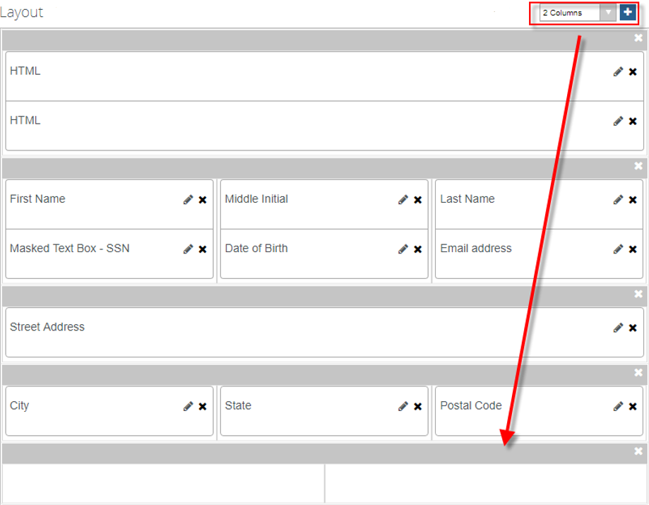

1. Drag two ***Masked Text Box*** fields from the ***Components*** fields into the panel.

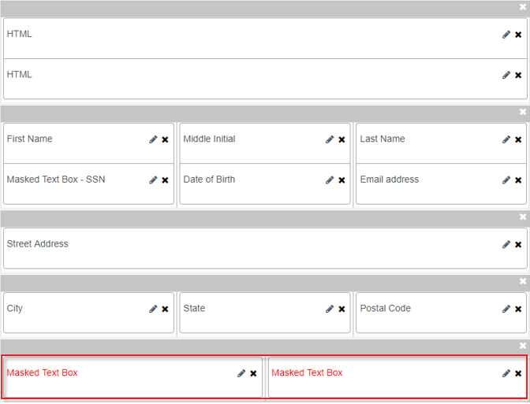

1. Edit the ***Description*** of each ***Masked Text Box*** component by selecting the pencil icon on the Layout pane. Update the first ***Masked Text Box*** to ***Home Phone Number*** and the second ***Masked Text Box*** to ***Mobile Phone Number.***



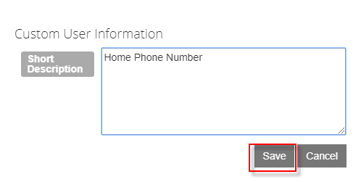

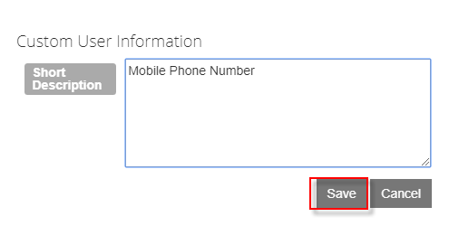

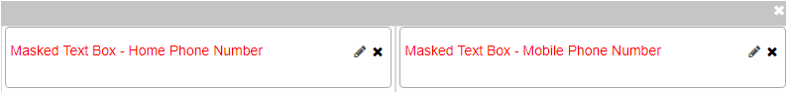

1. Update the properties for the ***Masked Text Box Home Phone Number*** in the ***Properties Pane*** as follows:

* Format: ***(###)###-####***
* Label: ***Home Phone***
* Model: ***vm.models.studentEntity.PhoneNumber*** (This will bind the field to the ***PhoneNumber*** field on the ***Student*** entity.)
* Required: ***true***

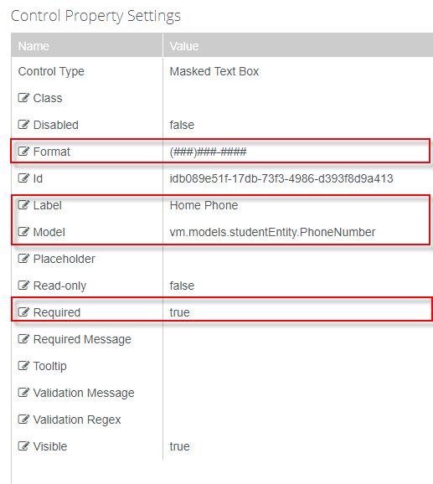

1. Update the properties for the ***Masked Text Box Mobile Phone Number*** in the ***Properties Pane*** as follows:

* Format: ***(###)###-####***
* Label: ***Mobile Phone***
* Model: ***vm.models.studentEntity.MobilePhoneNumber*** (This will bind the field to the ***MobilePhoneNumber*** field on the ***Student*** entity.)
* Required: ***true***

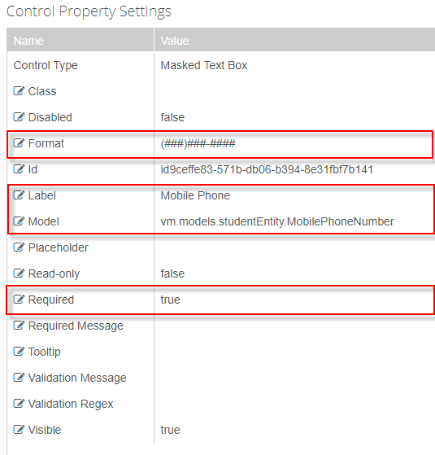

1. ***Save*** your form with the ***Form Name*** and ***Title*** as shown below. (Adding your initials to the end of the form name.)

* Form Name: ***2018 2019 V1 Independent Verification Step 1 SC***
* Title: ***2018–2019 V1 Standard Verification Independent Student***

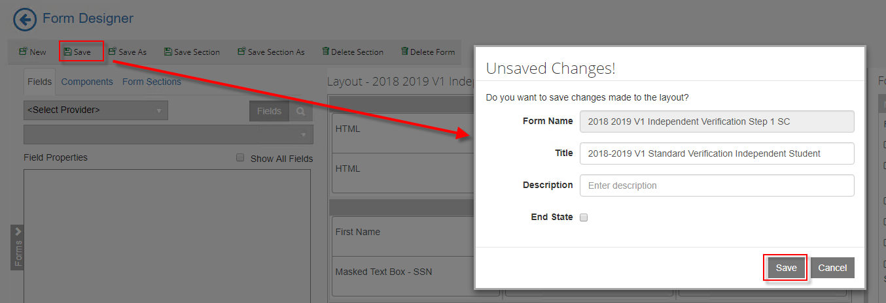

1. In the column drop-down above the designer, select ***1 Column*** and click select ***New*** to create a new form**.** A 1-Column panel is added to the designer.

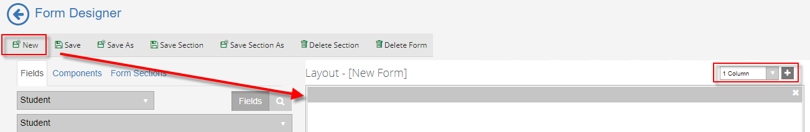

1. Drag two ***HTML*** fields and one ***Grid*** field from the ***Components*** fields into the panel.

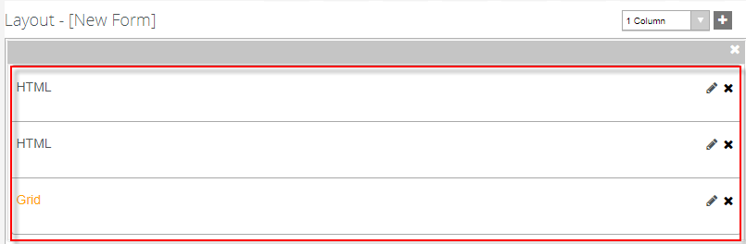

1. Update the ***HTML*** property for the first ***HTML*** component in the ***Properties Pane*** as follows:

***<b>2. Household Information </b>***

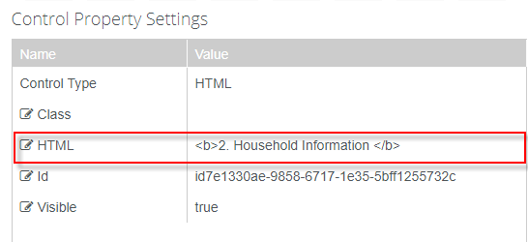

1. Update the ***HTML*** property for the second ***HTML*** component in the ***Properties Pane*** as follows:

***Please complete the table below, include: <br>***

***<ul>***

***<li>Yourself</li><br>***

***<li> Your spouse, if you are married.</li><br>***

***<li> Other people if they now live with you***

***and you provide more than half of their support and will continue to***

***provide more than half of their support through June 30, 2019.</li><br>***

***<li>Your children, if any, if you will provide***

***more than half of their support from July 1, 2018 through June 30,***

***2019. If you reported child support paid on your***

***FAFSA do not include child in your household size as***

***the amount paid has already been calculated by FAFSA.</li><br>***

***<li> Include the name of the college for any***

***household member, who will be enrolled, at least half time in a***

***degree, diploma, or certificate program at a***

***postsecondary educational institution any time between***

***July 1, 2018 and June 30, 2019. If more space is***

***needed, attach a separate page with the student’s name***

***and Social Security Number at the top.</li><br>***

***</ul>***

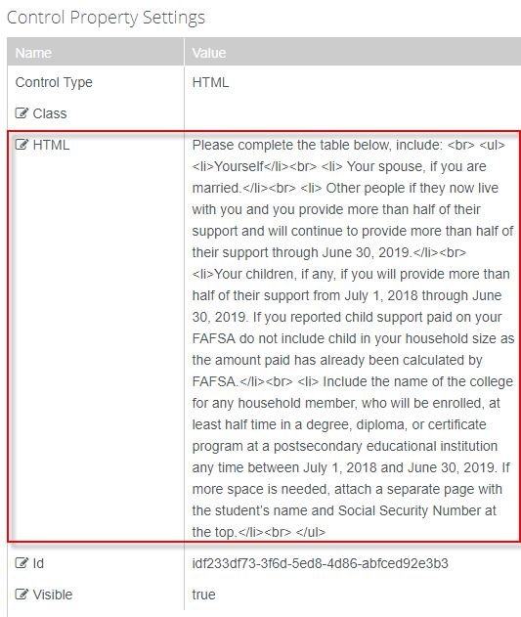

1. Update the model property for the ***Grid*** component in the ***Properties Pane*** as shown below.



1. We now need to build our columns for our grid. Click ***Edit*** next to the ***Columns*** property in the ***Properties Pane.***

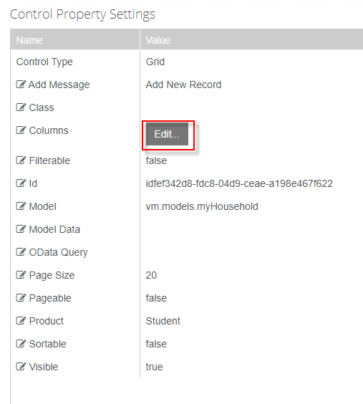

1. At the bottom of the form, update the properties as shown in the screenshot below.

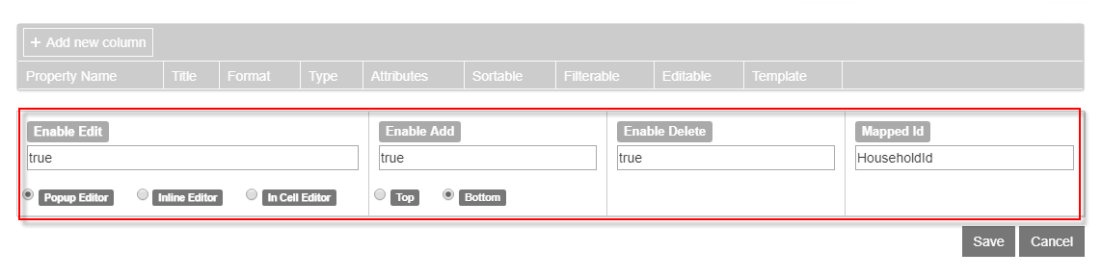

1. Click ***+*** ***Add new Column*** to add the columns as shown below. Click ***Save.***

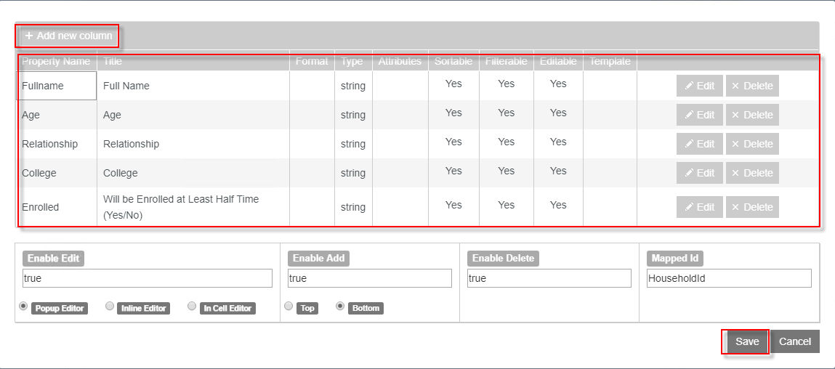

1. In the column drop-down above the designer, select ***1 Column*** and click the ***(+)*** to add the panel to the designer.

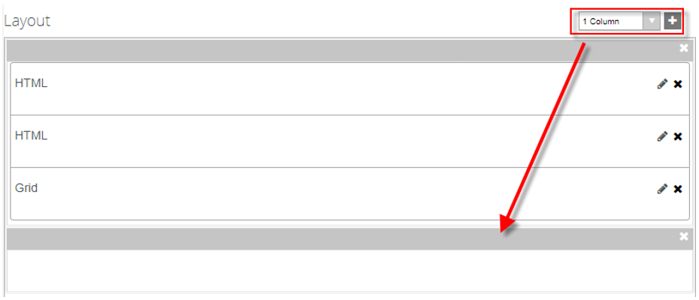

1. Drag the following fields into the panel from the ***Components*** fields as shown below.

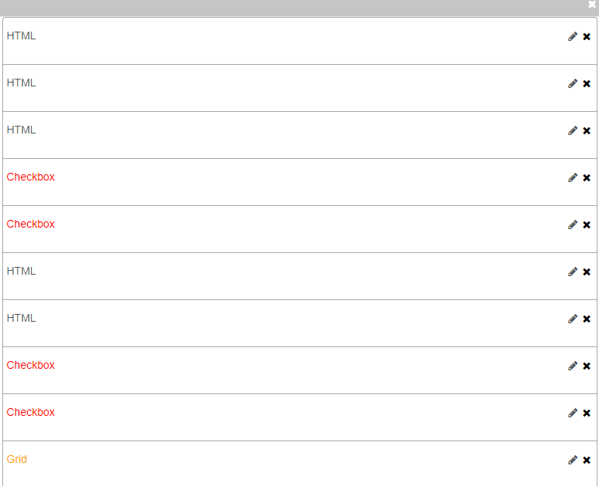

1. Update the ***HTML*** property for the first ***HTML*** component in the ***Properties Pane*** as follows:

***<b>3. 2016 Income Information</b>***

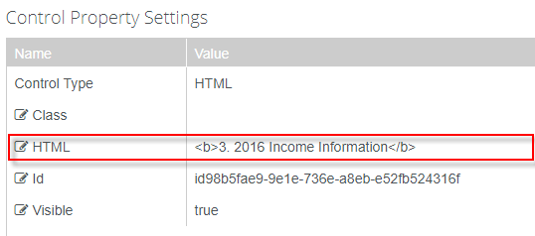

1. Update the ***HTML*** property for the second ***HTML*** component in the ***Properties Pane*** as follows:

***<b>Instructions for 2016 Tax Filers:</b> Complete this section if the student or spouse filed a 2016 IRS income tax return(s). The best way to verify income is by using the IRS Data Retrieval Tool (IRS DRT) that is part of FAFSA on the Web at FAFSA.gov. In most cases, no further documentation is needed to verify 2016income information that was transferred into the student’s FAFSA using the IRS DRT if that information was not changed by the FAFSA filer.***

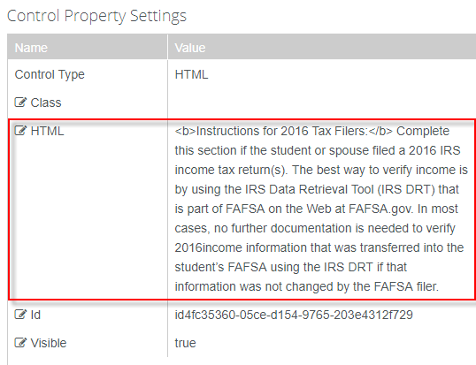

1. Update the ***HTML*** property for the third ***HTML*** component in the ***Properties Pane*** as follows:

***<b>Check the box that applies:</b>***

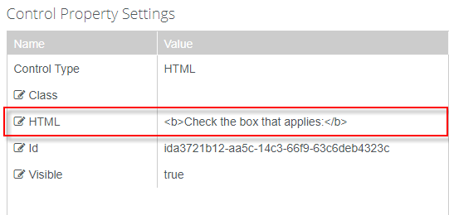

1. Update the ***Label*** property and the ***Model*** property for the first ***Checkbox*** component in the ***Properties Pane*** as follows:

* Label: ***The student/spouse used the IRS Data Retrieval Tool (DRT) on my FAFSA and did not alter the information.***
* Model: ***vm.models.myDictionary[0]***

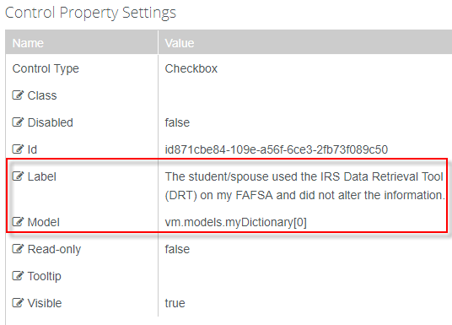

1. Update the ***Label*** property and the ***Model*** property for the second ***Checkbox*** component in the ***Properties Pane*** as follows:

* Label: ***The student/spouse is unable or chose not to use the IRS DRT, and instead am providing a 2016 IRS Tax Transcript. See Step 4for options on requesting your 2016 IRS Tax Transcript.***
* Model: ***vm.models.myDictionary[1]***

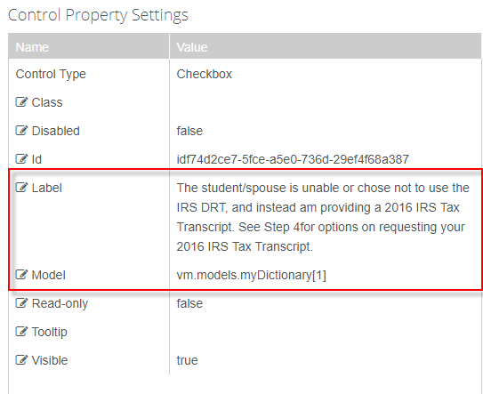

1. Update the ***HTML*** property for the fourth ***HTML*** component in the ***Properties Pane*** as follows:

***<b>Instructions for 2016 Non-tax Filers:</b> Complete this section if the student or spouse (if married) will not file and are not required to file a 2016 income tax return with the IRS. Non-tax Filers are required to provide a Statement of Non- filing Letter from the IRS. See Step 4 for the requirements of a Statement of Non-filing for 2016.***

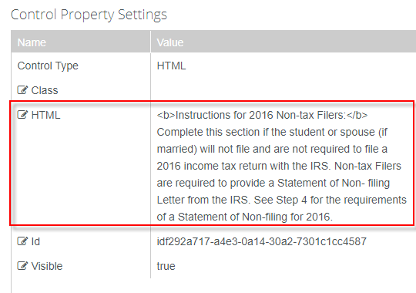

1. Update the ***HTML*** property for the fifth ***HTML*** component in the ***Properties Pane*** as follows:

***<b>Check the box that applies:</b>***

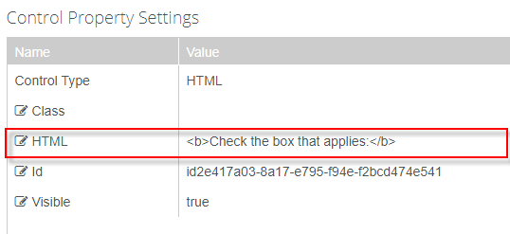

1. Update the ***Label*** property and the ***Model*** property for the third ***Checkbox*** component in the ***Properties Pane*** as follows:

* Label: ***The student/spouse did not file a 2016 Tax Return and had no income from work in 2016 and I am providing a Statement of Non-Filing Letter from the IRS.***
* Model: ***vm.models.myDictionary[2]***

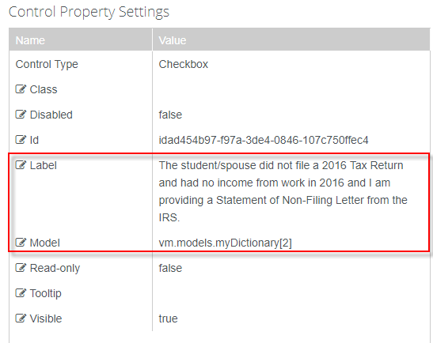

1. Update the ***Label*** property and the ***Model*** property for the fourth ***Checkbox*** component in the ***Properties Pane*** as follows:

* Label: ***The student/spouse did not file a 2016 Tax Return and I was employed in 2016. I have listed all employer(s) and income earnedbelow AND attach W-2 form(s). I am also providing a Statement of Non-filing Letter from the IRS for 2016.***
* Model: ***vm.models.myDictionary[3]***

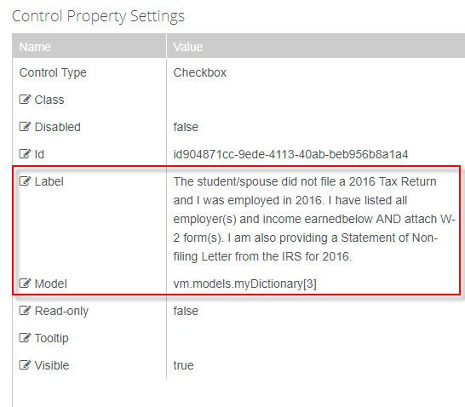

1. Update the model property for the ***Grid*** component in the ***Properties Pane*** as shown below.



1. We now need to build our columns for our grid. Click ***Edit*** next to the ***Columns*** property in the ***Properties Pane.***

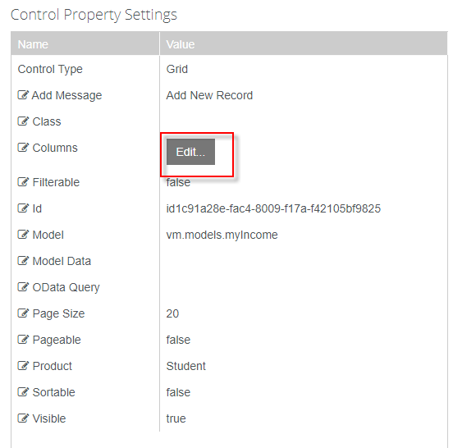

1. At the bottom of the form, update the properties as shown in the screenshot below.

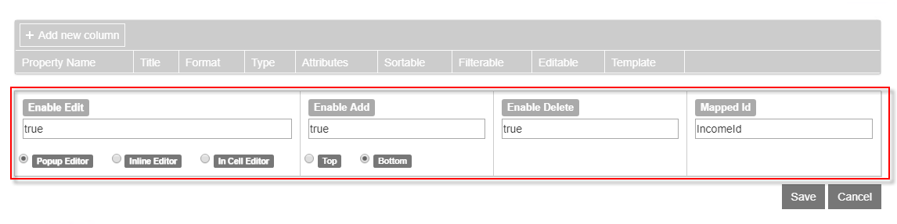

1. Click ***+*** ***Add new Column*** to add the columns as shown below. Click ***Save.***

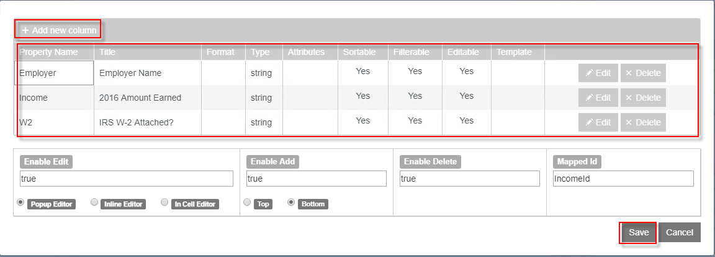

1. ***Save*** your form with the ***Form Name*** and ***Title*** as shown below. (Adding your initials to the end of the form name.)

* Form Name: ***2018 2019 V1 Independent Verification Step 2 SC***
* Title: ***2018–2019 V1 Standard Verification Independent Student***

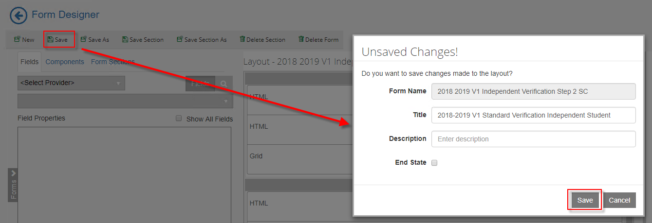

1. In the column drop-down above the designer, select to add a ***1 Column*** and click select ***New*** to create a new form**.** A 1-Column panel is added to the designer.

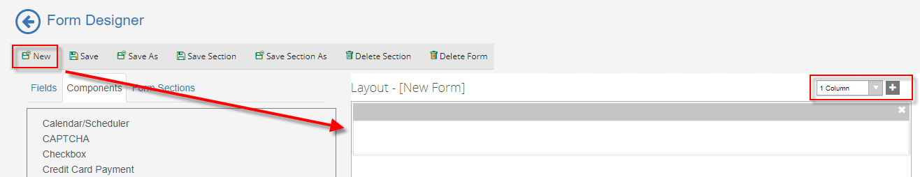

1. Drag the following fields into the panel from the ***Components*** fields as shown below.

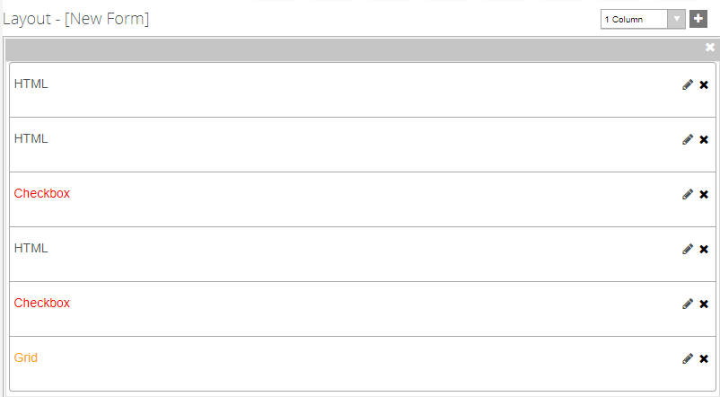

1. Update the ***HTML*** property for the first ***HTML*** component in the ***Properties Pane*** as follows:

***<b>5. Other Information to Be Verified</b>***

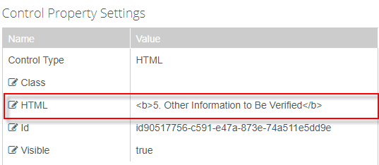

1. Update the ***HTML*** property for the second ***HTML*** component in the ***Properties Pane*** as follows:

***Complete this section if someone in the student’s household (listed in Section 2) received benefits from the Supplemental Nutrition Assistance Program or SNAP (formerly known as food stamps) any time during the 2015 or 2016 calendar years.***

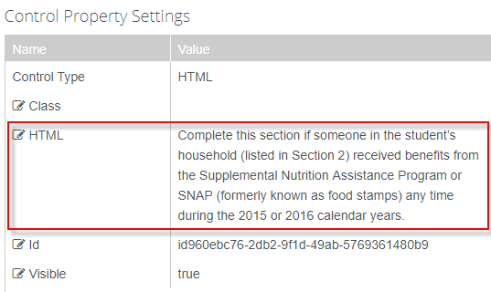

1. Update the ***Label*** property and the ***Model*** property for the first ***Checkbox*** component in the ***Properties Pane*** as follows:

* Label: ***One of the persons listed in Section 2 of this worksheet received SNAP benefits in 2015 or 2016. If asked by my school, I will provide documentation of the receipt of SNAP benefits during 2015 and/or 2016.***
* Model: ***vm.models.myDictionary[4]***

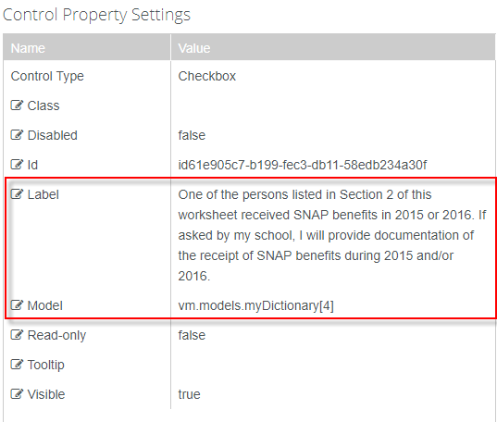

1. Update the ***HTML*** property for the third ***HTML*** component in the ***Properties Pane*** as follows:

***Complete this section if you or your spouse, if married, paid child support in 2016.***

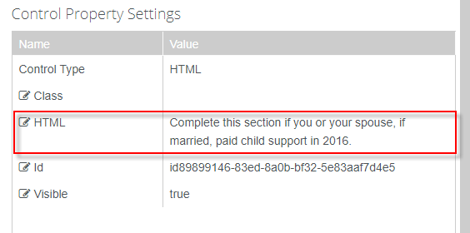

1. Update the ***Label*** property and the ***Model*** property for the second ***Checkbox*** component in the ***Properties Pane*** as follows:

* Label: ***Either I, or if married my spouse who is listed in Section 2 of this worksheet, paid child support in 2016. I have indicated below the name of the person who paid the child support, the name of the person to whom the child support was paid, the names of the children for whom child support was paid, and the total annual amount of child support that was paid in 2016 for each child. If asked by my school, I will provide documentation of the payment of child support.***
* Model: ***vm.models.myDictionary[5]***

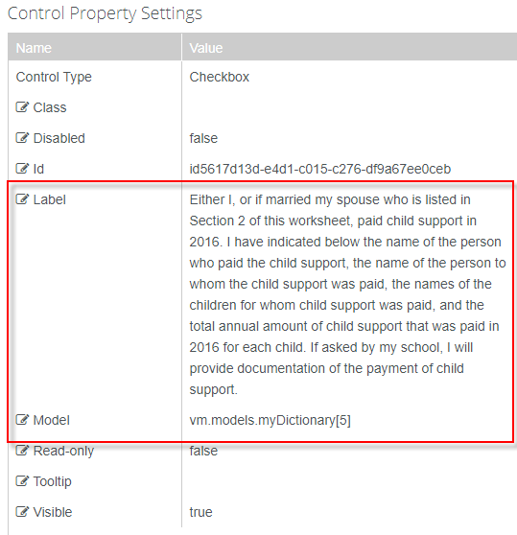

1. Update the model property for the ***Grid*** component in the ***Properties Pane*** as shown below.



1. We now need to build our columns for our grid. Click ***Edit*** next to the ***Columns*** property in the ***Properties Pane.***

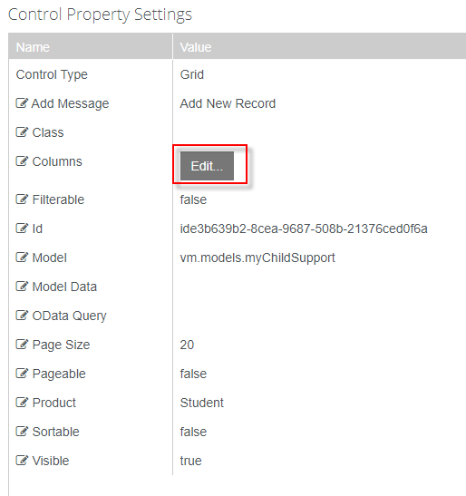

1. At the bottom of the form, update the properties as shown in the screenshot below.

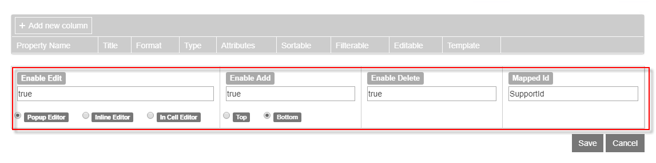

1. Click ***+*** ***Add new Column*** to add the columns as shown below. Click ***Save.***

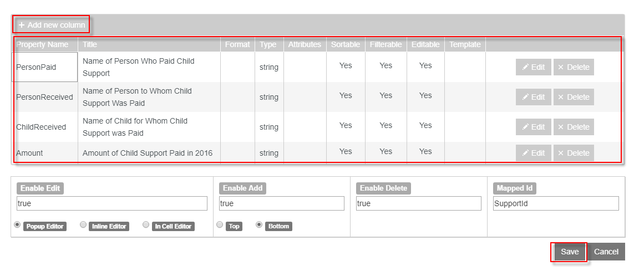

1. In the column drop-down above the designer, select ***1 Column*** and click the ***(+)*** to add the panel to the designer.

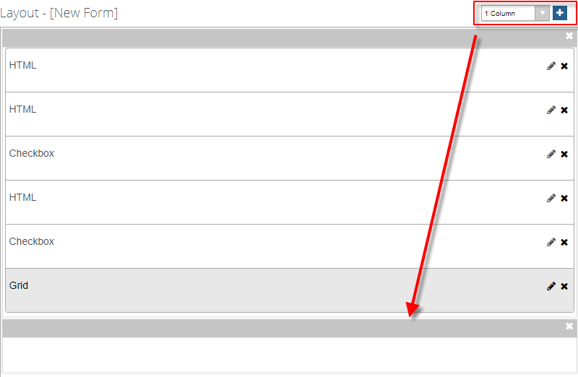

1. Drag an ***HTML*** field into the panel from the ***Components*** fields.

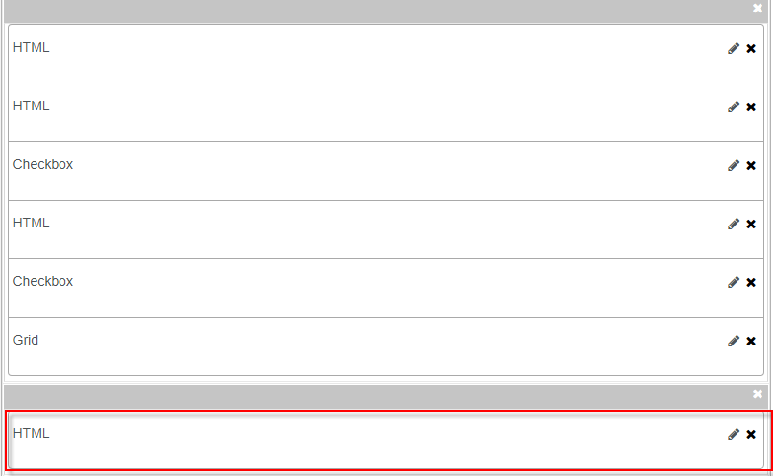

1. Update the ***HTML*** property for the component in the ***Properties Pane*** as follows:

***<b>6. Certification and Signature</b>***

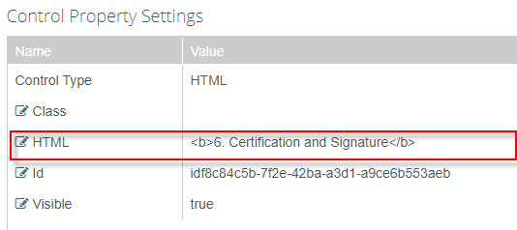

1. In the column drop-down above the designer, select ***2 Columns*** and click the ***(+)*** to add the panel to the designer.

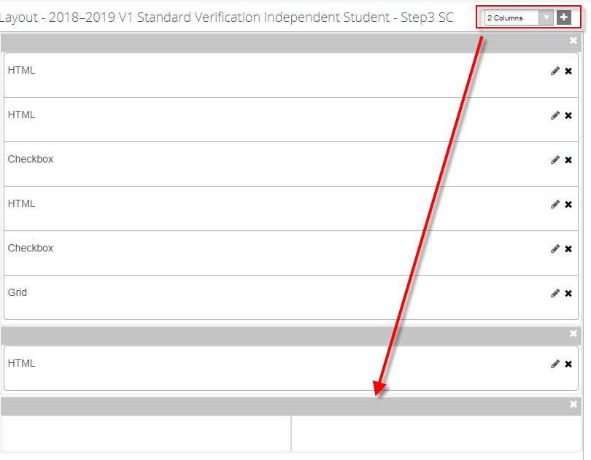

1. Drag two ***HTML*** fields from the ***Components*** fields into the panel.

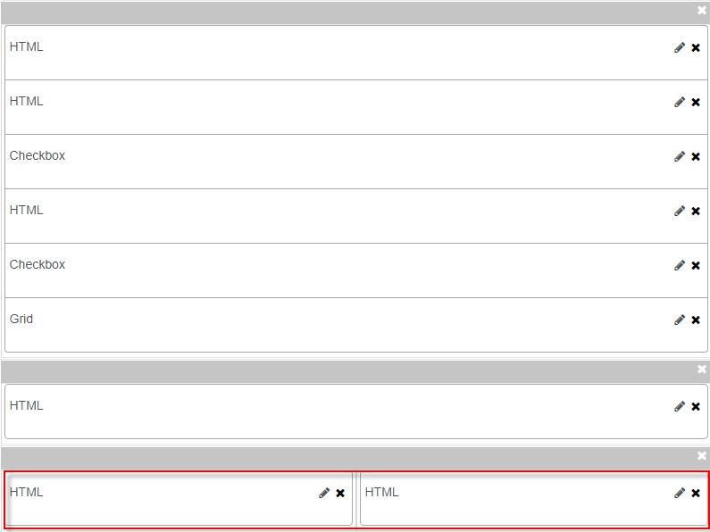

1. Update the ***HTML*** property for the first ***HTML*** component in the ***Properties Pane*** as follows:

***<b>the student must sign and date this worksheet. By signing, you certify that all of the information reported on this worksheet is complete and correct.</b>***

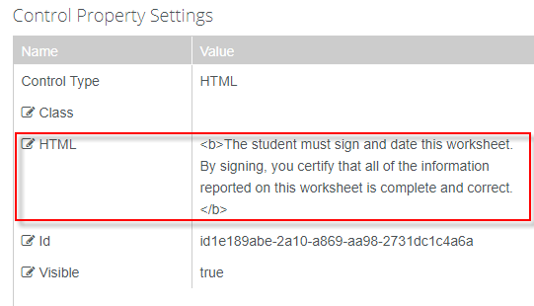

1. Update the ***HTML*** property for the second ***HTML*** component in the ***Properties Pane*** as follows:

***<div style="width:500px;height:100px;padding:10px;border:1px dotted black;">***

***<b>WARNING: If you purposely give false or misleading information on this worksheet, you may be fined, be sentenced to jail, or both.</b>***

***</div>***

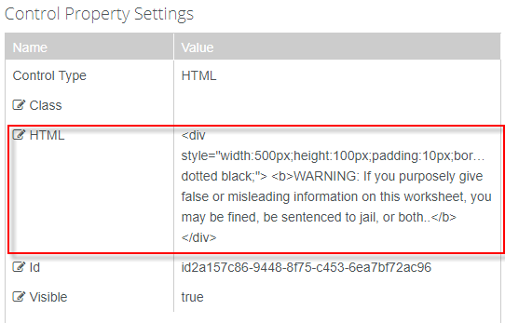

1. Drag two ***DocuSign*** fields from the ***Components*** fields into the panel below the ***HTML*** fields.

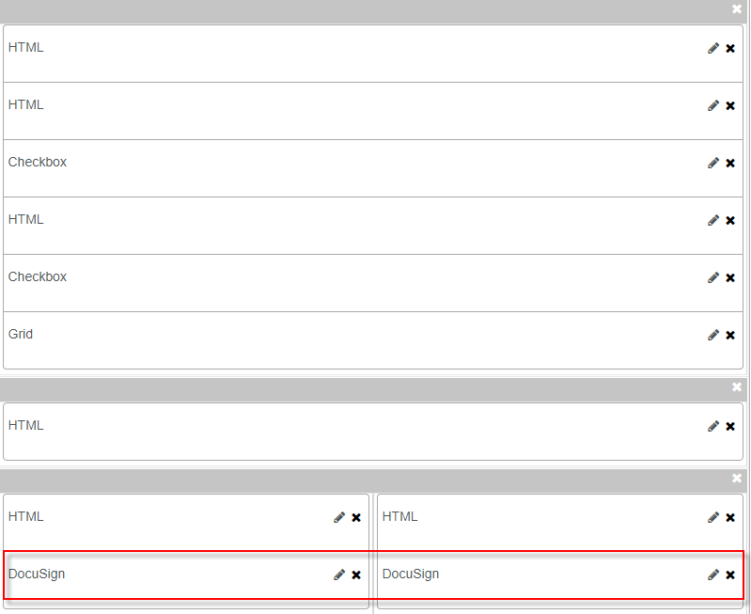

1. Update the ***Type*** property for the first ***DocuSign*** field in the ***Properties Pane*** as shown below.

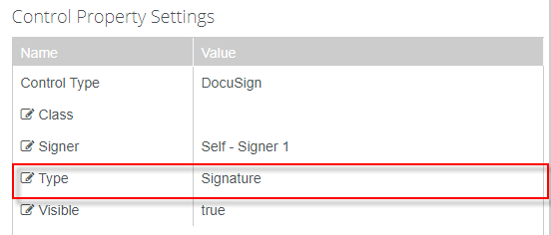

1. Update the ***Type*** property for the second ***DocuSign*** field in the ***Properties Pane*** as shown below.

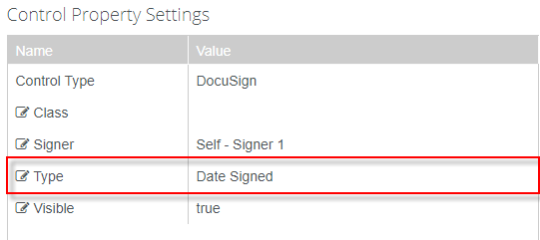

1. ***Save*** your form with the ***Form Name*** and ***Title*** as shown below. (Add your initials to the end of the form name.)

* Form Name: ***2018 2019 V1 Independent Verification Step 3 SC***
* Title: ***2018–2019 V1 Standard Verification Independent Student***

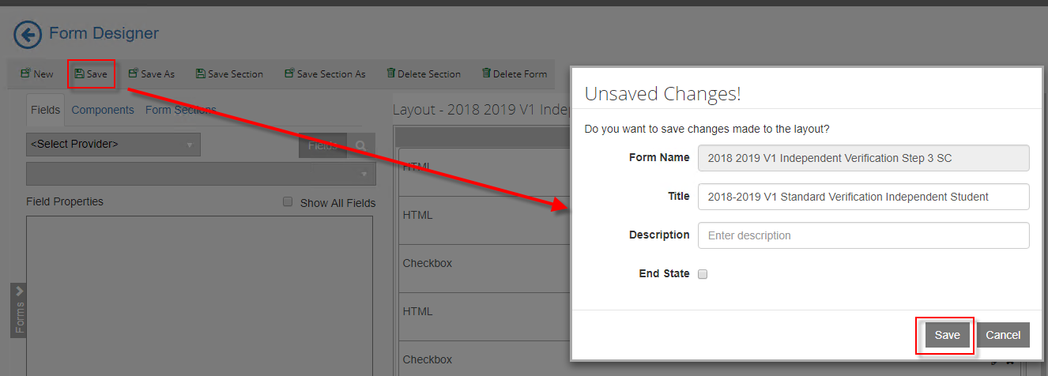

1. In the column drop-down above the designer, select ***1 Column*** and click select ***New*** to create a new form**.** A 1-Column panel is added to the designer.

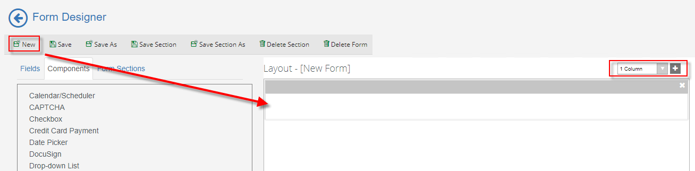

1. Drag the following fields into the panel from the ***Components*** fields as shown below.

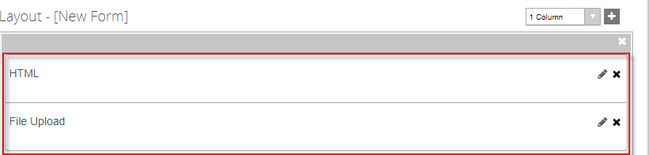

1. Update the ***HTML*** property for the ***HTML*** component in the ***Properties Pane*** as follows:

***<b>Please upload all supporting documentation and select "Submit". If you do not have any documentation to upload, select "Submit" to complete the Verification process. </b>***

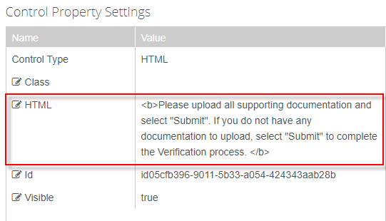

1. ***Save*** your form with the ***Form Name*** and ***Title*** as shown below. (Adding your initials to the end of the form name.)

* Form Name: ***2018 2019 V1 Independent Verification Step 4 SC***
* Title: ***2018–2019 V1 Standard Verification Independent Student***

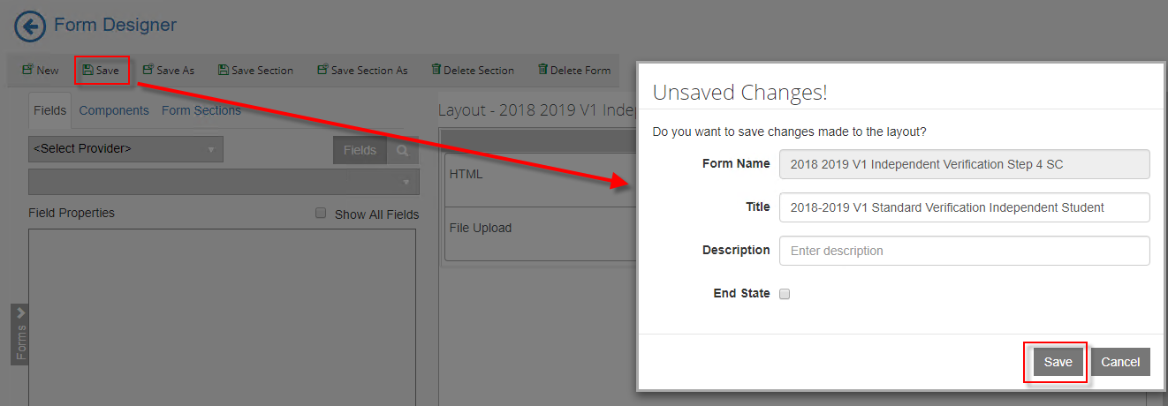

1. On the top left bar, click on the ***arrow*** to navigate out of Form Designer.

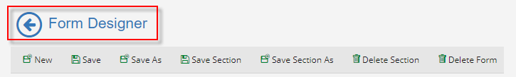

1. Select Sequence Designer.

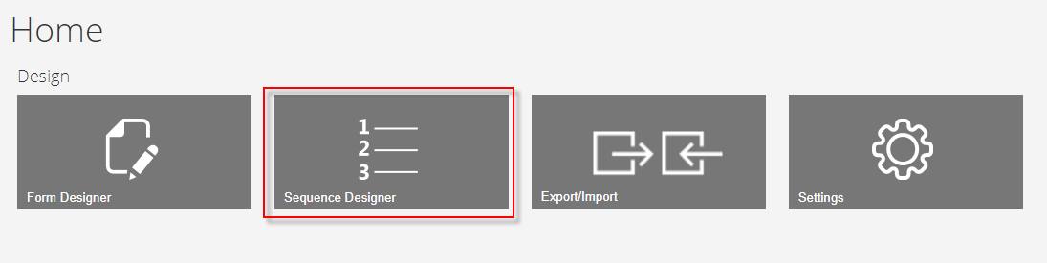

1. Select ***New*** and a new panel will be created for you to drag your forms into for creating your sequence.

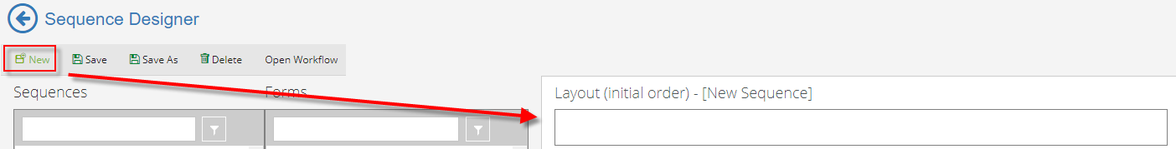

1. Drag the four Verification forms that you created into the New Sequence panel. After the third form but before the fourth form drag the ***Default-Frame*** form. This form is used when you are using ***DocuSign.***

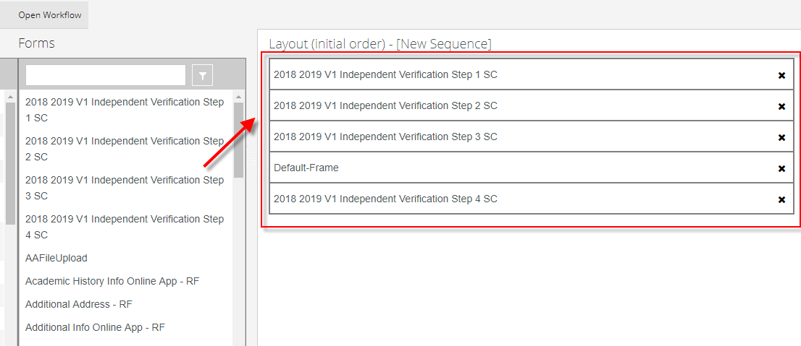

1. ***Save*** the Sequence with your initials at the end as shown below.

* Sequence Name***: 2018 2019 V1 Independent Verification Sequence SC***
* Title***: 2018–2019 V1 Standard Verification Independent Student Sequence***

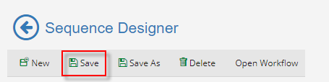

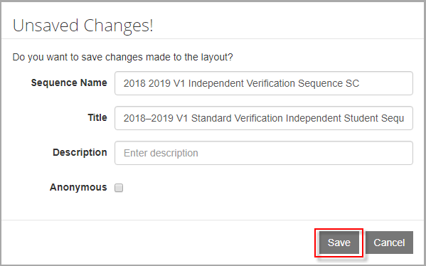

1. Select the ***Sequence*** in the ***Sequence pane*** and in the ***Properties Pane*** ensure the ***AuthenticationProduct*** is ***Student*** and change the ***End State Form*** to ***Custom-Confirmation Standard No Auto Close*** and ***Save*** your changes.

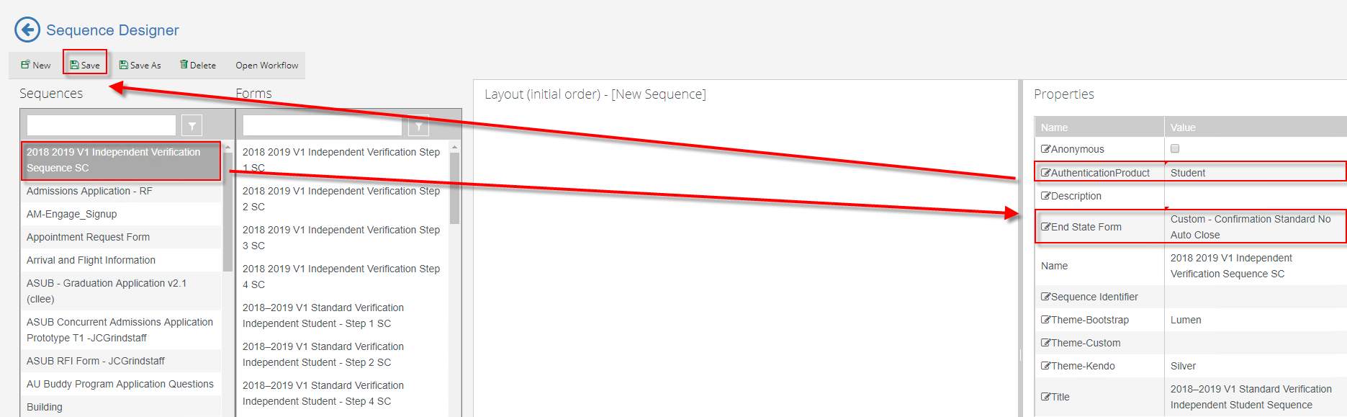

1. Once saved, select the ***Sequence*** in the ***Sequence pane*** and select ***Open Workflow*.**

**Note:** This will open Workflow Composer and create the State Machine Workflow shell for us to start creating our supporting workflow for the form. You can also open the workflow directly from Workflow Composer.

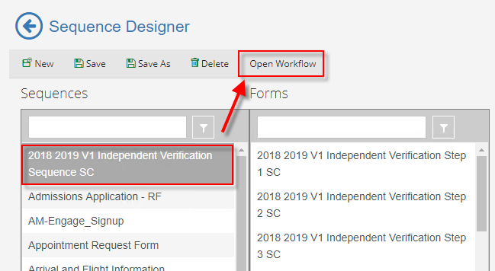

1. Rename the ***StateMachine******Flow*** to ***StateMachine-VerificationIndependent*.** You can do this by double-clicking on the title at the top.

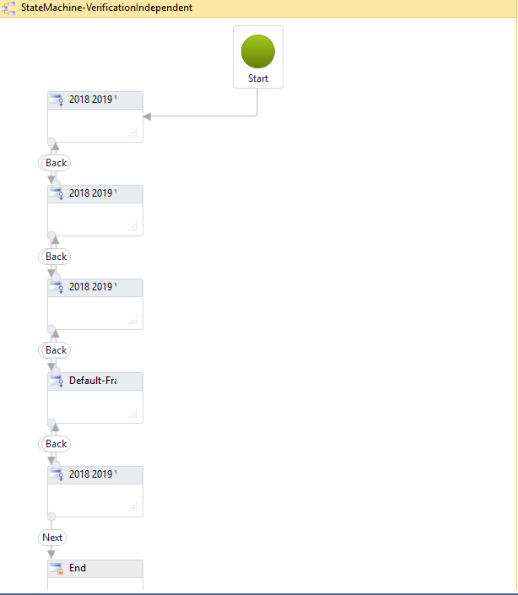

1. Select the second sequence in the state machine flow to give it the focus and hit the right arrow on your keyboard to move the sequence to the right. Do this for every other sequence. This helps to organize our state machine flow to better navigate.

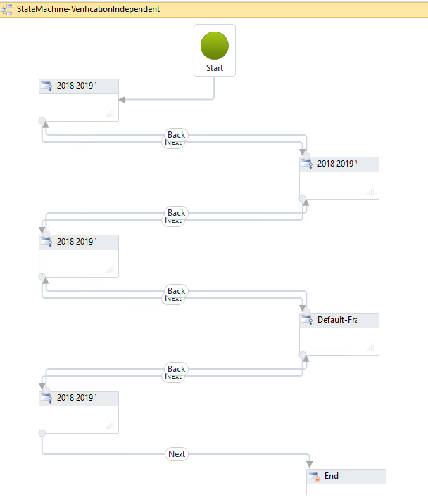

1. ***Double-click*** the first sequence in the State Machine flow. This will allow you to specify what you want to occur upon entry of the form.

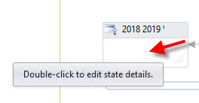

1. The first thing that we want to do is find the student that is completing the form in order to display values back to our ***Verification*** form. Drag a ***Sequence*** activity onto the designer in the ***Entry*** section of the activity. Rename the sequence to ***Find Student*.**

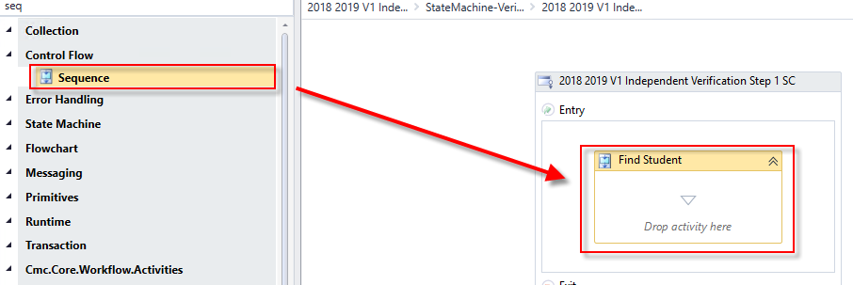

1. Drag the ***LookupUser*** activity onto the designer into the ***Sequence***. We use this activity to find the student completing the form. Rename the activity to ***Lookup Student*.**

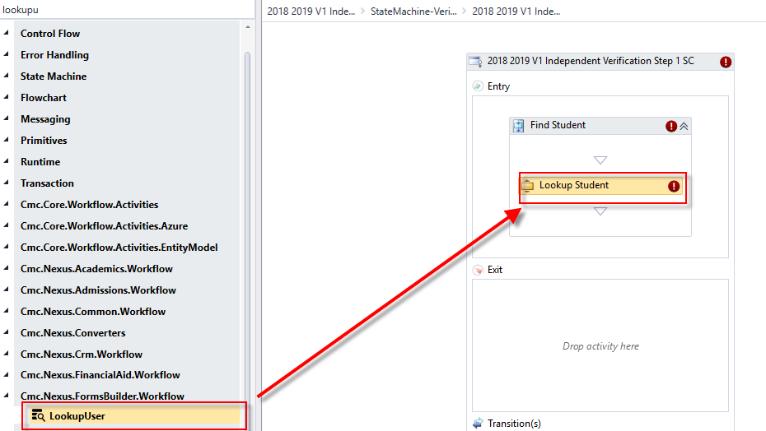

1. Create a ***variable***:

* Name: ***studentid***
* Variable type: ***Int32***
* Scope: ***StateMachine-VerificationIndependent***

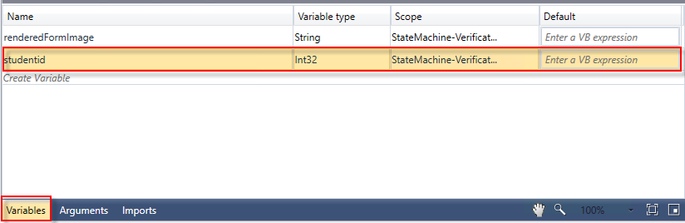

1. Complete the properties for the ***Lookup Student LookupUser*** activity as shown below:

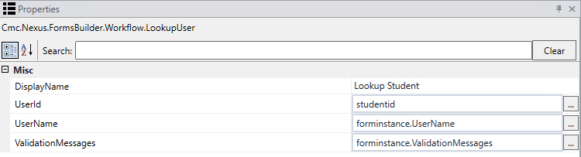

1. We then want to get the data from the ***studentEntity*** so we can display back to our form. We use the ***GetEntity*** activity. Drag the ***GetEntity*** activity onto the designer below the ***Lookup Student LookupUser*** activity. When the box pops up, ***Browse for Types*.** Navigate to: ***Cmc.Nexus.Common.Contracts>Cmc.Nexus.Common.Entities>StudentEntity*** and click ***OK.***

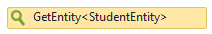

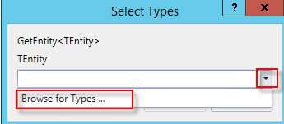

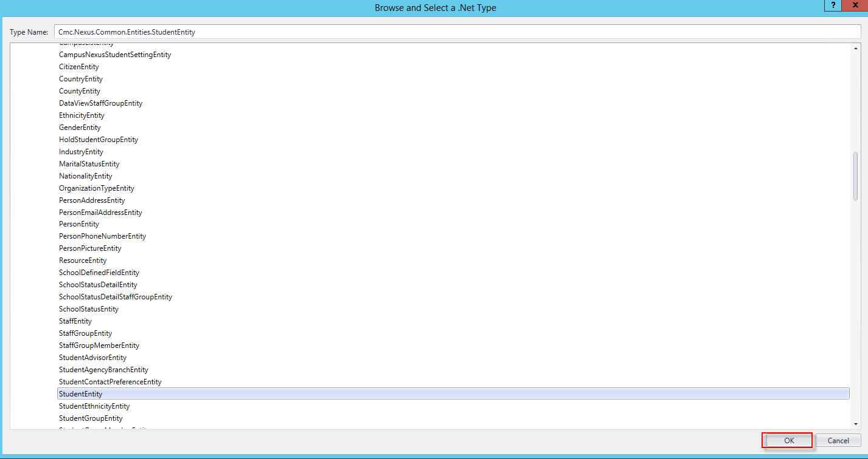

1. Specify the properties in the ***Properties Pane*** for the ***GetEntity*** activity.

**Note:** The ***EntityId***is your variable of ***studentid*** and the Result is the ***studentEntity***.

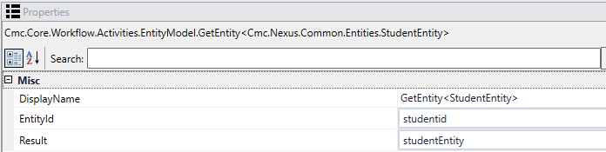

1. In order to specify the document to which we want to attach the ***PDF*** once the student completes the form, we need to look up the document so we can reuse it in our workflow. Drag a ***LookupReferenceItem*** activity onto the designer below the ***GetEntity*** activity. Assign the following values to the activity:

* Display Name: ***Find Document***
* Reference Item Type:  ***Document Type***
* Reference Item: ***Verification for Independent***
* Reference Item Id: ***This is the Id of the document selected above and will auto populate.***

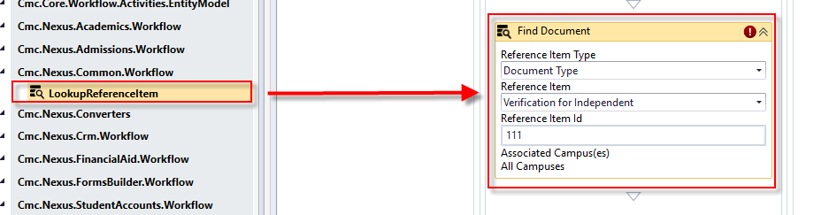

1. Create a ***variable***:

* Name: ***Ref***
* Type: ***You will have to browse for the type. Cmc.Nexus.Common.Contracts>Cmc.Nexus.Common.Services>ReferenceItem***
* Scope: ***StateMachine-VerificationIndependent***

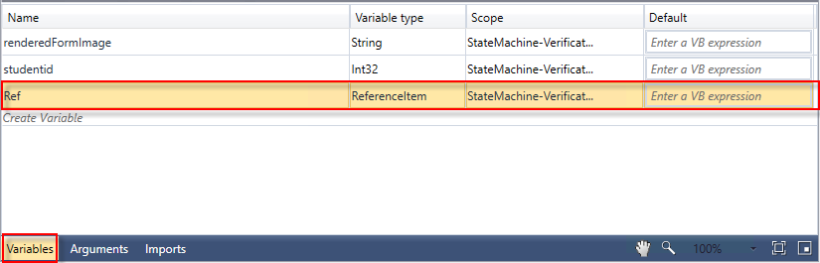

1. Assign the variable to the ***Find Document LookupReferenceItem*** in the ***Properties Pane*** and complete any remaining properties as shown below.

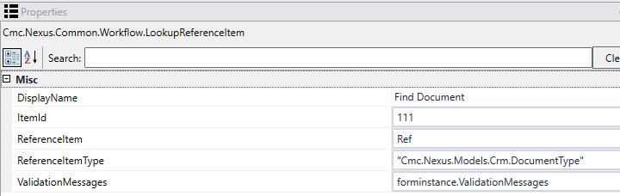

1. We now want to see if the document that we looked up above is associated to the student record in ***CampusNexus Student***. Drag the ***LookupStudentDocuments*** activity onto the designer below the ***Find Document LookupReferenceItem*** activity. Complete the following for the activity:
2. Rename the activity to: ***Find Document for Student***
3. Student Id: *studentid (This will push the studentid that we looked up earlier in our workflow to the Find Document for Student LookupStudentDocuments activity in order to find the student.)*
4. Document Type Id: ***Ref.Id (This pushes the document id that we looked up in our Find Document LookupReferenceItem activity into the Find Document for Student LookupStudentDocuments activity in order to find the specified document for the student.)***

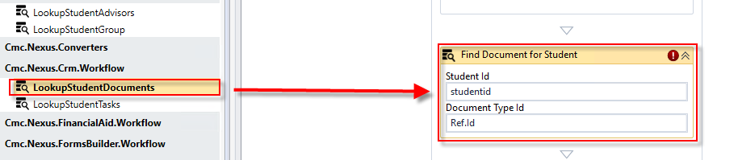

1. Create a ***variable***:

* Name: ***Verif***
* Type: ***You will have to browse for the type. In the drop-down select Array of [T] then select Browse for Types…***

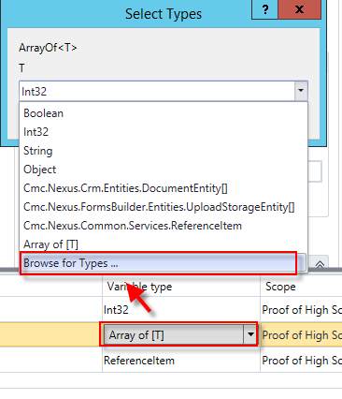

* Browse for: ***Cmc.Nexus.Crm.Contracts>Cmc.Nexus.Crm.Entities>DocumentEntity*** and click ***OK***
* Scope: ***StateMachine-VerificationIndependent***

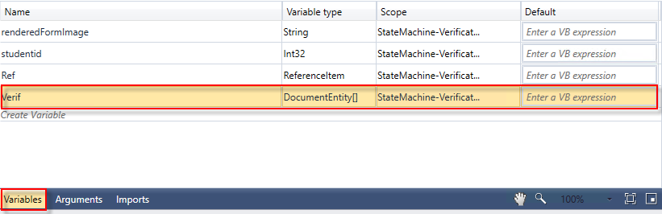

1. Assign the variable to the ***Find Document for Student LookupStudentsDocuments*** activity in the ***Properties Pane*** and complete any remaining properties as shown below.

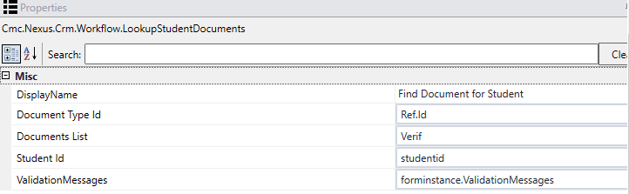

1. Drag two ***Assign*** activities below the ***Find Document for Student LookupStudentDocuments*** activity. Rename both activities as shown below.

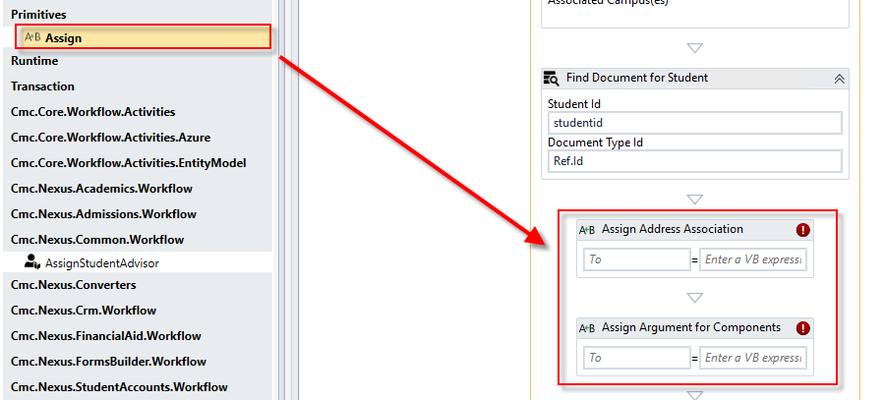

1. For the ***Assign Address Association*** Assign activity, complete the properties as follows: ***studentEntity.StudentAddressAssociation= Cmc.Nexus.Common.Entities.StudentAddressAssociation.IgnoreInStudentAssociation***

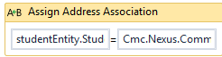

1. For the Assign Arguments for Components Assign activity, we need to create an Argument.

* Name: ***myDictionary***
* Direction: ***In/Out***
* Argument type: Browse for: ***mscorlib>System.Collections.Generic>Dictionary<TKey, TValue>***
* Select ***String***, ***Object*** and ***OK***.

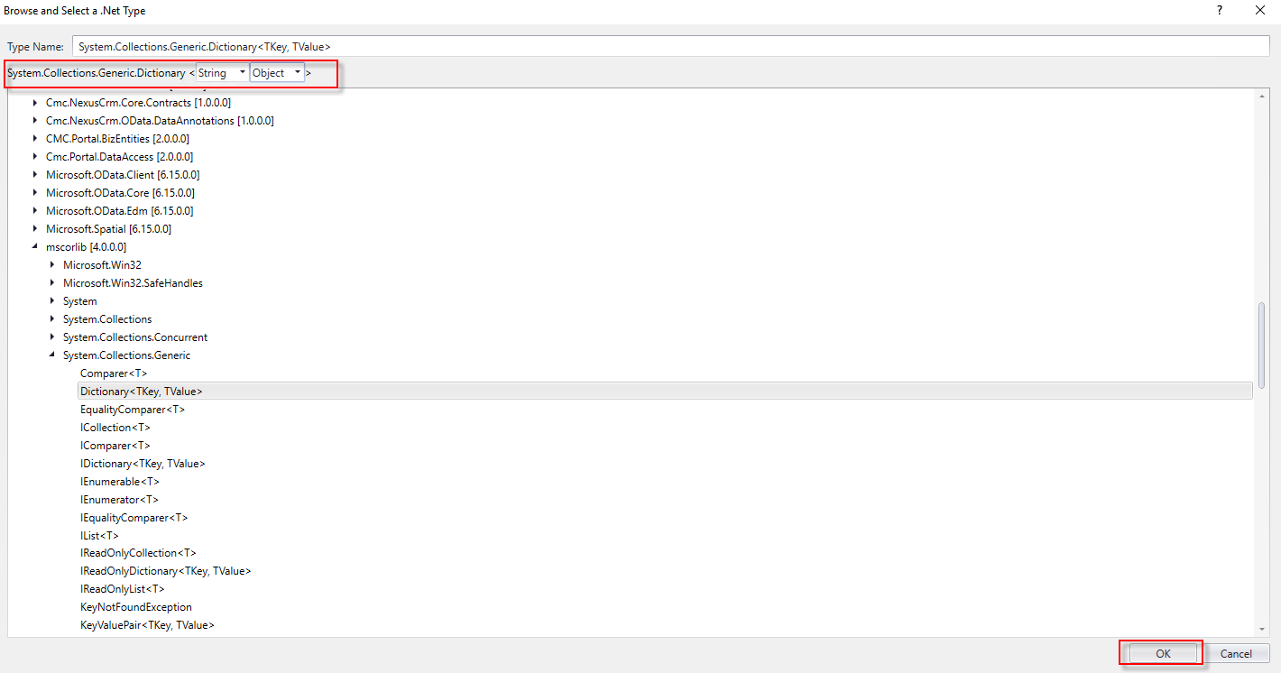

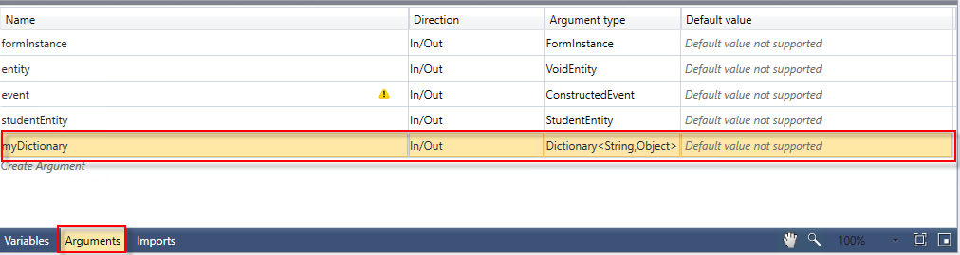

1. For the ***Assign Arguments for Components Assign*** activity, complete the properties as follows: ***myDictionary=New Dictionary(Of String, Object)()***

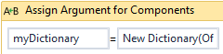

1. Now we want to log all the field values from the ***studentEntity*** to our log files. Drag the ***LogObject*** activity into the sequence below the ***Assign Argument for Components*** ***Assign*** activity. In the ***Properties Pane*** for the ***LogObject*** activity next to the ***Object*** property enter ***studentEntity.***

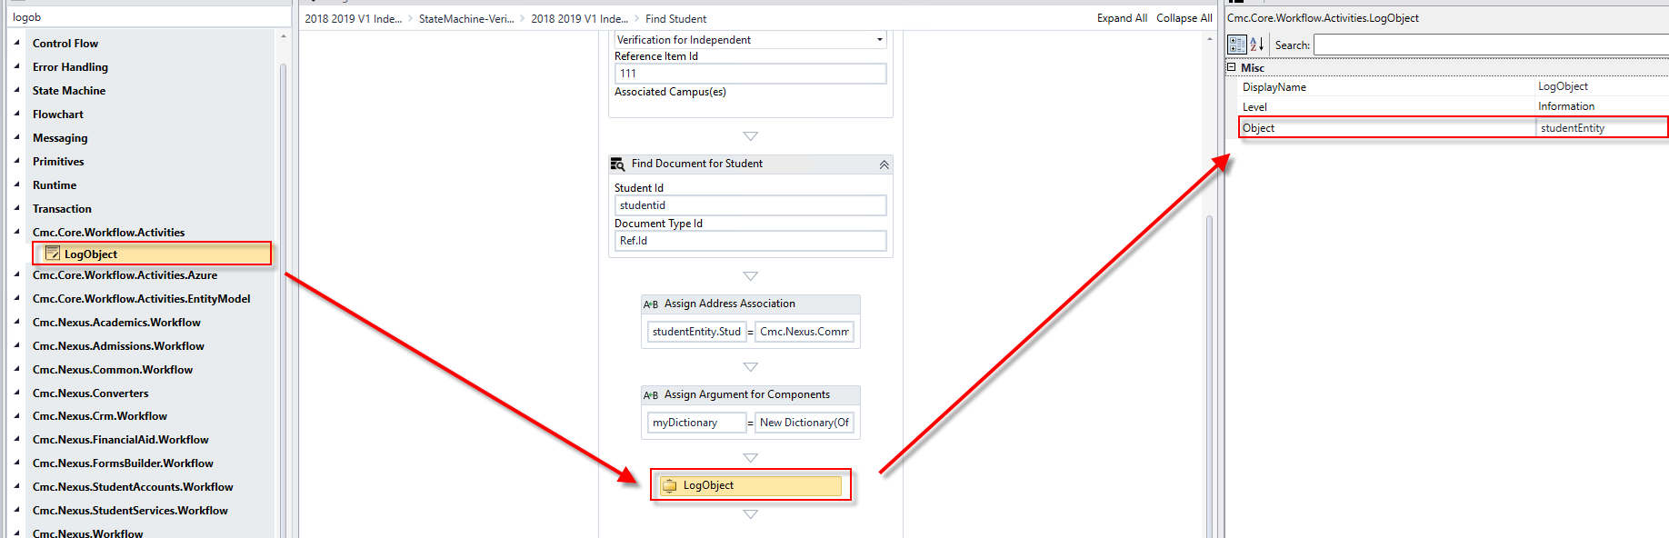

1. We now want to create three arguments for our ***Grid*** components on our form. The name of each will match what we used for our model in the form: ***myIncome, myHousehold, myChildSupport.*** The ***Direction*** for all three will be ***In/Out.*** The ***Argument type*** will be an ***Array of [T]*** and you will need to ***Browse for Types…Cmc.Nexus.FormsBuilder.Contracts>Cmc.Nexus.FormsBuilder.Entities>*** ***SerializableDynamicObject.***

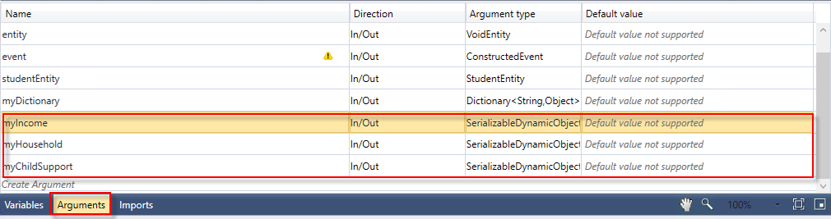

1. We are now going to move through our StateMachine workflow as we are navigating through our form sequence. At this point, we have our student and have found the document to which we will attach our PDF in the student's Document Center. We do not want to do anything else until the student gets ready to electronically sign the form.

You can collapse the activities created in the previous steps and then move through your workflow. Follow the steps below to navigate through each transition in the workflow.

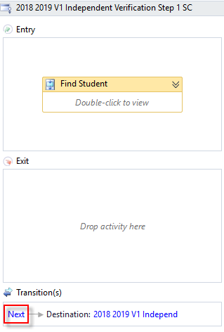

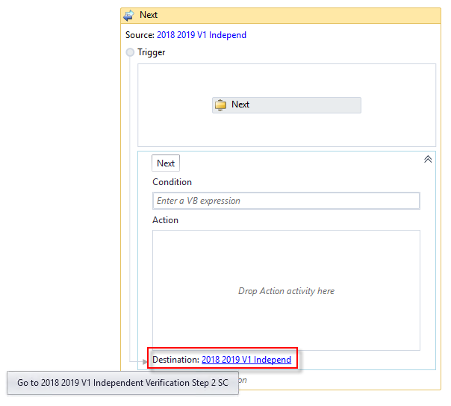

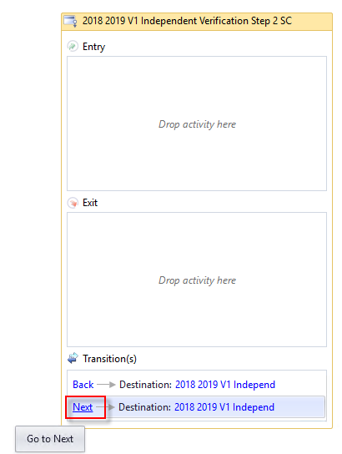

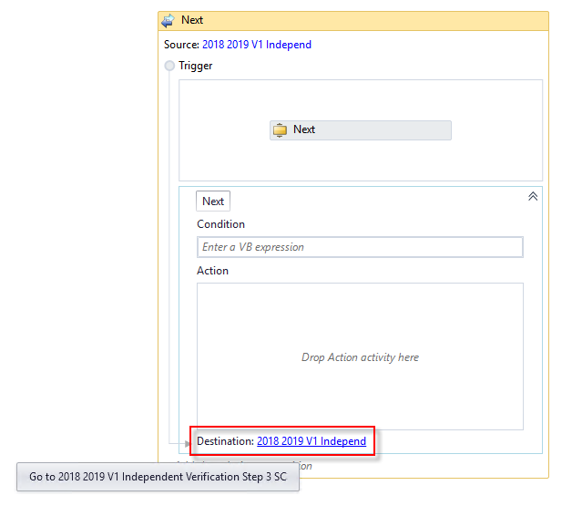

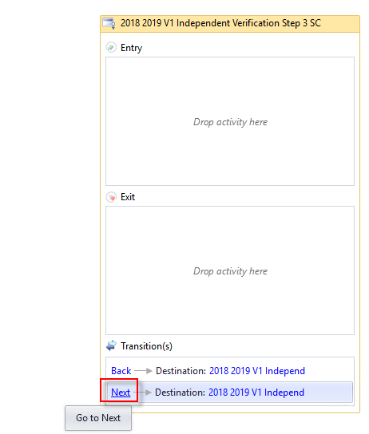

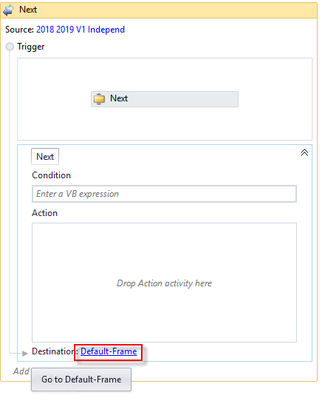

1. In the ***Entry*** section of the ***Default-Frame***, drag a ***Sequence*** activity into the section and rename it ***Print PDF get DocuSign Config.***

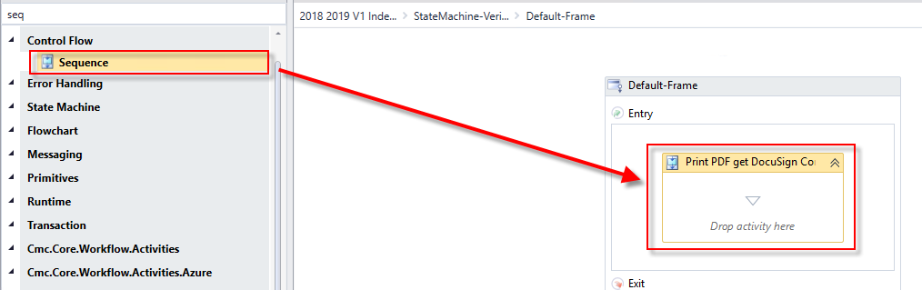

1. Drag an ***Assign*** activity into the sequence.
2. Rename to: ***Assign URL***
3. Create a ***variable***:

* Name: URL
* Type: ***string***
* Scope: ***StateMachine-VerificationIndependent***

1. Assign Activity Values: ***URL=forminstance.RendererBaseUrl + "#/viewCreator/" + formInstance.WorkflowDefinitionId.ToString + "/forms=2018+2019+V1+Independent+Verification+Step+1+SC,2018+2019+V1+Independent+Verification+Step+2+SC,2018+2019+V1+Independent+Verification+Step+3+SC"***

**Note:** After forms=, it should be the exact name of your forms where the + is used for any spaces.

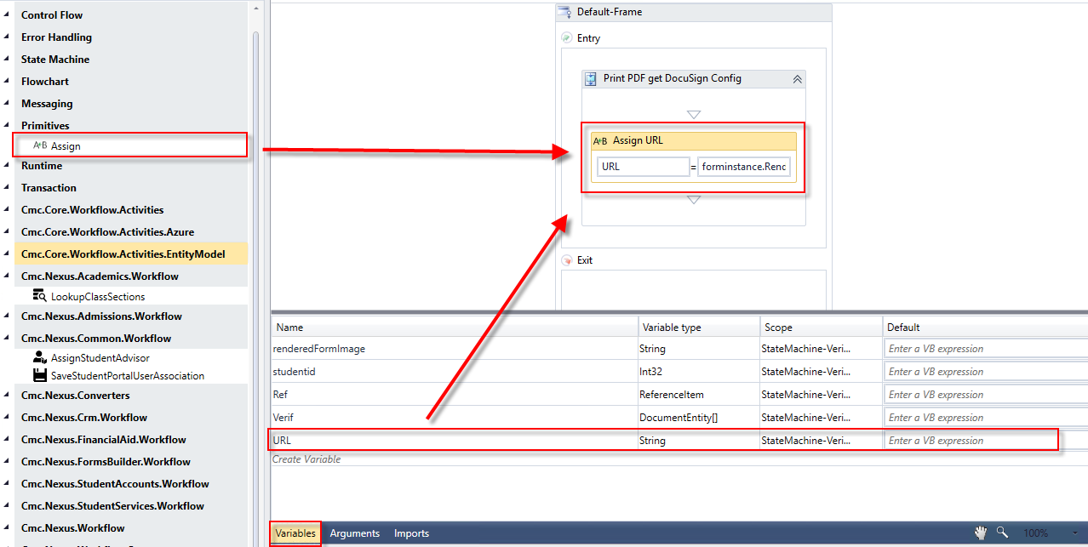

1. Drag a ***Persist*** activity beneath the ***Assign URL Assign*** activity.

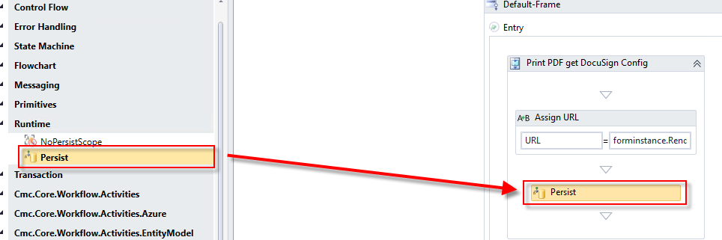

1. Drag a ***PrintUrltoPdf*** activity beneath the ***Persist*** activity.
2. Create a ***variable***:

* Name: ***Pdf***
* Type: ***Array of [T], Browse for Types….miscorlib>System>Byte***
* Scope: ***StateMachine-VerificationIndependent***

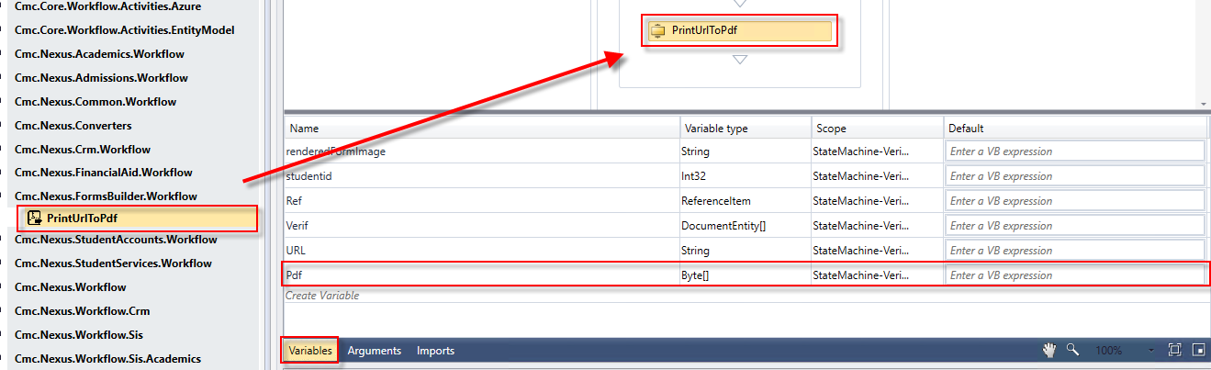

1. Complete the ***PrintUrltoPdf*** properties:

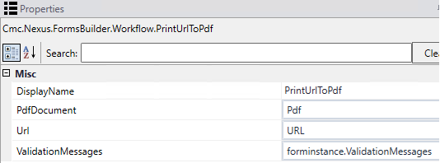

1. Drag a ***LogLine*** activity beneath the ***PrintUrlToPdf*** activity.

* Rename the activity: ***Log Pdf URL***
* Text: ***Environment.NewLine + "Log URL" + URL.tostring***
* Level: ***Error***

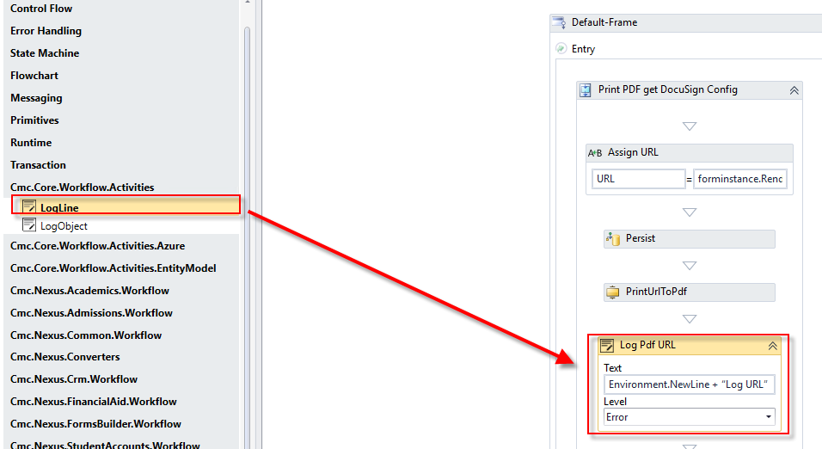

1. Drag a **Sequence** activity below the ***Log Pdf URL Logline*** activity and ***Rename*** the Sequence ***DocuSign Config***.

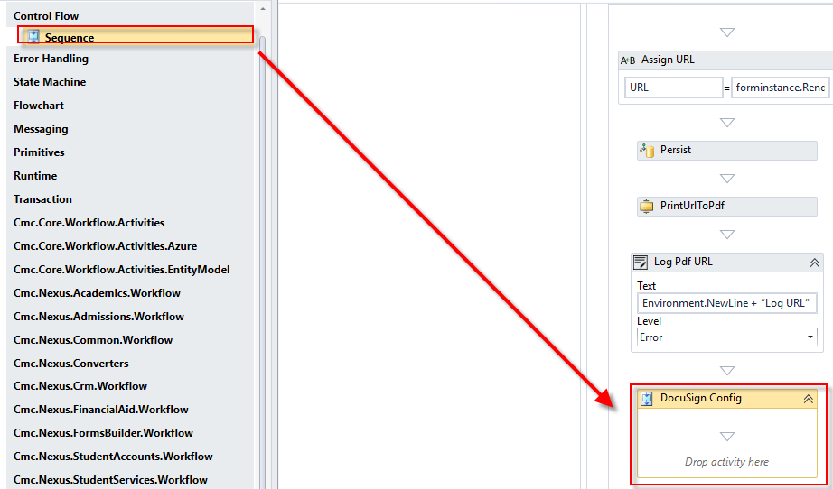

1. Create the following ***variables***:

* Name: ***DocuSignConfig***
* Type: ***Cmc.Nexus.FormsBuilder.Contracts>Cmc.Nexus.FormsBuilder.Entities>DocuSignConfig***
* Scope: ***StateMachine-VerificationIndependent***
* Name: ***DocuSignDocument***
* Type: ***Cmc.Nexus.FormsBuilder.Contracts>Cmc.Nexus.FormsBuilder.Entities>DocuSignDocument***
* Scope: ***StateMachine-VerificationIndependent***
* Default: ***New DocuSignDocument***
* Name: ***DocuSignRecipient***
* Type: ***Cmc.Nexus.FormsBuilder.Contracts>Cmc.Nexus.FormsBuilder.Entities>DocuSignRecipient***
* Scope: ***StateMachine-VerificationIndependent***
* Default: ***New DocuSignRecipient***
* Name: ***DocuSignRequest***
* Type: ***Cmc.Nexus.FormsBuilder.Contracts>Cmc.Nexus.FormsBuilder.Entities>DocuSignRequest***
* Scope: ***StateMachine-VerificationIndependent***
* Name: ***SignedDocument***
* Type: ***Cmc.Nexus.FormsBuilder.Contracts>Cmc.Nexus.FormsBuilder.Entities>DocuSignDocument***
* Scope: ***StateMachine-VerificationIndependent***

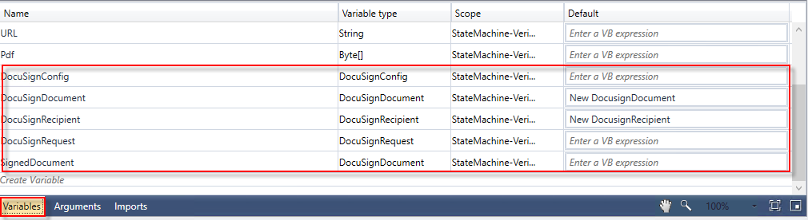

1. Create the following argument:

* Name: ***frameUrl***
* Direction: ***In/Out***
* Argument type: ***String***

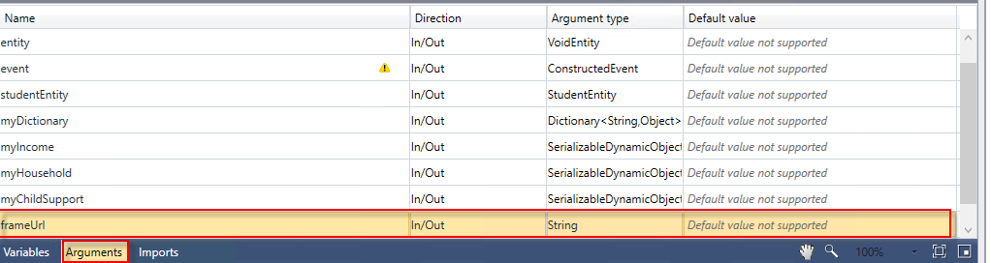

1. Drag the ***GetDocuSignConfig*** activity into the ***DocuSign Config*** sequence.

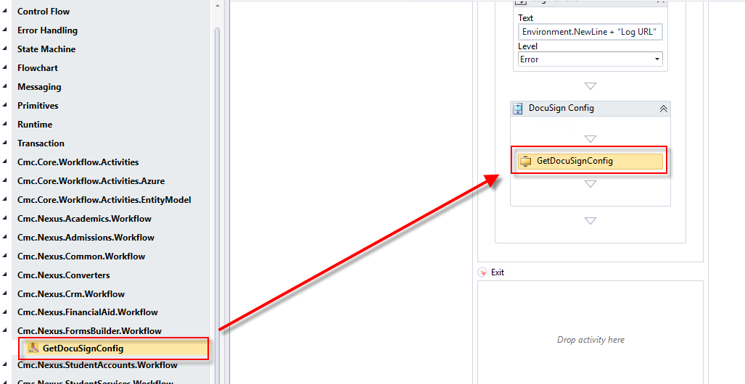

1. Complete the properties for the activity as shown below.

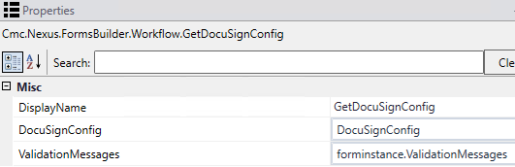

1. Drag a ***LogLine*** activity beneath the ***GetDocuSignConfig*** activity.

* Rename the activity: ***Log DocuSign Config values***
* Text: ***Environment.NewLine + "Assigning DocuSign Values" + Environment.NewLine***
* Level: ***Error***

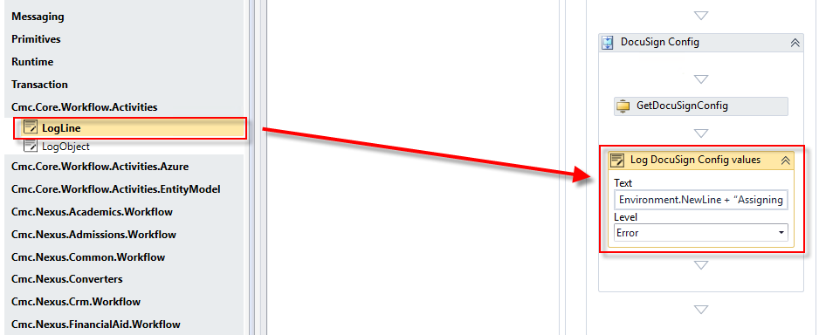

1. Drag ***nine******Assign*** activities beneath the ***Log DocuSign Config values LogLine*** activity**.** Assign the following values:
2. ***DocuSignConfig.EmailSubject = "CMC Campus DocuSign Testing" (Rename the activity to Assign Email Subject)***
3. ***DocuSignConfig.ReturnUrl = forminstance.RendererBaseUrl + "#/docusigncomplete" (Rename the activity to Assign Url)***
4. ***DocuSignConfig.BasePath = "***[***https://demo.docusign.net/restapi***](https://demo.docusign.net/restapi)***" (Rename the activity to Assign Base Path)***
5. ***DocuSignDocument.DocumentId = "1" (Rename the activity to Assign Document Id)***
6. ***DocuSignDocument.Name = "Verification Independent Pdf" (Rename the activity to Assign Document Name)***
7. ***DocuSignDocument.Content = Pdf (Rename the activity to Assign Document Content)***
8. ***DocuSignRecipient.Name = studentEntity.FirstName + studentEntity.LastName (Rename the activity to Assign Recipient Name)***
9. ***DocuSignRecipient.Email = studentEntity.EmailAddress (Rename the activity to Assign Recipient Email)***
10. ***DocuSignRecipient.SignerId = "1" (Rename the activity to Assign Signer ID)***

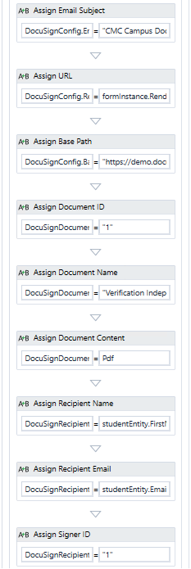

1. Drag the ***CreateDocuSignRequest*** activity beneath the last ***Assign*** activity.

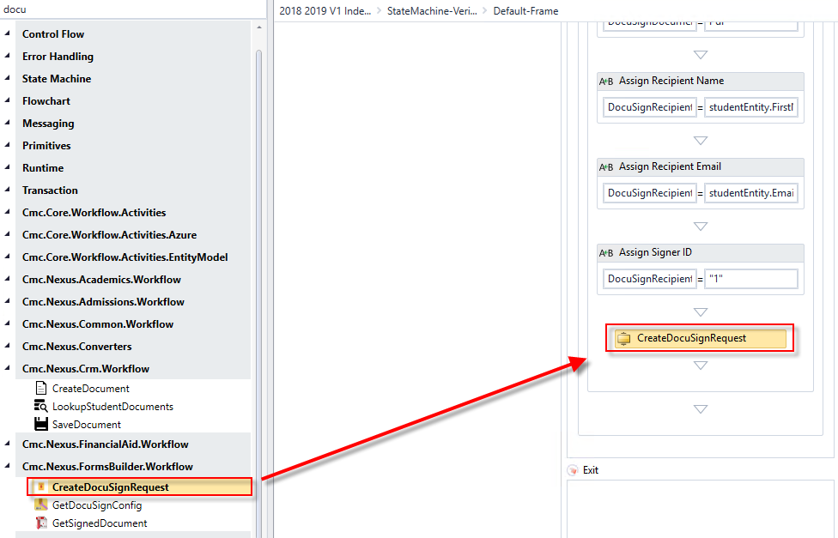

1. Complete the properties for the activity as shown below.

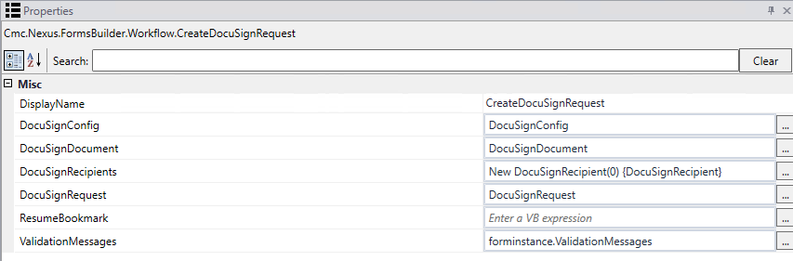

1. Drag an ***Assign*** activity below the ***CreateDocuSignRequest*** activity.
2. Rename the activity to ***Assign URL*.**
3. Assign the value: ***frameUrl = DocuSignRequest.Url***

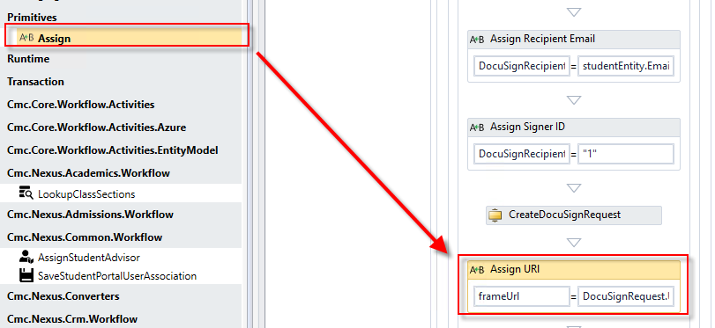

1. Select ***Next*** at the bottom of the form to go to the next transition.

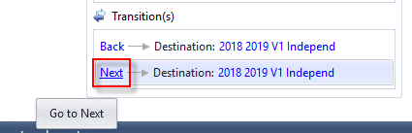

1. Perform the following:
2. Rename the ***WaitForFormBookmark*** activity and the ***Next*** button text to ***Continue*.**
3. Drag the ***GetSignedDocument*** activity below the ***Continue WaitForFormBookmark*** activity. This will create a ***Sequence*** around the two activities.
4. ***Rename the Sequence*** activity to ***Get Signed Document*** ***and Create Pdf***.

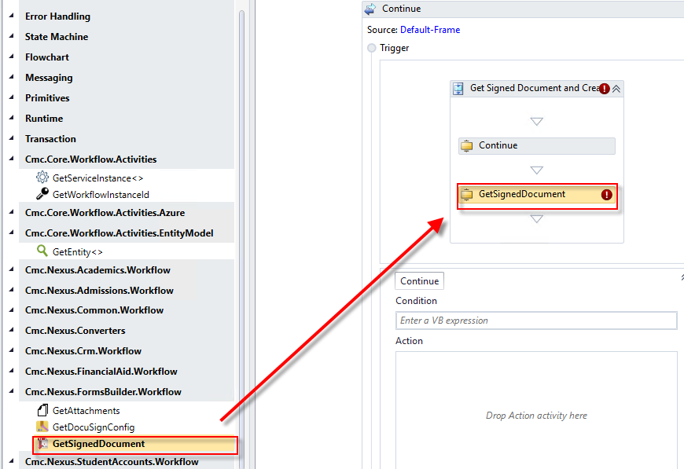

1. Complete the properties for the ***GetSignedDocument*** activity as shown below.

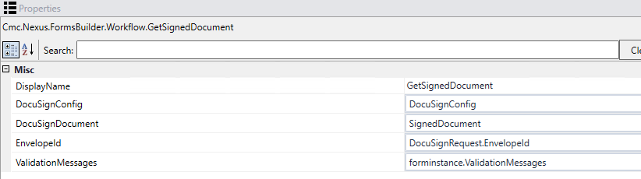

1. Drag an ***If*** activity below the ***GetSignedDocument*** activity.

* Rename the activity to ***If document exists.***
* Condition: ***Verif.Length>0***

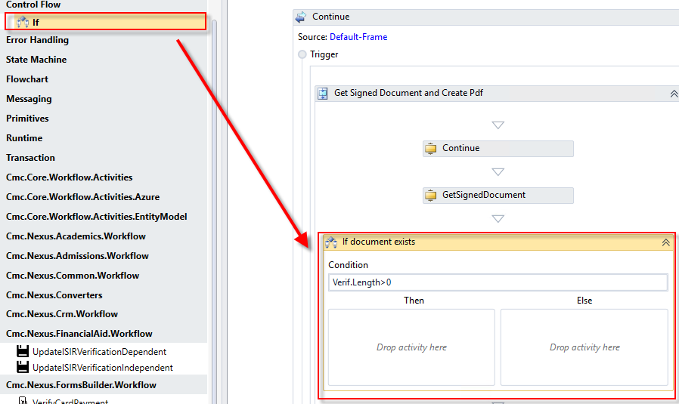

1. Drag a ***GetEntity*** activity into the ***Then*** portion of the ***If document exists If*** activity. Browse for Type: ***Cmc.Nexus.Crm.Entities.DocumentEntity***

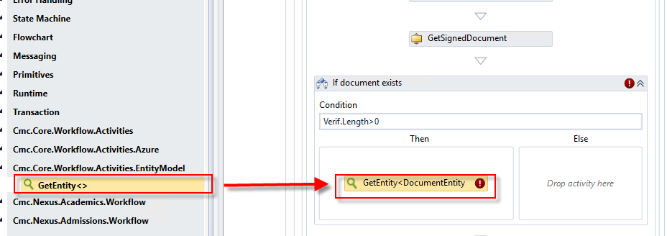

1. Create a ***variable:***

* Name: ***DocumentEntity***
* Variable type: ***Cmc.Nexus.Crm.Entities.DocumentEntity***
* Scope: ***StateMachine-VerificationIndependent***

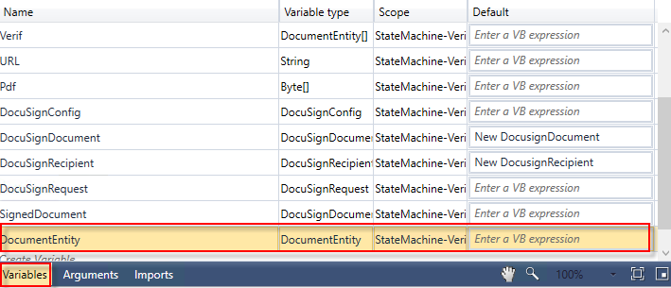

1. Complete the properties for the ***GetEntity*** activity as shown below.

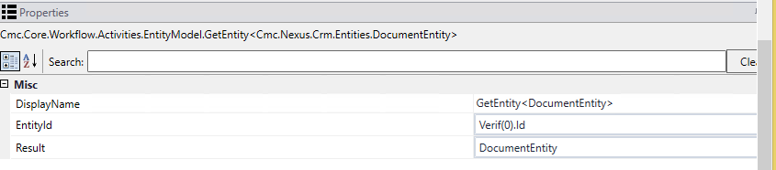

1. Drag the ***CreateDocument*** activity into the ***Else*** portion of the ***If document exists If*** activity. Complete the activity as shown below.

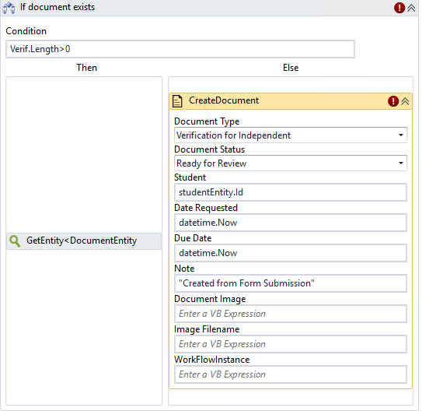

1. In the properties for the ***CreateDocument*** activity, enter ***DocumentEntity*** for the ***Document*** property.

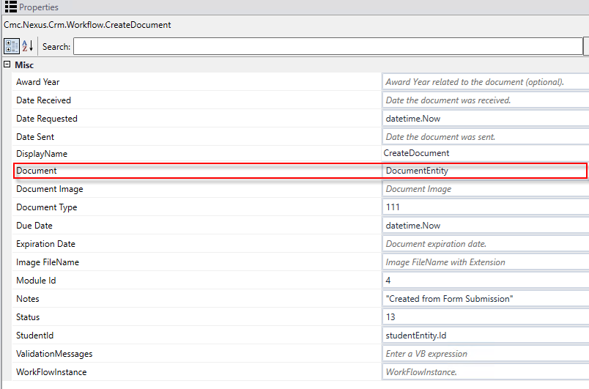

1. Drag a ***Sequence*** activity below the ***If*** activity. ***Rename*** the activity to ***Assign Doc Values*.**

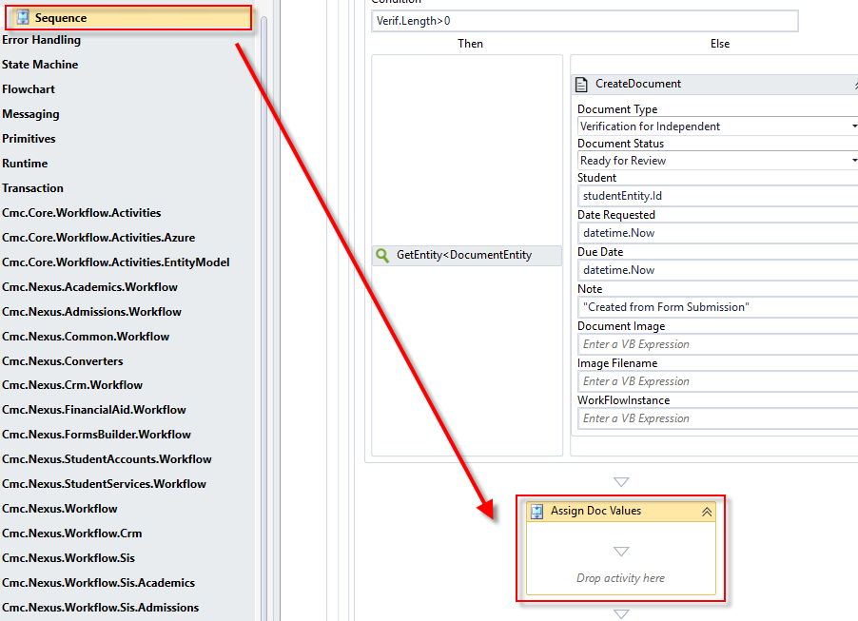

1. Drag ***six******Assign*** activities into the ***Sequence*.** Assign the following values:
2. ***DocumentEntity.DocumentImage = SignedDocument.Content (Rename the activity to Assign Document Image)***
3. ***DocumentEntity.OriginalFileName = "Signedpdf.Pdf" (Rename the activity to Assign File Name)***
4. ***DocumentEntity.ImageType = "Pdf" (Rename the activity to Assign Image Type)***
5. ***DocumentEntity.DocumentStatusId = 13 (Rename the activity to Assign Status)***
6. ***DocumentEntity.ReceivedDate = datetime.Now (Rename the activity to Assign Received Date)***
7. ***DocumentEntity.IsDocumentAddedManually = true (Rename the activity to Assign Doc Added)***

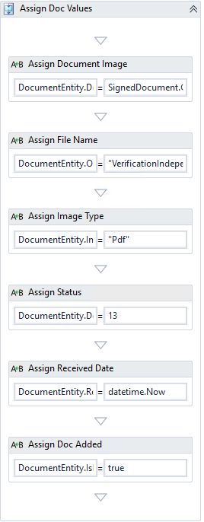

1. Drag the ***SaveDocument*** activity below the ***Assign Doc Values*** Sequence. Complete the properties for the activity as shown below.

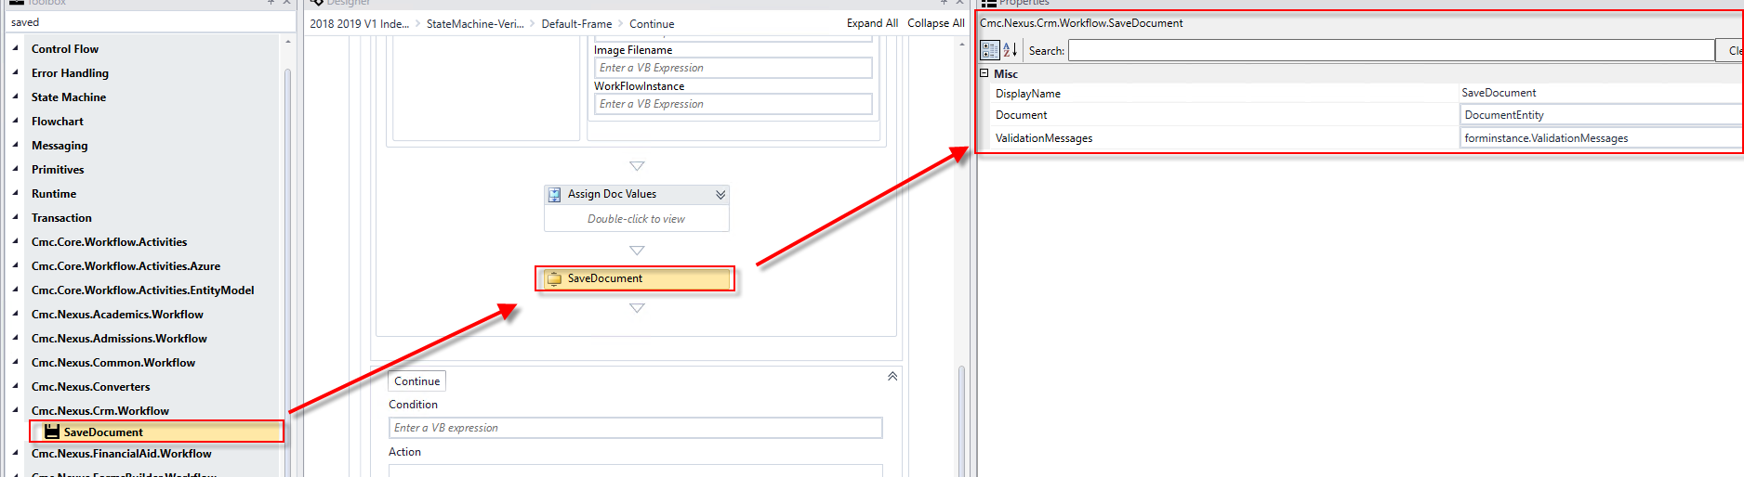

1. Drag a ***LogLine*** activity below the ***SaveDocument*** activity.

* Rename the activity: ***Log Creating Document***
* Text: ***Environment.NewLine + "Creating Document with pdf" + Environment.NewLine***
* Level: ***Error***

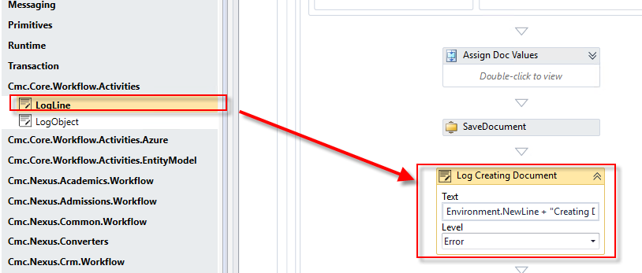

1. Drag a ***SaveEntity*** activity below the ***Log Creating Document LogLine*** activity. Browse for Type: ***Cmc.Nexus.Common.Entities.StudentEntity***

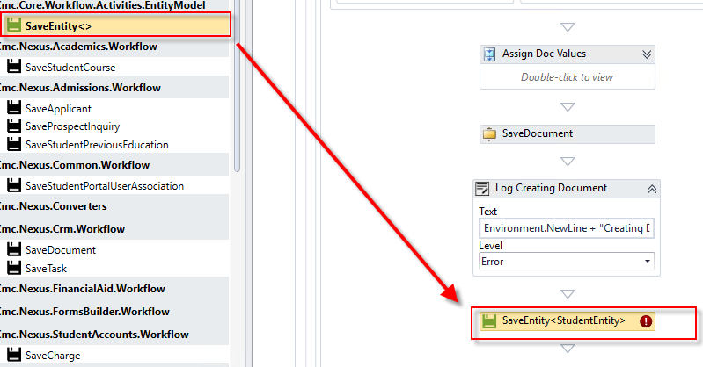

1. Complete the properties for the ***SaveEntity*** activity as shown below.

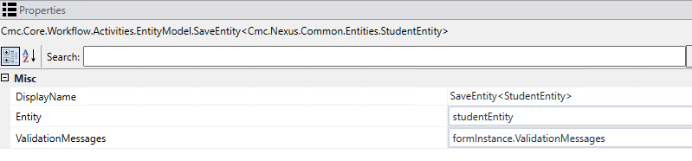

1. Drag a ***CreateTask*** activity below the ***SaveEntity*** activity. Complete the activity as shown below.

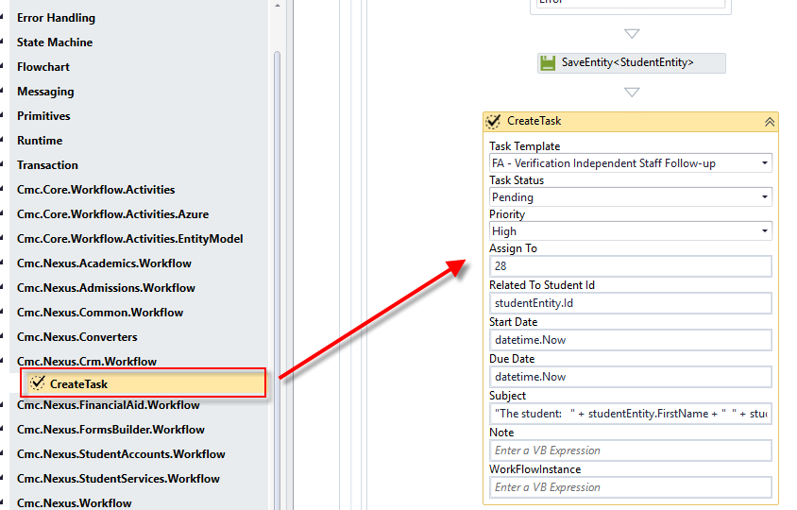

1. Create a ***variable:***

* Name: ***Task***
* Variable type: ***Cmc.Nexus.Crm.Contracts>Cmc.Nexus.Crm.Entities>TaskEntity***
* Scope: ***StateMachine-VerificationIndependent***

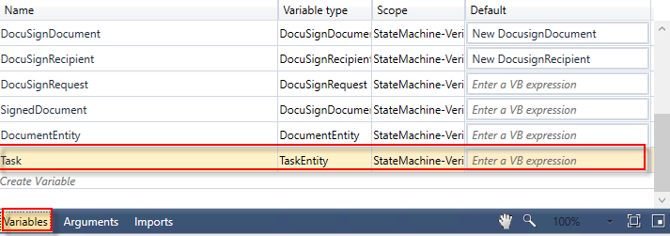

1. In the properties for the ***CreateTask*** activity, enter ***Task*** for the ***Task*** property.

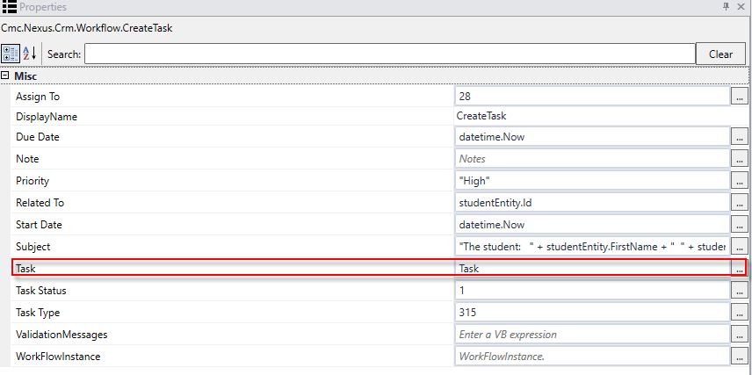

1. Drag a ***SaveTask*** activity below the ***CreateTask*** activity. Complete the properties as shown below.

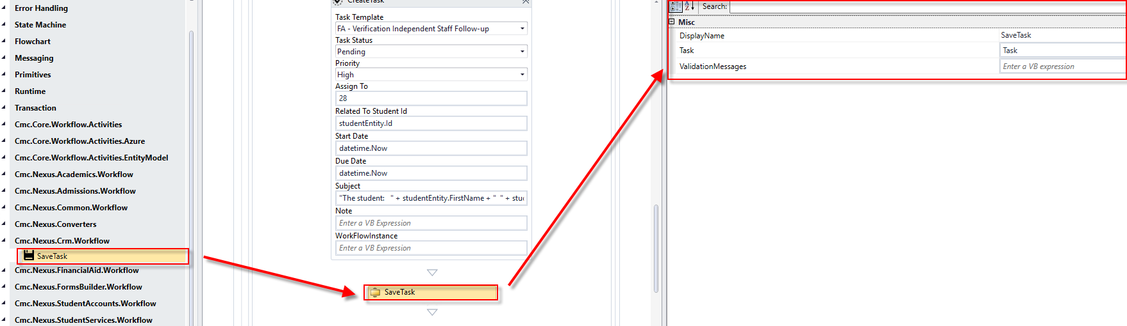

1. Enter ***Not FormInstance.ValidationMessages.HasErrors*** for the ***Condition*** to ensure any errors on the form are returned.

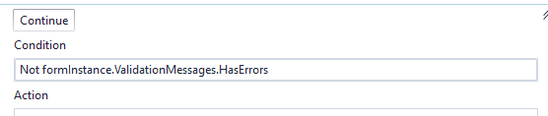

1. At the bottom of the screen, click to enter the last transition in our form.

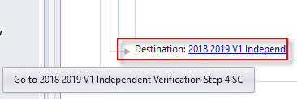

1. Click ***Next*** to enter the transition.

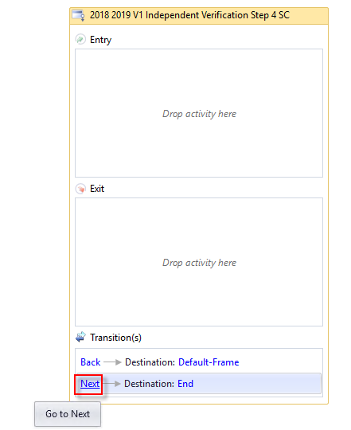

1. Perform the following:
2. Rename the ***WaitForFormBookmark*** activity and the ***Next*** button text to ***Submit*.**
3. Drag a ***Sequence*** activity below the ***Submit WaitForFormBookmark*** activity. This will create a ***Sequence*** around the two activities. Rename the sequence to ***Get attachments and Save in Doc Center.*** Rename the top sequence to ***Save.***

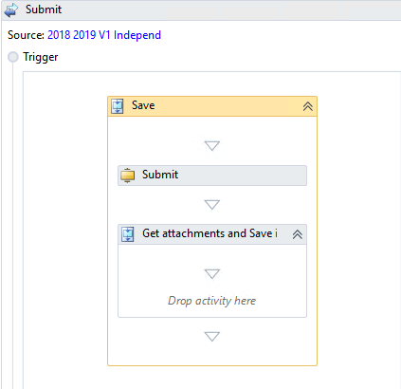

1. We now want to get the attachment that the student is uploading in the form so we can attach it to the student and update values accordingly. Drag the ***GetAttachments*** activity into the ***Get attachments and Save in Doc Center Sequence*** activity.

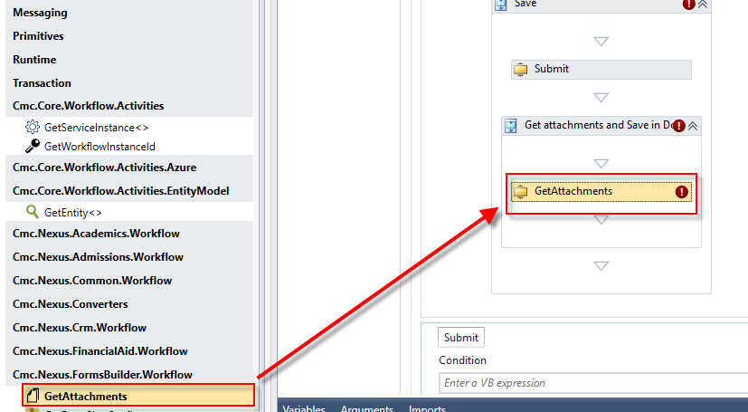

1. Create a ***variable***:

* Name: ***ULDocs***
* Variable type: ***Select Array of [T] and then Browse for Types…Cmc.Nexus.FormsBuilder.Contracts>Cmc.Nexus.Formsbuilder.Entities>UploadStorageEntity***
* Scope: ***StateMachine-VerificationIndependent***

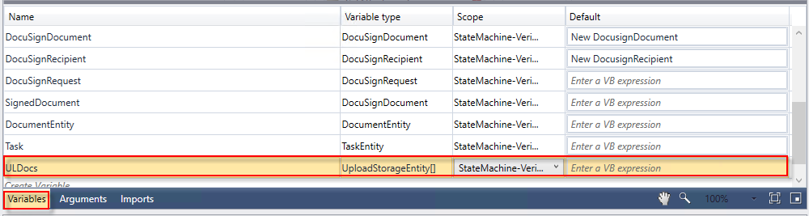

1. Assign the variable to the ***GetAttachments***activity next to the ***Dcouments*** property in the ***Properties Pane***. Also, complete the property for ***ValidationMessages.***

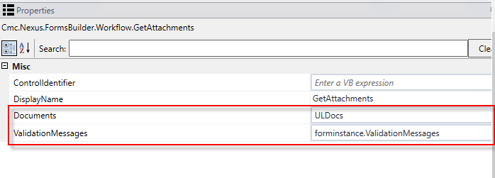

1. For the ***GetAttachments*** activity we also need to know the ***ControlIdentifier*** in order to get the uploaded document. This is found on our field on our form in Forms Builder. Navigate back to the ***Verification*** form in Forms Builder. Go to the properties for the ***File Upload*** field and copy the Id. Paste Id in the ***Properties Pane*** next to the ***ControlIdentifier*** propertyfor the ***GetAttachments*** activity.

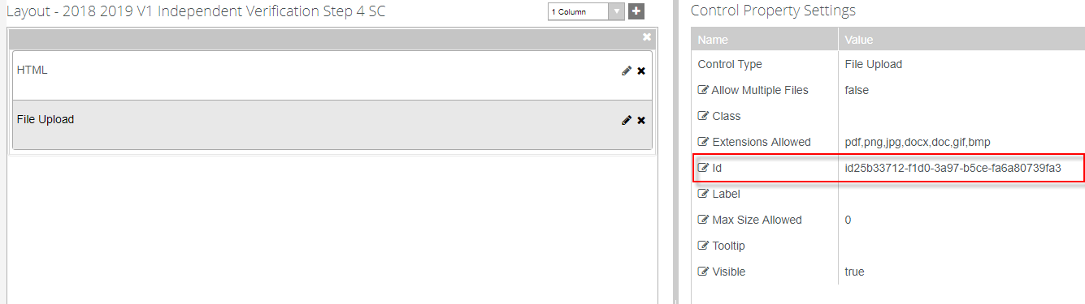

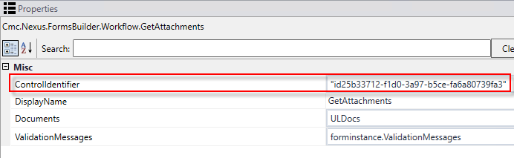

1. Drag a ***LogLine*** activity below the ***GetAttachments*** activity.

* Rename the activity***: Log Count***
* Text: ***Environment.NewLine + "Number of Documents" + ULDocs.Length.ToString + Environment.NewLine***
* Level: ***Error***

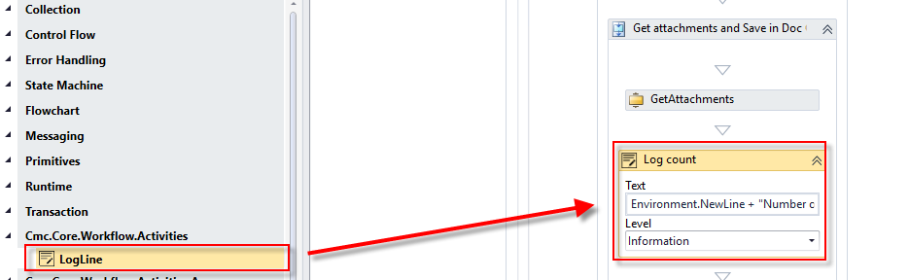

1. Drag an ***Assign*** activity below the ***Log count LogLine*** activity.
2. Rename to: ***Assign Attachment***
3. Create a variable:

* Name: ***Documents, Type: Array of [T] and Cmc.Nexus.Crm.Contracts>Cmc.Nexus.Crm.Entities>DocumentEntity***
* Scope***: StateMachine-VerificationIndependent***

1. Assign Activity Values: ***Documents= New DocumentEntity(ULDocs.Length){}***

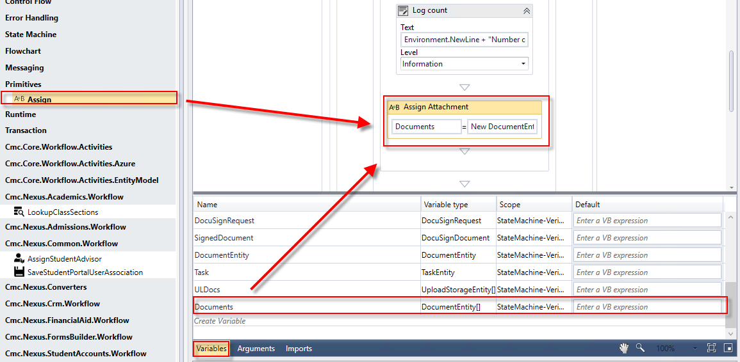

1. Drag a ***ForEach*** activity below the ***Assign Attachment Assign*** activity. Update the properties as shown below for the activity.

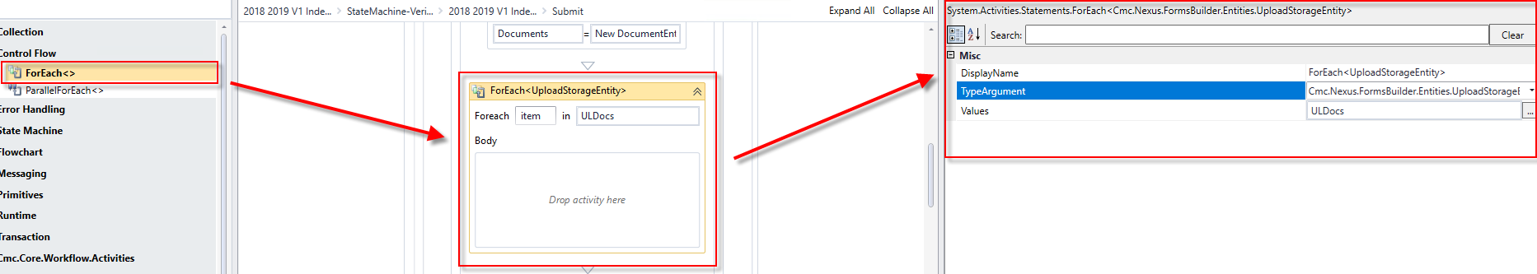

1. Drag a ***Sequence*** activity into the ***Body*** of the ***ForEach*** activity. Rename the sequence to ***Add to Doc Center***:

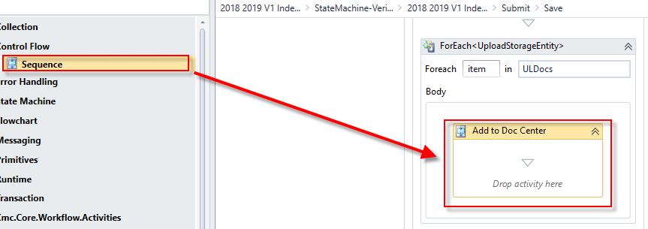

1. Drag a ***CreateDocument*** activity into the ***Add to Doc Center Sequence*** activity. Complete the properties as shown below.

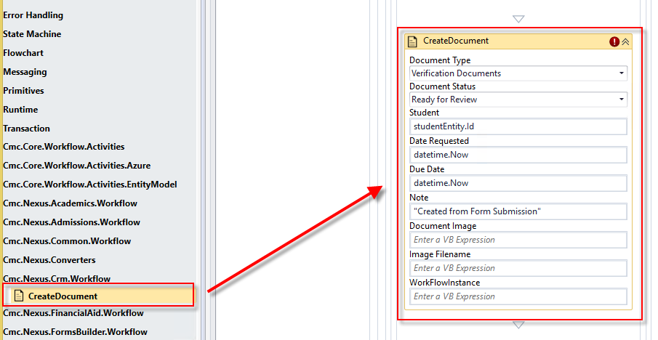

1. Create a ***variable:***

* Name: ***Count***
* Variable type: ***Int32***
* Scope: ***StateMachine-VerificationIndependent***
* Default: ***0***

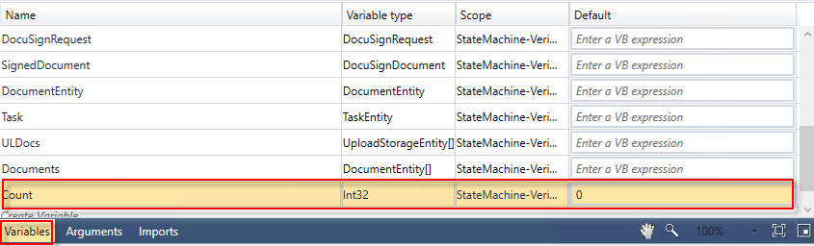

1. For the ***CreateDocument*** activity, assign ***Documents(Count)*** to the ***Document*** property in the ***Properties Pane***.

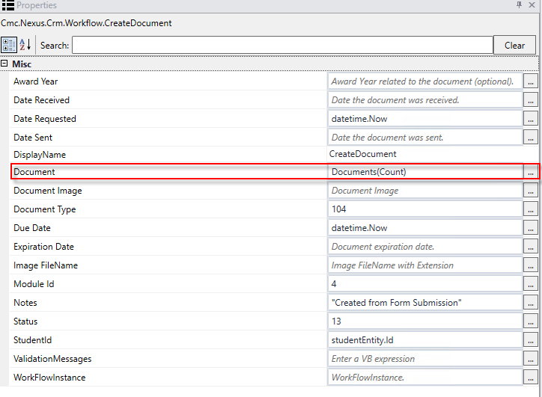

1. We are now ready to assign all of our values in order to update the student record in CampusNexus Student. In the ***Toolbox*,** drag ***five******Assign*** activities onto the designer below the ***CreateDocument*** activity. Perform the following:
2. Rename: ***Assign File Name***

* ***Documents(Count).OriginalFileName= item.FileName***

1. Rename: ***Assign Image***

* ***Documents(Count).DocumentImage = item.FileData***

1. Rename: ***Assign Status***

* ***Documents(Count).DocumentStatusId = 13***

1. Rename***: Assign Image Type***

* ***Documents(Count).ImageType = item.Extension***

1. Rename: ***Assign Received Date***

* ***Documents(Count).ReceivedDate = datetime.Now***

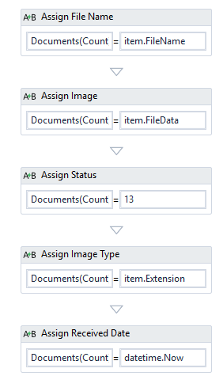

1. Drag the ***SaveDocument*** activity below the last ***Assign*** activity. Complete the properties as shown below.

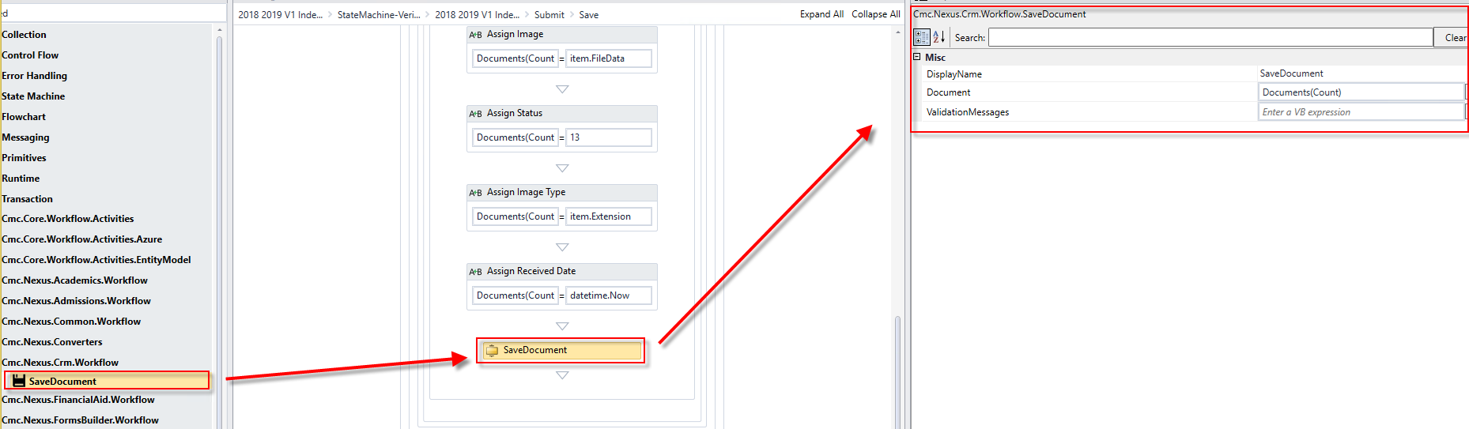

1. Drag an ***Assign*** activity below the ***SaveDocument*** activity. Rename the activity to: ***Assign Count.*** Complete the properties as shown below for the activity.

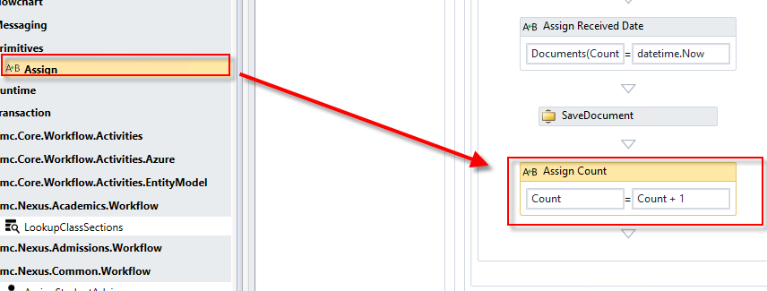

1. Enter ***Not FormInstance.ValidationMessages.HasErrors*** for the ***Condition*** to ensure any errors on the form are returned.

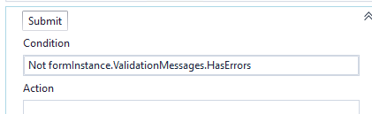

1. Confirm there are no errors in the Error List pane.

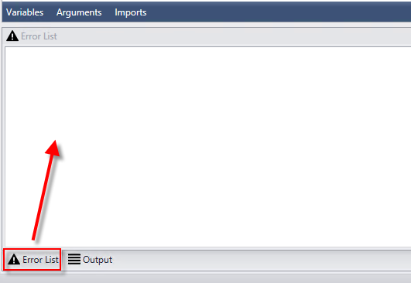

1. ***Save*** your workflow to ***C:\CampusNexus\Insight2018\Verification***.

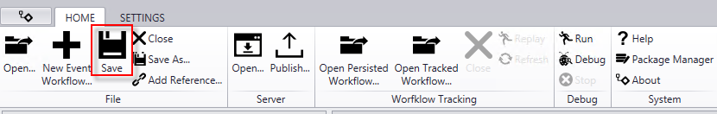

1. ***Publish*** your workflow. Make sure you select the ***Enable This Workflow Version?*** check boxand click ***Publish*.** Click ***OK*** to the confirmation.

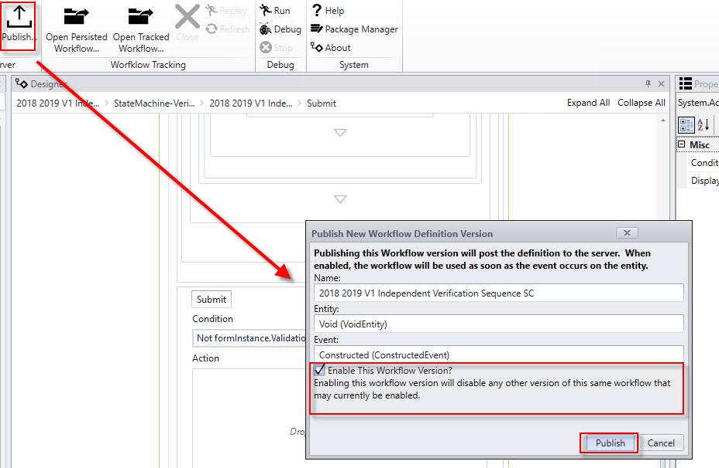

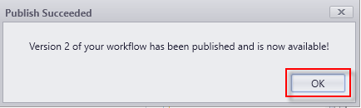

1. Navigate to ***Google Chrome*** and launch ***Renderer*** from the ***Bookmarks bar***.

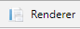

1. Find your ***Verification*** sequence and copy the ***URL*** to the clipboard.

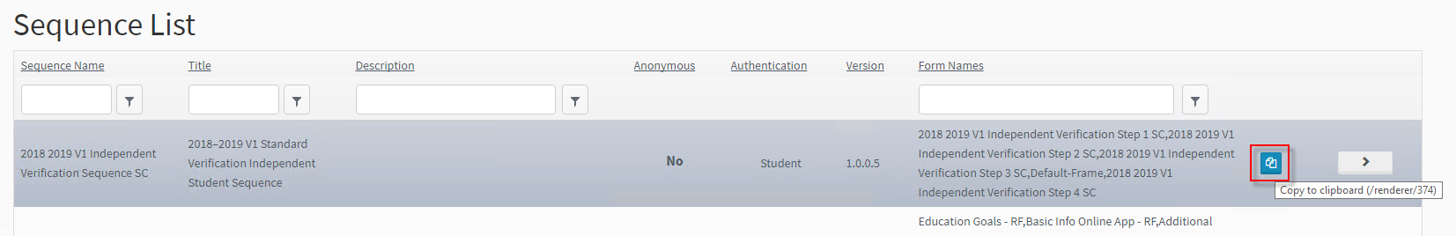

1. Navigate to ***Lists > Contact Manager > Activities*** in ***CampusNexus Student VB Client.*** Edit the ***FA – Verification Independent Student Email*** activity and paste the ***URL*** link of your sequence in the body of the email as shown below. ***Save*** your changes.

**Note:** When we test out the Verification Process, the activity will be sent to the student containing the link to the Verification sequence.

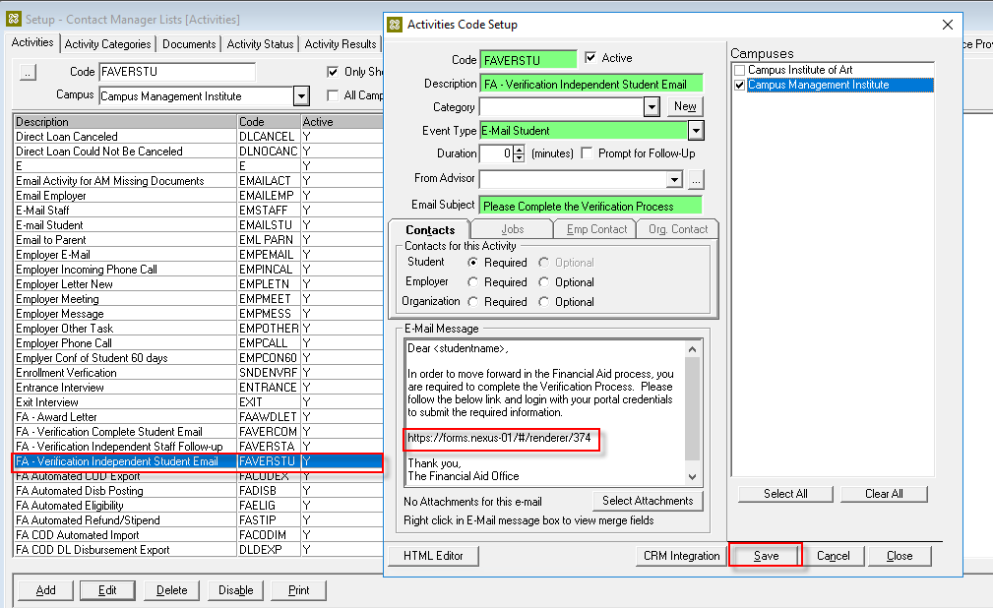

# Lesson 2: Create Workflows to Automate the Verification Process

## Lesson Overview

In this lesson, we will create the supporting workflows that will email the student the link to our Verification sequence as well as the workflow that will notify the student when the Verification process has been completed.

### Exercise 2: Create a Workflow to Send the Financial Aid Verification Form Link to the Student

This workflow will trigger based on the ***Verification for Independent Document*** being added to the student's Document Center. If the ISIR is selected for Verification, upon import of the ISIR, the document will be automatically added to the student's Document Center and the workflow will send the link to the Verification sequence to the student.

1. Launch ***Workflow***.

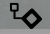

1. Click ***New Event Workflow***.



1. In the Entities pane, expand the ***Cmc.Nexus.Contracts*** and ***Cmc.Nexus***. Select ***Person Document(PersonDocument)***. In the ***Events*** pane, select ***Saved (Saved Event).*** Enter the ***Name Send Link to Verification Form SC*** (Add your initials to the end of the name) and click ***OK***.

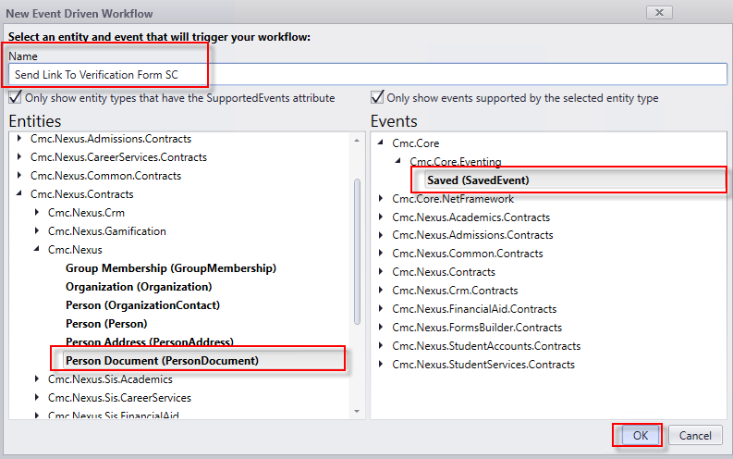

1. Select the default Sequence that was created on the Designer to give it the focus; delete it. Your designer should be empty as shown below.

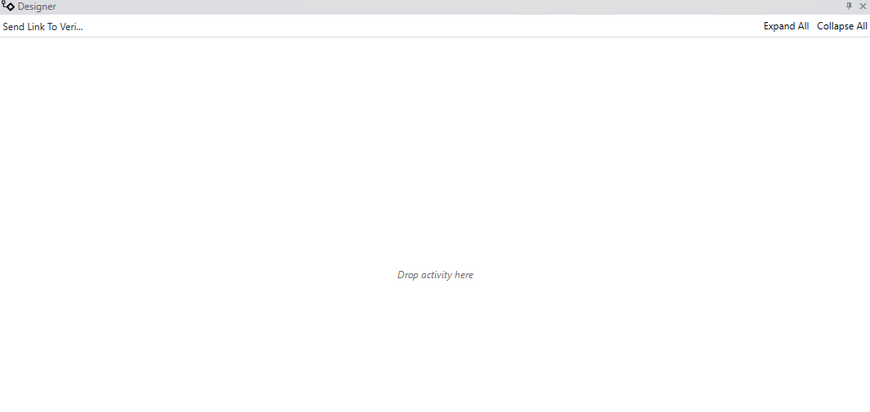

1. Drag the ***Flowchart***activity from the ***Toolbox*** onto the Designer. Rename the activity to ***Send Link to Form.***

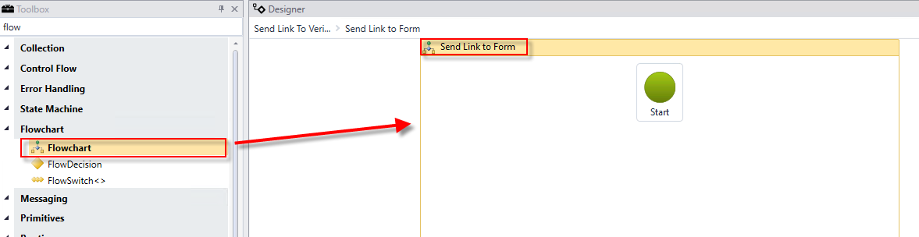

1. Drag the ***Sequence***activity into the ***Send Link to Form Flowchart*** activity below the green ***Start*** icon. Connect the green ***Start*** icon to the ***Sequence*** activity from the bottom to top. Rename the ***Sequence*** activity to ***Find Document to trigger Email of Link.***

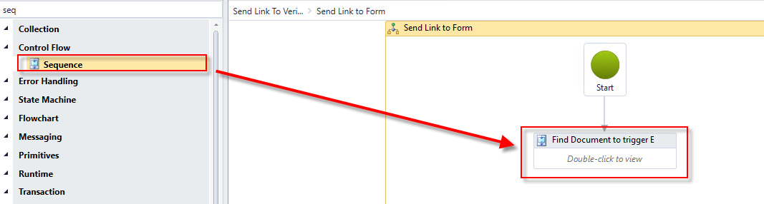

1. Double-click the ***Find Document to trigger Email of Link Sequence*** activity and drag a ***LookupReferenceItem*** activity into the activity. Assign the following values to the activity:

* Display Name: ***Find Document***
* Reference Item Type:  ***Document Type***
* Reference Item: ***Verification for Independent***
* Reference Item Id: ***This is the Id of the document selected above and will auto populate.***



1. Create a ***variable***:

* Name: ***Ref***
* Type: ***You will have to browse for the type. Cmc.Nexus.Common.Contracts>Cmc.Nexus.Common.Services>ReferenceItem***
* Scope: ***Send Link to Form***

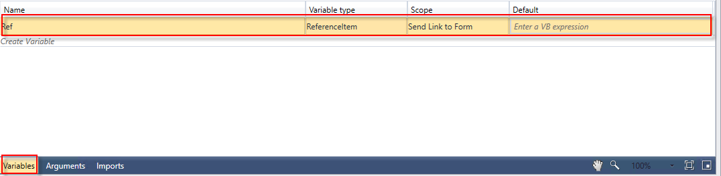

1. Assign the variable to the ***Find Document LookupReferenceItem*** next to the ***ReferenceItem*** property in the ***Properties Pane.***

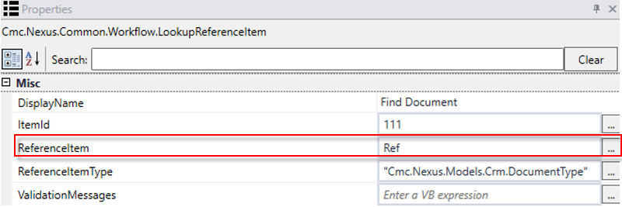

1. Click the first link in the cookie trail at the top of the Designer to return to the view of the entire Flowchart*.*

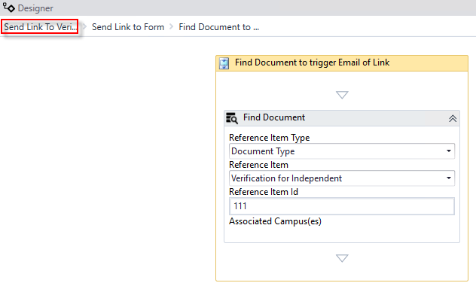

1. Drag the ***FlowDecision*** activity into the ***Send Link to Form Flowchart*** activity below the ***Find Document to trigger Email of Link Sequence*** activity. Connect the two activities.

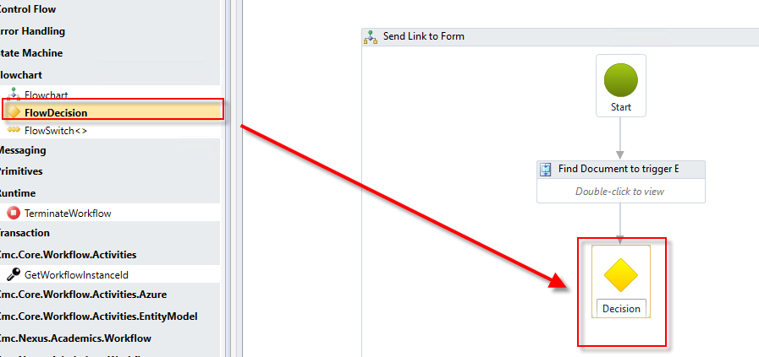

1. Complete the properties for the ***FlowDecision*** as shown below.

* Condition: ***entity.HasChanged(persondocument.DocumentTypeIdProperty) and entity.DocumentTypeId = Ref.Id***
* DisplayName: ***Doc on File?***

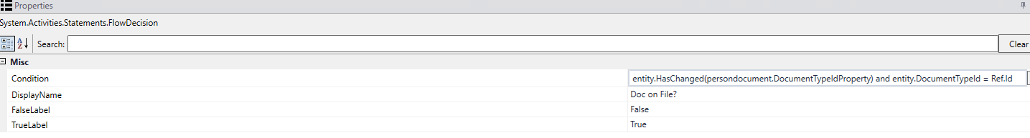

1. Drag a ***Sequence*** activity from the ***Toolbox*** into the ***Send Link to Form Flowchart*** activity on the Designer. Connect the Sequence to the ***Doc on File? FlowDecision*** activity as the ***True*** branch of the workflow. Rename the activity ***Send Email to Student.***

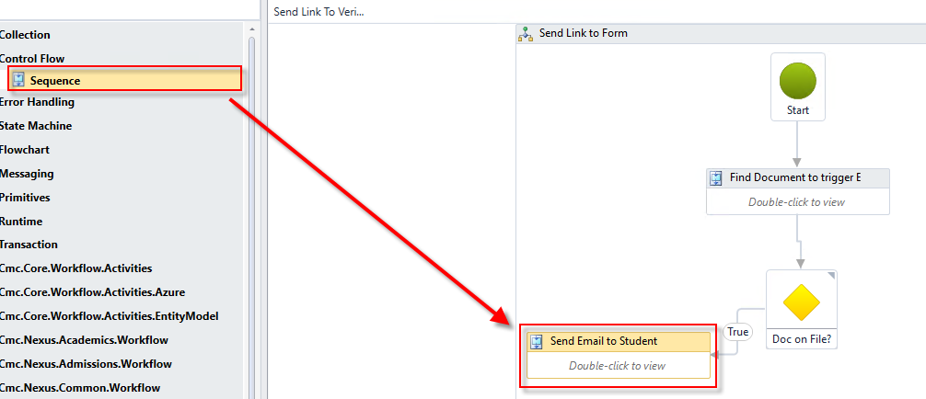

1. Drag a ***Sequence*** activity from the ***Toolbox*** into the ***Send Link to Form Flowchart*** activity on the Designer. Connect the activity to the ***Doc on File? FlowDecision*** activity as the ***False*** branch of the workflow. Rename the activity ***Terminate Workflow****.*

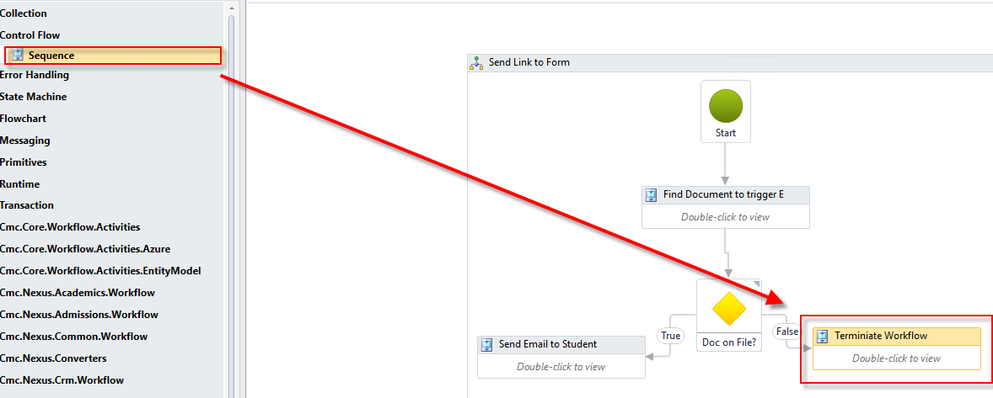

1. Double-click the ***Terminate Workflow sequence*** activity. Create a ***variable:***

* Name: ***Reason***
* Variable type: ***String***
* Scope: ***Send Link to Form***
* Default: ***"This is not the document we are looking for. Ending WF."***

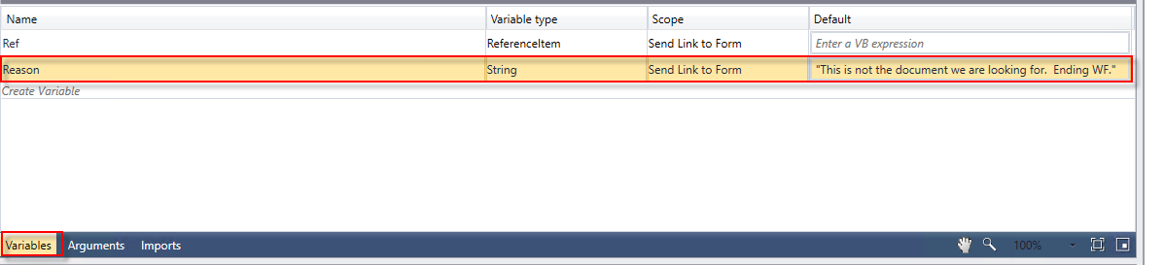

1. Drag the ***LogLine*** activity into the sequence. Complete the properties as shown below.

* Rename the ***LogLine*** activity to: ***Log Ending WF***
* Text: ***Environment.NewLine + Environment.NewLine + Reason + Environment.NewLine***
* Level: ***Information***

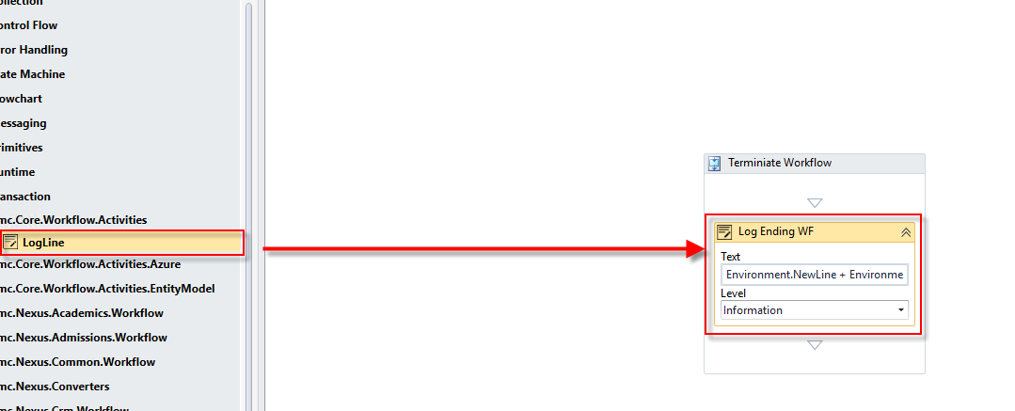

1. Drag the ***TerminateWorkflow***activity under the ***Log Ending WF LogLine*** activity. Complete the properties for the activity as shown below*.*

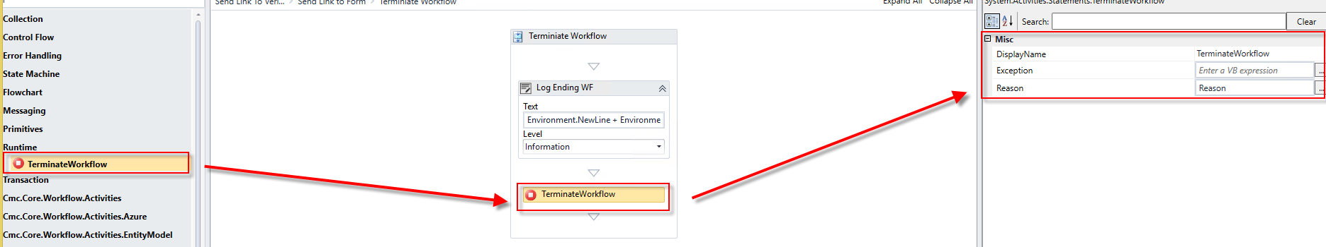

1. Click the first link in the cookie trail at the top of the Designer to return to the view of the entire Flowchart*.*

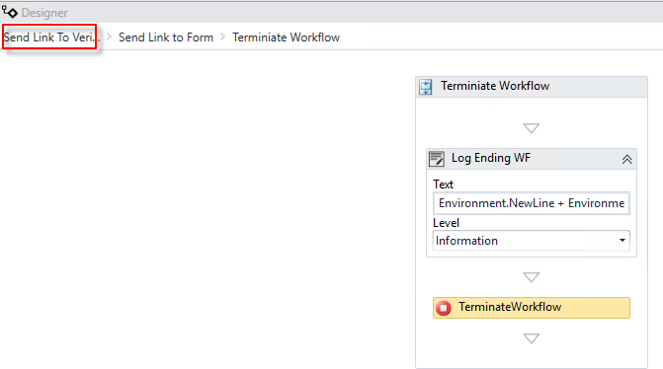

1. Double-click the ***Send Email to Student Sequence*** activity. Drag the ***LogLine*** activity into the sequence. Complete the properties as shown below.

* Rename the activity to: ***Log Sending Email***
* Text: ***Environment.NewLine + Environment.NewLine + "Sending Verification Link for Independent Student " + Environment.NewLine***
* Level: ***Information***

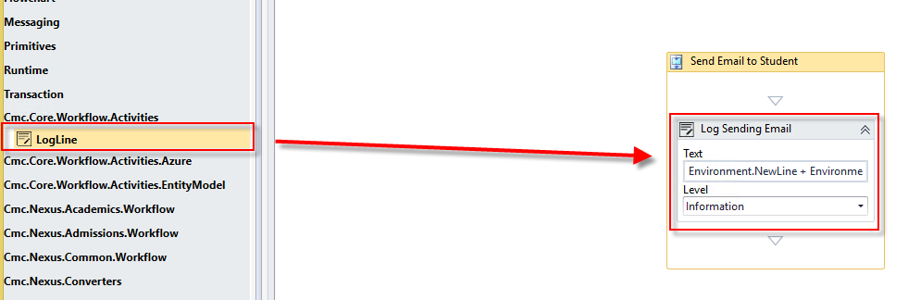

1. Drag a ***LookupListItem*** activity into the sequence below the ***Log Sending Email LogLine*** activity. Complete the properties as shown below.

* Rename activity to: ***Find Advisor***
* Item Type: ***Staff***
* List Item: ***Campus University***

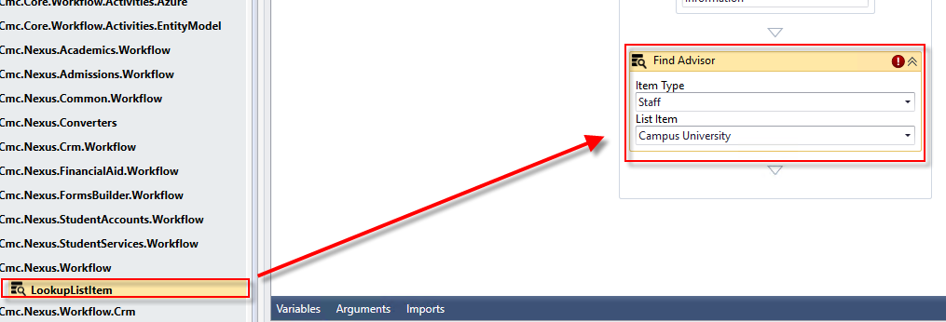

1. Create a ***variable:***

* Name: ***advisor***
* Variable type: ***LookupItem*** (You may have to browse for the variable type. The variable type can be found under **Cmc.Nexus.Contracts > Cmc.Nexus > LookupItem**)
* Scope: ***Send Link to Form***

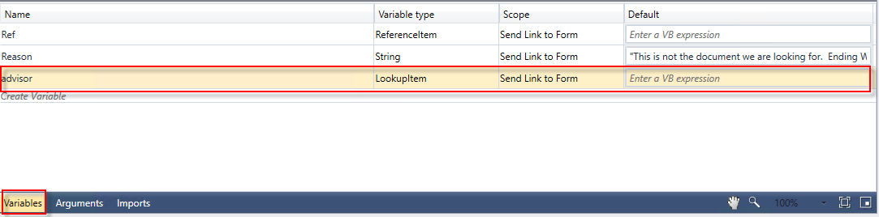

1. Assign the ***variable*** to the ***Find Advisor LookupListItem*** activity next to the ***ListItem*** property in the ***Properties Pane***.

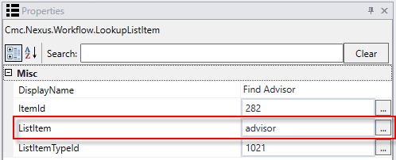

1. Drag the ***CreateTask*** activity from the ***Toolbox*** below the ***Find Advisor LookupListItem*** activity. Complete the properties for the activity as shown below.

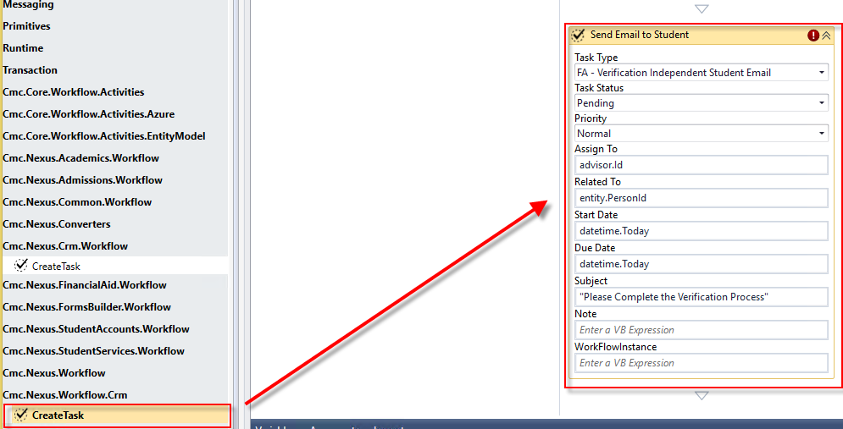

1. Create a ***variable:***

* Name: ***task***
* Variable type: ***Task*** (You may have to browse for the variable type. The variable type can be found under **Cmc.Nexus.Contracts > Cmc.Nexus.Crm > Task**)
* Scope: ***Send Link to Form***

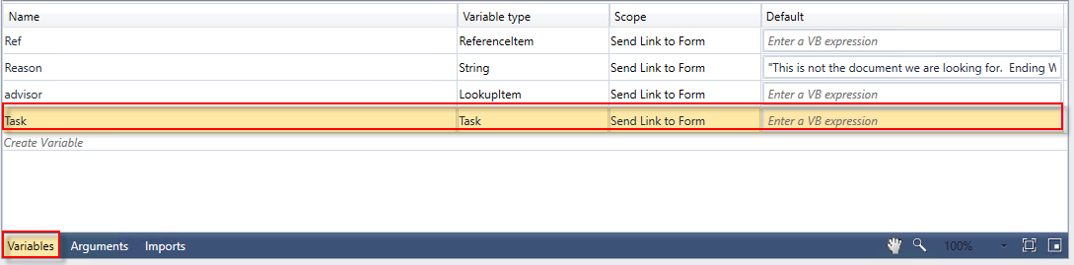

1. Assign the variable to the ***Send Email to Student CreateTask*** activity next to the ***Task*** property in the ***Properties Pane***.

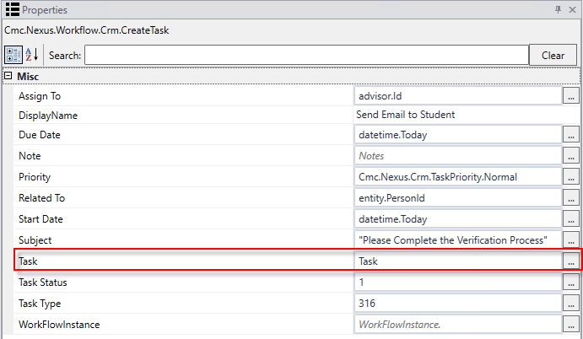

1. Drag the ***SaveTask*** activity from the Toolbox below the ***Send Email to Student CreateTask*** activity. Complete the properties as shown below.

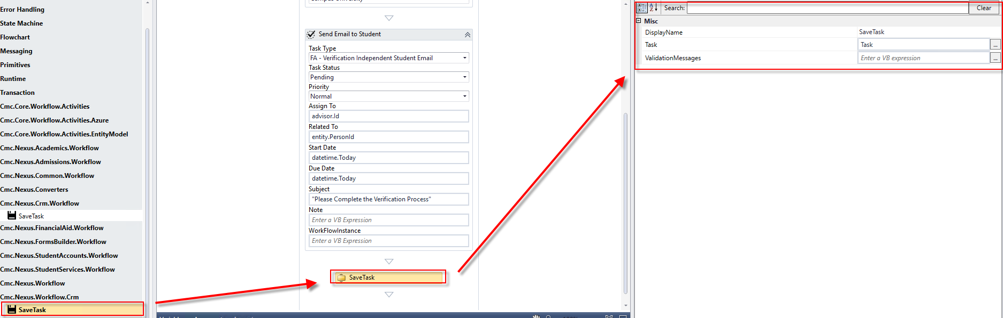

1. Click the first link in the cookie trail at the top of the Designer to return to the view of the entire Flowchart*.*

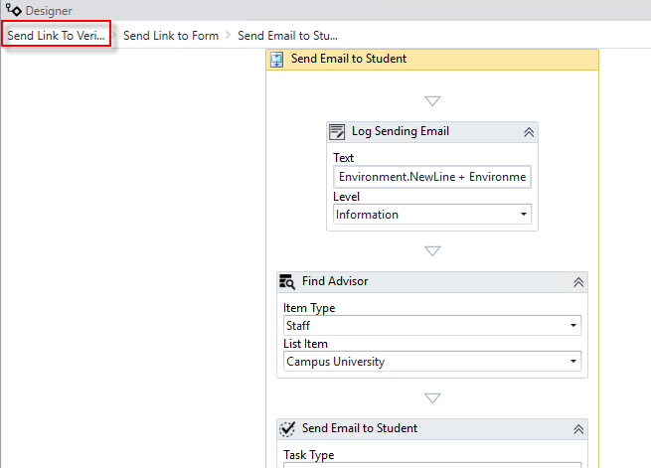

1. Confirm there are no errors in the Error List pane.



1. ***Save*** your workflow to: ***C:\CampusNexus\Insight2018\Verification***



1. ***Publish*** your workflow. Make sure you select the ***Enable This Workflow Version?*** check boxand select ***Publish*.** Click ***OK*** to the confirmation.

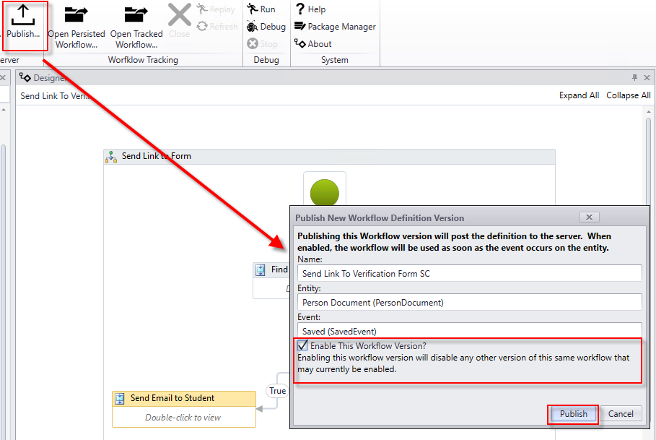

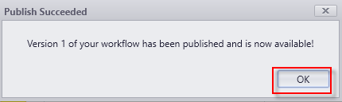

### Exercise 3: Create a Workflow to Send an Email Confirmation to the Student upon Financial Aid Verification Process Completion

This workflow will trigger based on the student being removed from the ***Nexus Verification Group.*** Once the Verification process has been completed by the staff member and the student removed from the group, the student will receive an email notification.

1. Launch ***Workflow***.



1. Click ***New Event Workflow***.



1. In the **Entities** pane, expand the ***Cmc.Nexus.Contracts and Cmc.Nexus***. Select ***Group Membership(GroupMembership)***. In the ***Events*** pane, select ***Saved (Saved Event)***. Enter the ***Name Send Notification to Student on Verification Complete SC*** (add your initials to the end of the name) and click ***OK***.

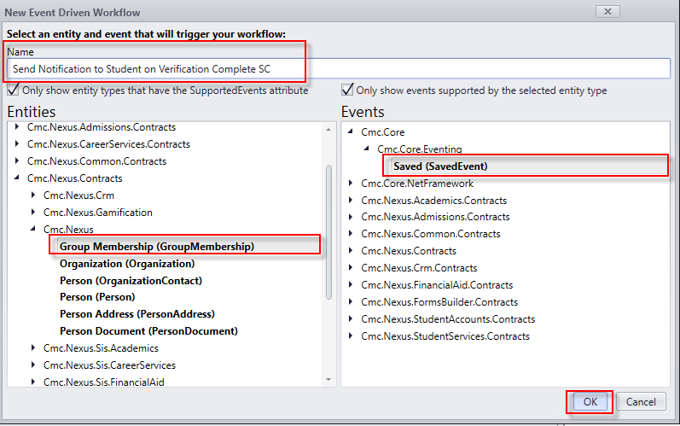

1. Select the default Sequence that was created on the Designer to give it the focus; delete it. Your designer should be empty as shown below.

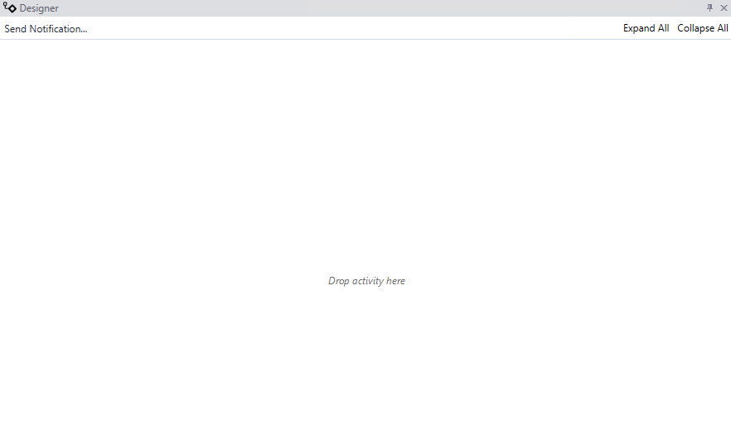

1. Drag the ***Flowchart***activity from the ***Toolbox*** onto the Designer. Rename the activity to ***Send Notification.***

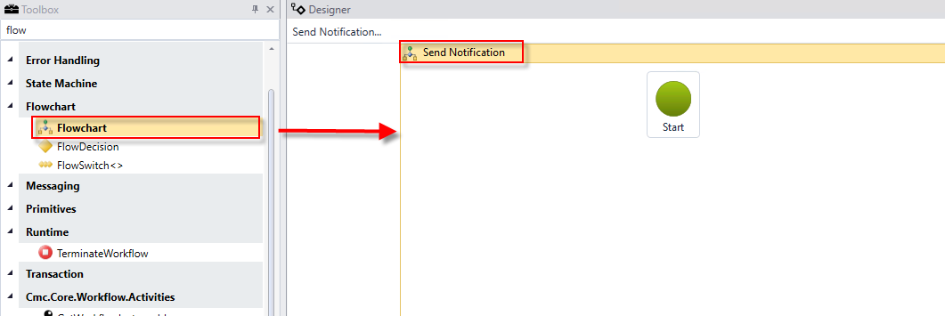

1. Drag the ***Sequence***activity into the ***Send Notification Flowchart*** activity below the green ***Start*** icon. Connect the green ***Start*** icon to the ***Sequence*** activity from the bottom to top. Rename the ***Sequence*** activity ***Find Group.***

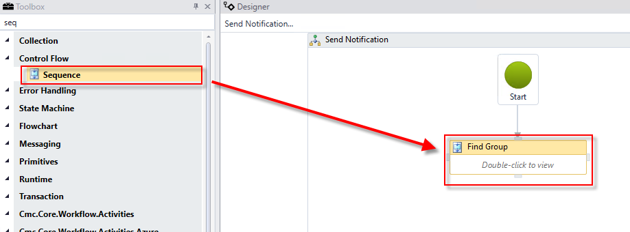

1. Double-click the ***Find Group Sequence*** activity. Drag a ***LookupGroup*** activity into the activity. Assign the following values to the activity:

* Display Name: ***Find Verification Group***
* Search for Group: ***Nexus Verification Group***

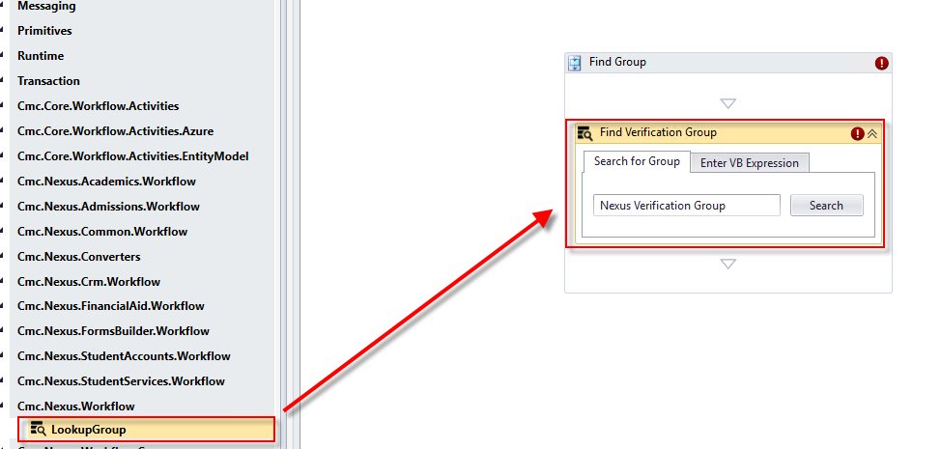

1. Create a ***variable***:

* Name: ***Groupremove***
* Type: You will have to browse for the type. ***Cmc.Nexus.Contracts>Cmc.Nexus>Group***
* Scope: ***Send Notification***

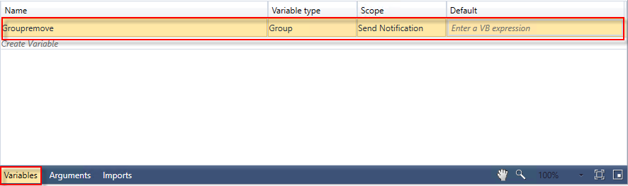

1. Assign the variable to the ***LookupGroup*** activity next to the ***Group*** property in the ***Properties Pane***.

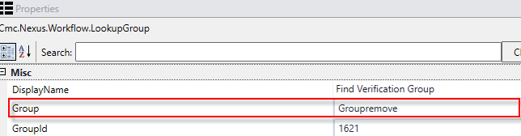

1. Click the first link in the cookie trail at the top of the Designer to return to the view of the entire Flowchart*.*

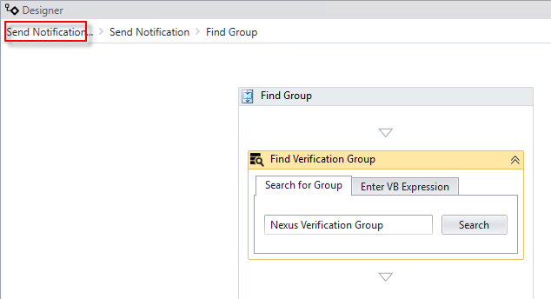

1. Drag the ***FlowDecision*** activity into the ***Send Notification Flowchart*** activity below the ***Find Group Sequence*** activity. Connect the two activities.

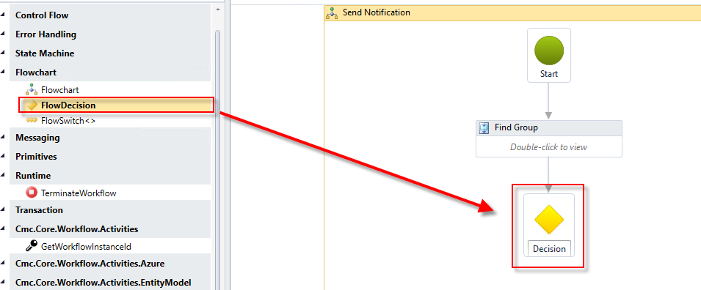

1. Complete the properties for the ***FlowDecision*** as shown below.

* Condition: ***entity.GroupId = Groupremove.Id and entity.HasChanged(GroupMembership.RemovedDateProperty)***
* DisplayName: ***Removed?***

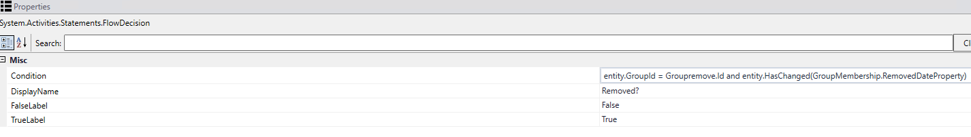

1. Drag a ***Sequence*** activity from the ***Toolbox*** into the ***Send Notification Flowchart*** activity on the Designer. Connect the Sequence to the ***Removed? FlowDecision*** activity as the ***True*** branch of the workflow. Rename the activity to: ***Send Verif Complete Notification.***

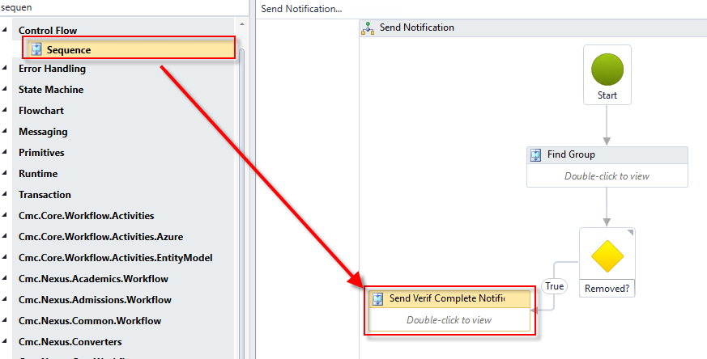

1. Drag a ***Sequence*** activity from the ***Toolbox*** into the ***Send Notification Form Flowchart*** activity on the Designer. Connect the activity to the ***Removed? FlowDecision*** activity as the ***False*** branch of the workflow. Rename the activity to: ***Terminate Workflow****.*

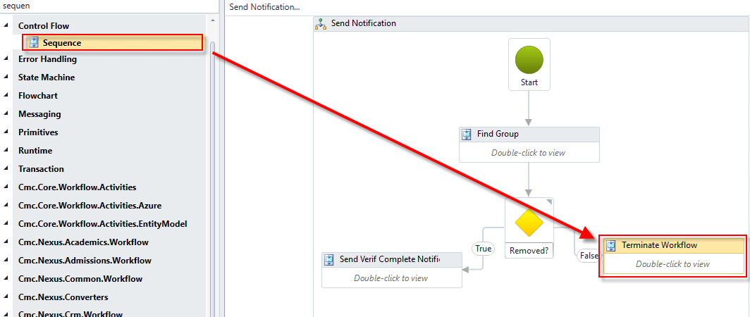

1. Double-click the ***Terminate Workflow sequence*** activity. Create a ***variable:***

* Name: ***Reason***
* Variable type: ***String***
* Scope: ***Send Notification***
* Default: ***"The student was not removed from the group. Ending WF."***

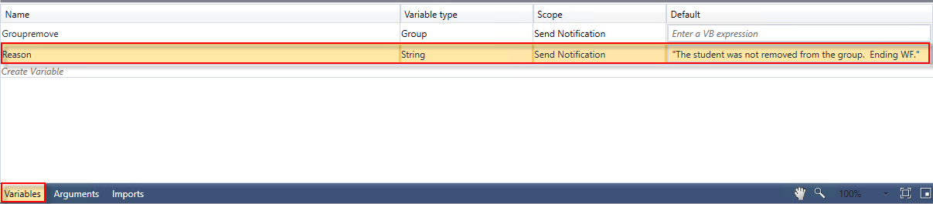

1. Drag the ***LogLine*** activity into the sequence. Complete the properties as shown below.

* Rename the ***LogLine*** activity to: ***Log Ending WF***
* Text: ***Environment.NewLine + Environment.NewLine + Reason + Environment.NewLine***
* Level: ***Information***



1. Drag the ***TerminateWorkflow***activity under the ***Log Ending WF LogLine*** activity. Complete the properties for the activity as shown below*.*



1. Click the first link in the cookie trail at the top of the Designer to return to the view of the entire Flowchart*.*

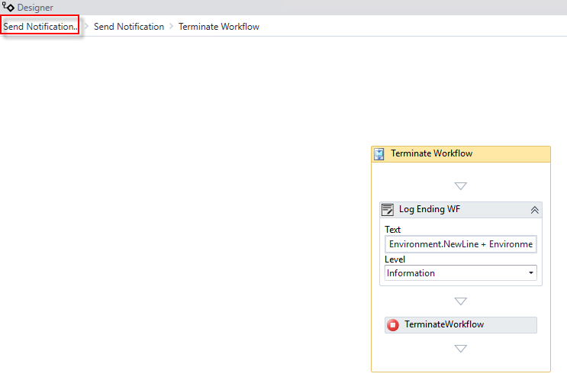

1. Double-click the ***Send Verif Complete Notification Sequence*** activity. Drag the ***LogLine*** activity into the sequence. Complete the properties as shown below.

* Rename the activity to: ***Log Sending Notification***
* Text: ***Environment.NewLine + Environment.NewLine + "Sending Notification for Verification Complete " + Environment.NewLine***
* Level: ***Information***

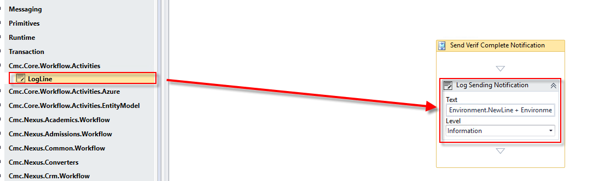

1. Create a ***variable:***

* Name: ***theStudent***
* Variable type: ***Person*** (You may have to browse for the variable type. The variable type can be found under ***Cmc.Nexus.Contracts > Cmc.Nexus > Person***)
* Scope: ***Send Notification***

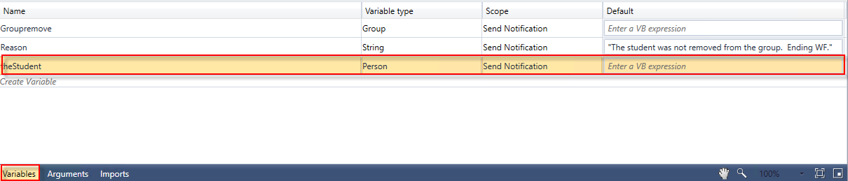

1. Drag the ***LookupPerson*** activity into the sequence below the ***Log Sending Notification LogLine*** activity. Complete the properties as shown below.

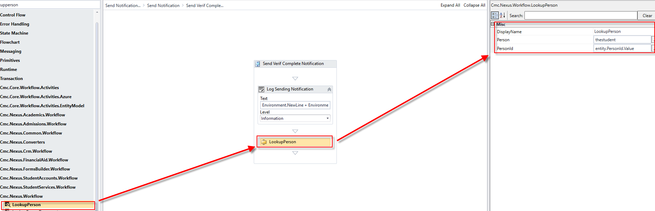

1. Drag the ***CreateTask*** activity from the ***Toolbox*** below the ***LookupPerson*** activity. Complete the properties for the activity as shown below.

Enter the following for the body: "Dear " + thestudent.FirstName + "," + Environment.NewLine + Environment.NewLine + "The Verification process has been completed. You will be notified when your financial aid package is complete and your awards are ready for viewing. If you have any questions, please contact your Financial Aid Advisor at: 1-888-CAMPUS1." + Environment.NewLine + Environment.NewLine + "Thank you, " + Environment.NewLine + "The Financial Aid Team"

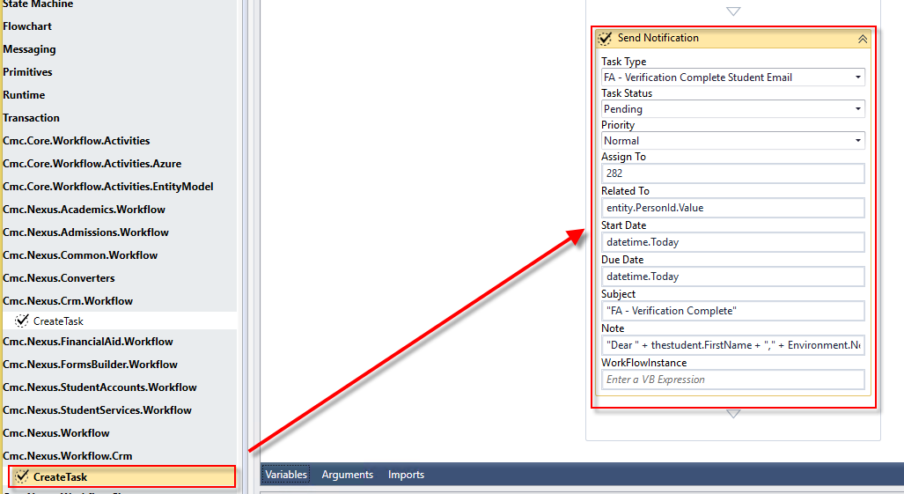

1. Create a ***variable:***

* Name: ***task***
* Variable type: ***Task*** (You may have to browse for the variable type. The variable type can be found under ***Cmc.Nexus.Contracts > Cmc.Nexus.Crm > Task***)
* Scope: ***Send Notification***

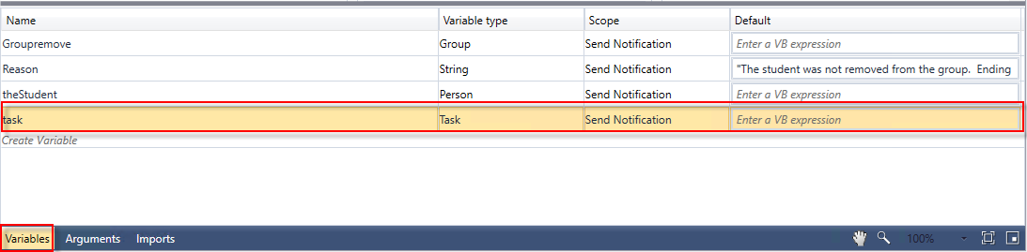

1. Assign the variable to the ***Send Notification CreateTask*** activity next to the ***Task*** property in the ***Properties Pane***.

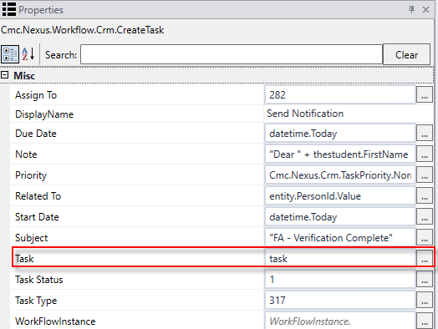

1. Drag the ***SaveTask*** activity from the Toolbox below the ***Send Notification CreateTask*** activity. Complete the properties as shown below.

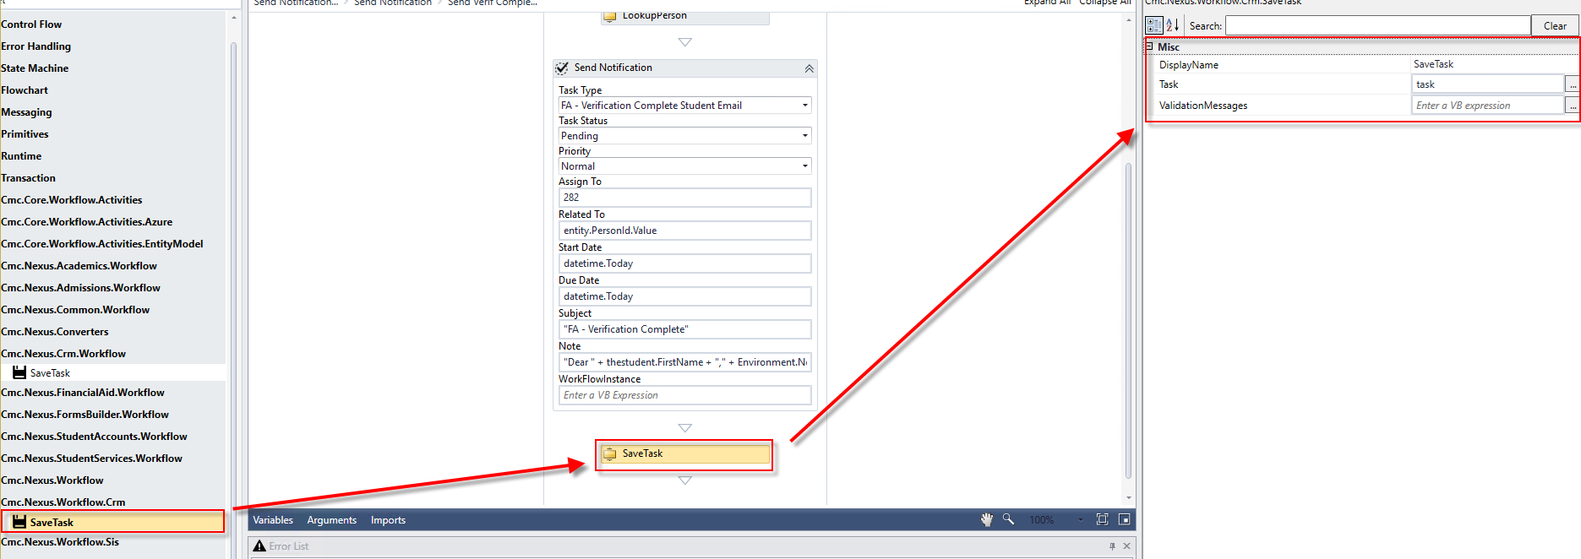

1. Click the first link in the cookie trail at the top of the Designer to return to the view of the entire Flowchart*.*

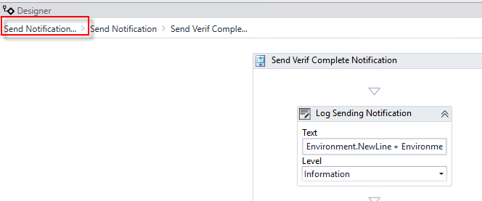

1. Confirm there are no errors in the Error List pane.



1. ***Save*** your workflow to ***C:\CampusNexus\Insight2018\Verification***.



1. ***Publish*** your workflow. Make sure you select ***Enable This Workflow Version?*** and select ***Publish*.** Click ***OK*** to the confirmation.

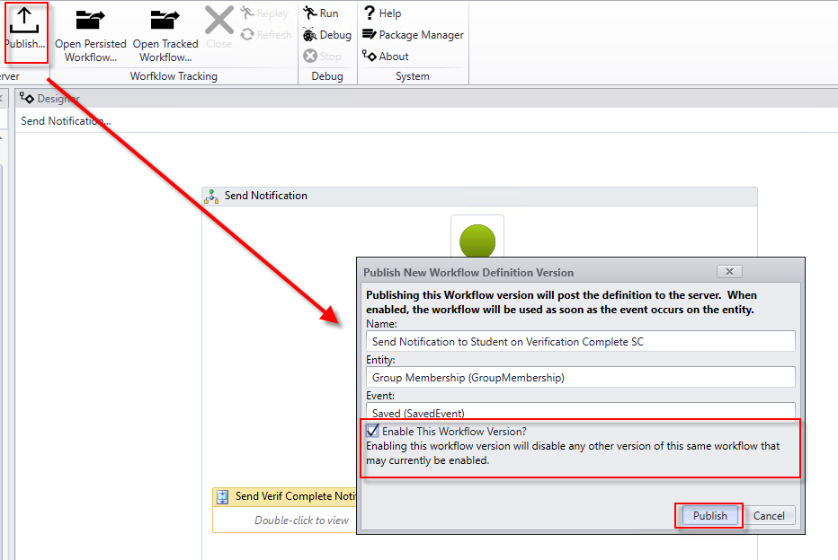



# Lesson 3: Validate the Financial Aid Verification Process

## Lesson Overview

In this exercise, we will validate our Student Self-Service Verification Process.

**Note:** The screenshots below are not for the student with which you will be testing. The instructor will assign you a student to validate the process against.

### Exercise 4: Validate the Student Self-Service Form and Supporting Workflows for the Financial Aid Verification Process

1. Navigate to ***CampusNexus Student VB Client.*** Edit the ***Student Master*** and update the email address for your test student to a valid email.

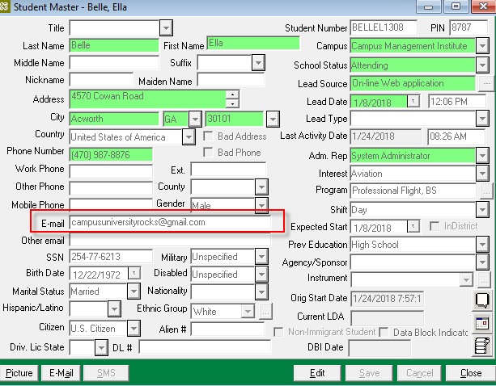

1. Navigate to ***Daily > Financial Aid > Import Data > Application Data***.

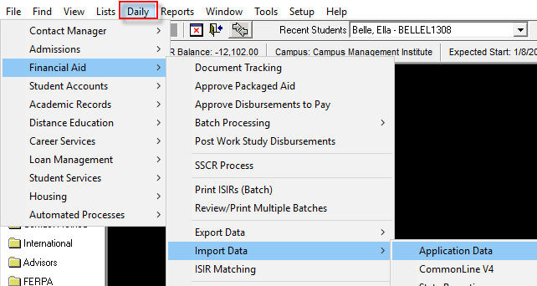

1. Select the following:

* FA Award Year: ***2018-19***
* Select path for ISIR file(s): ***C:\CampusNexus\Insight2018\Verification***
* Files Available: ***Select the ISIR file in the list***

1. Click ***Process.***

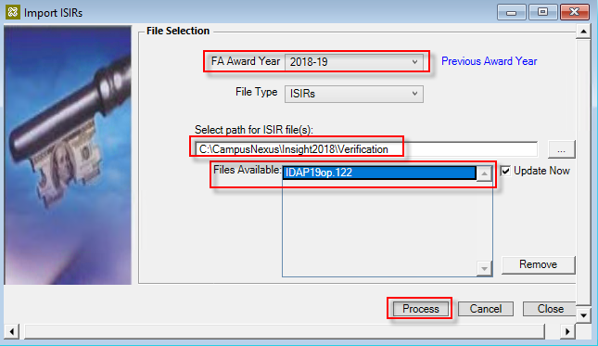

1. View the ***ISIR Import Report.*** Close the report and the import form.

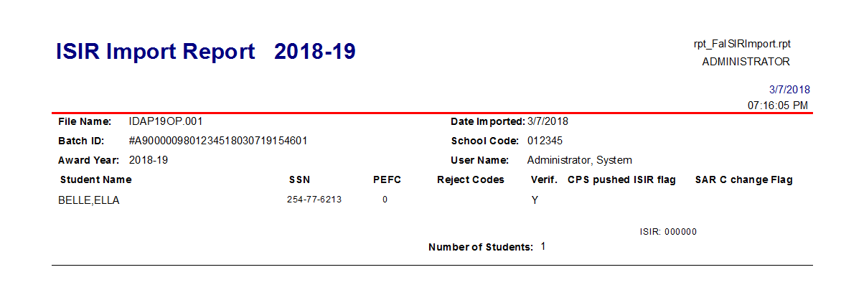

1. Navigate to ***View > Financial Aid > ISIR*** to view the ISIR data for the student.

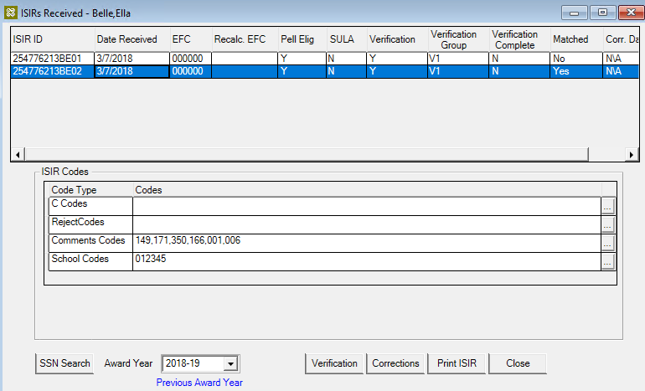

1. Verify that the student was added to the ***Nexus Verification Group (2018-19).***

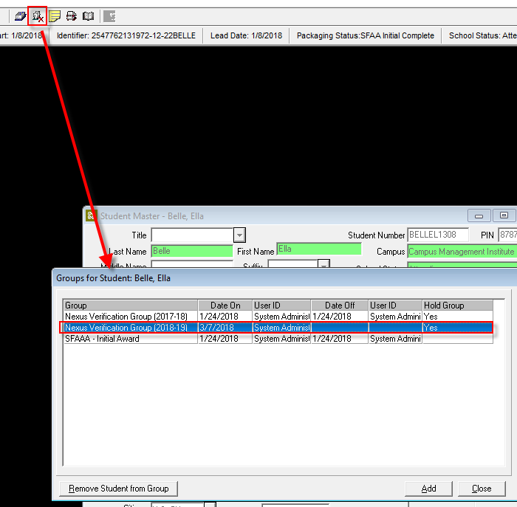

1. Navigate to the ***CampusNexus web client*** to manage students in the ***Verification Hold Group***.

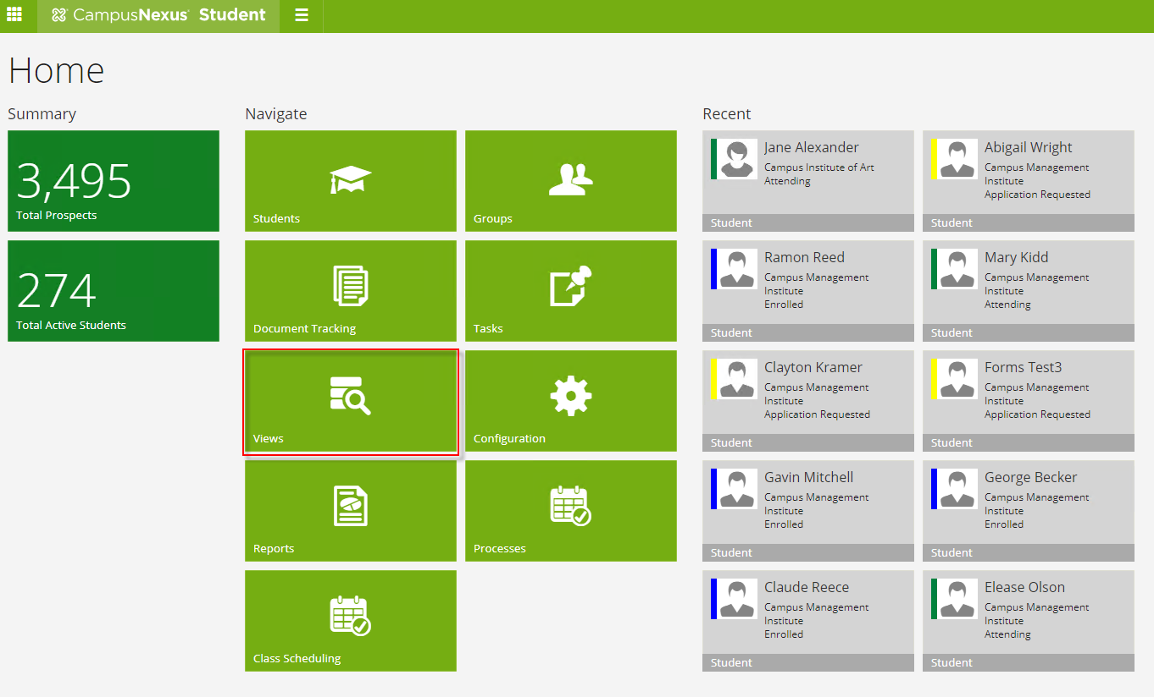

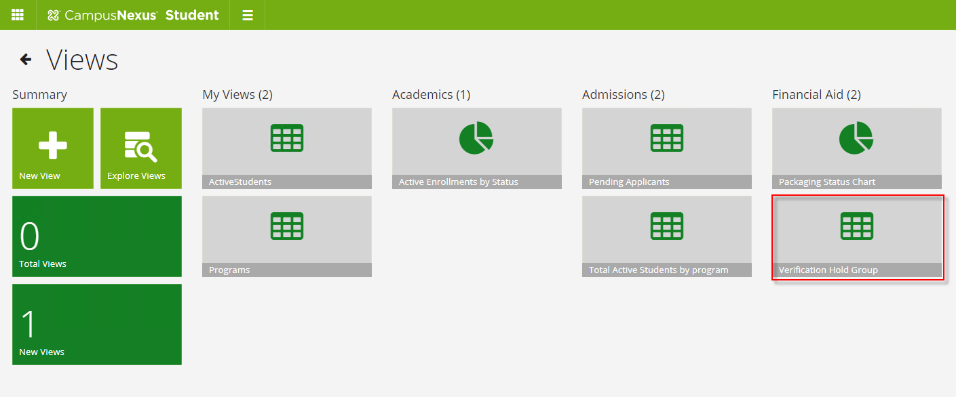

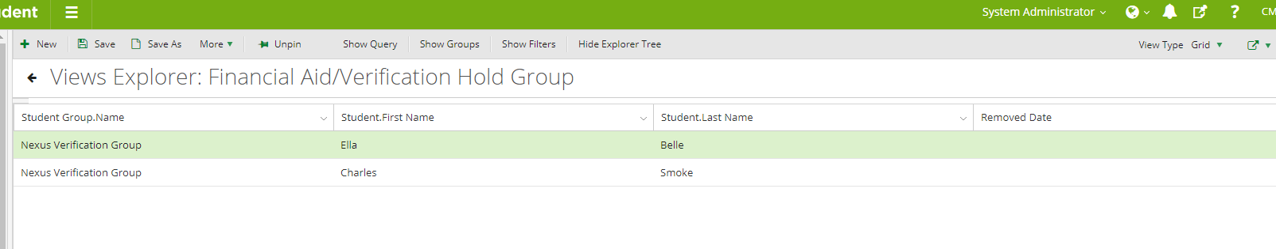

1. Verify that the ***Verification for Independent*** document was added to the student's Document Center.

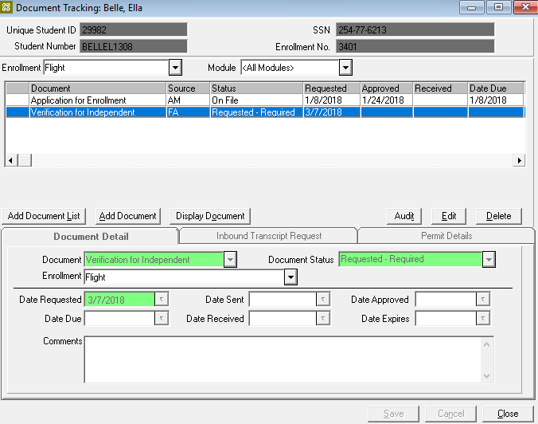

1. Verify the student was sent an email with the link to complete the ***Verification Sequence.***

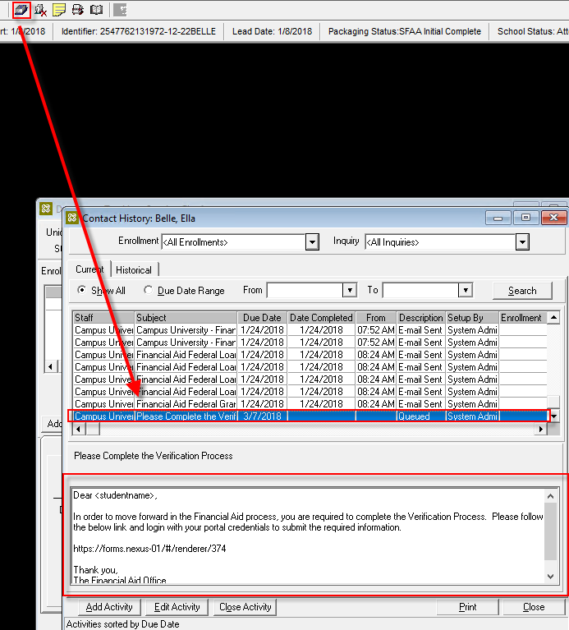

1. Check the email and select the link to complete the ***Verification Sequence.***

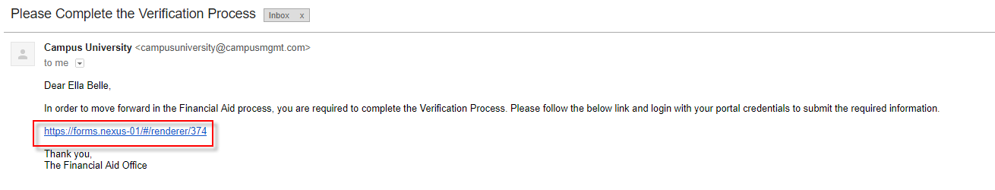

1. Log in as your student. (The instructor will give you the login credentials.)

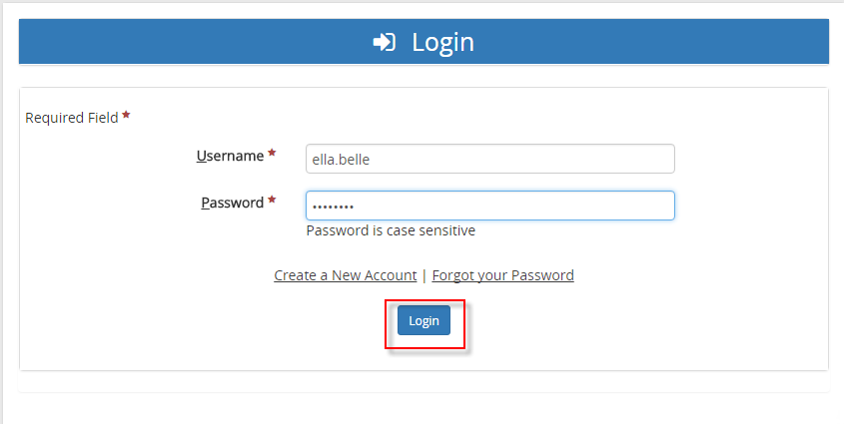

1. Complete the ***Verification Sequence***.

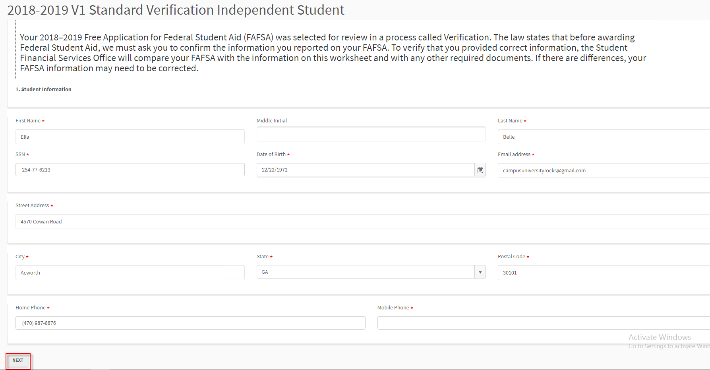

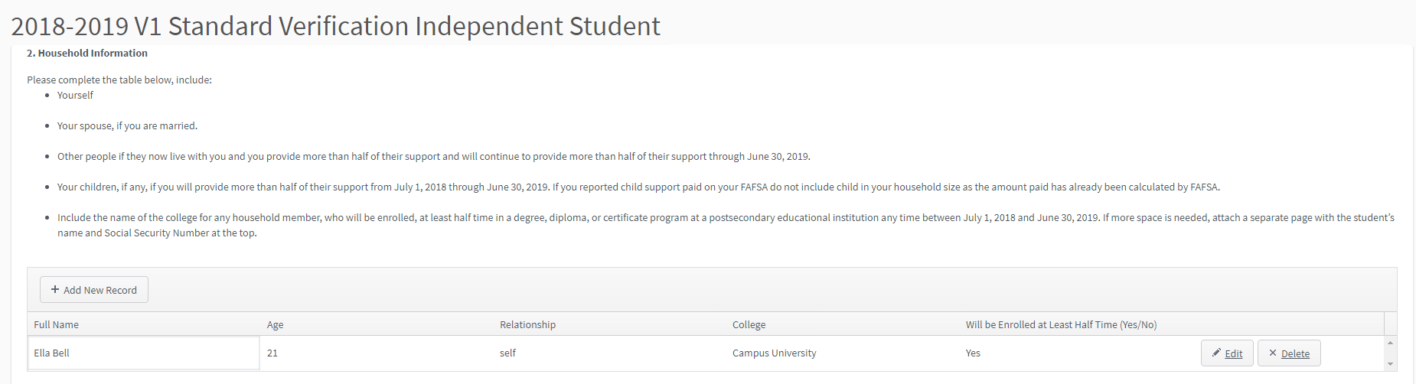

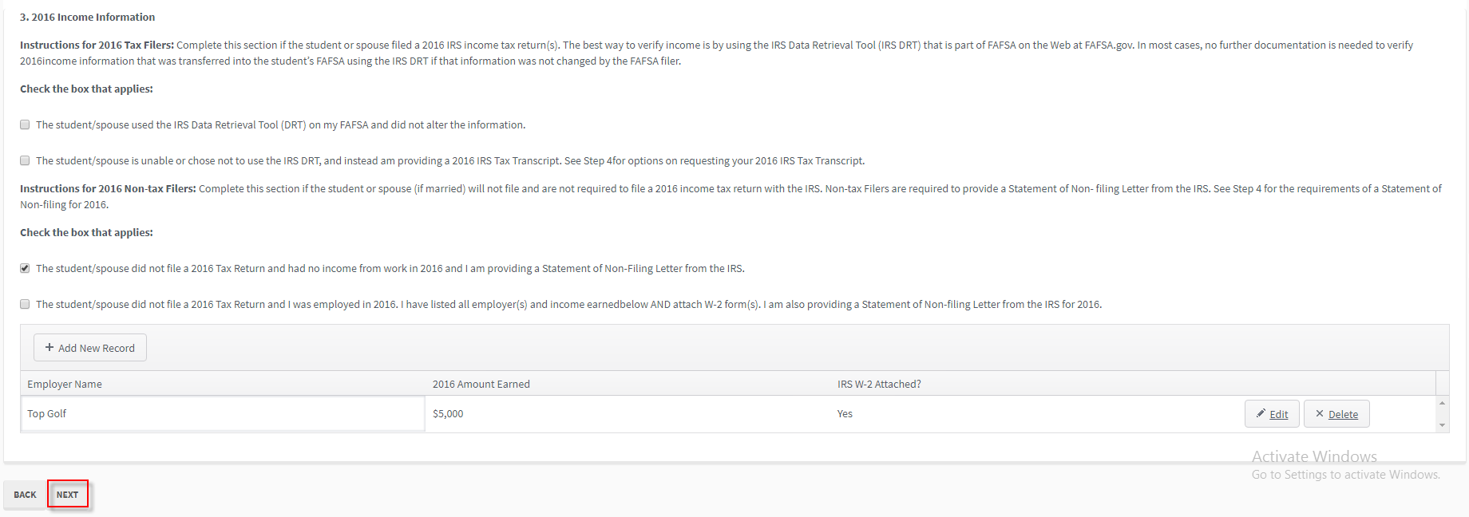

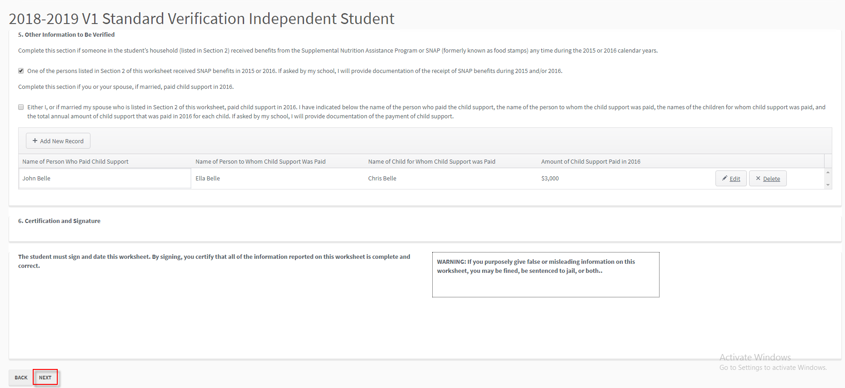

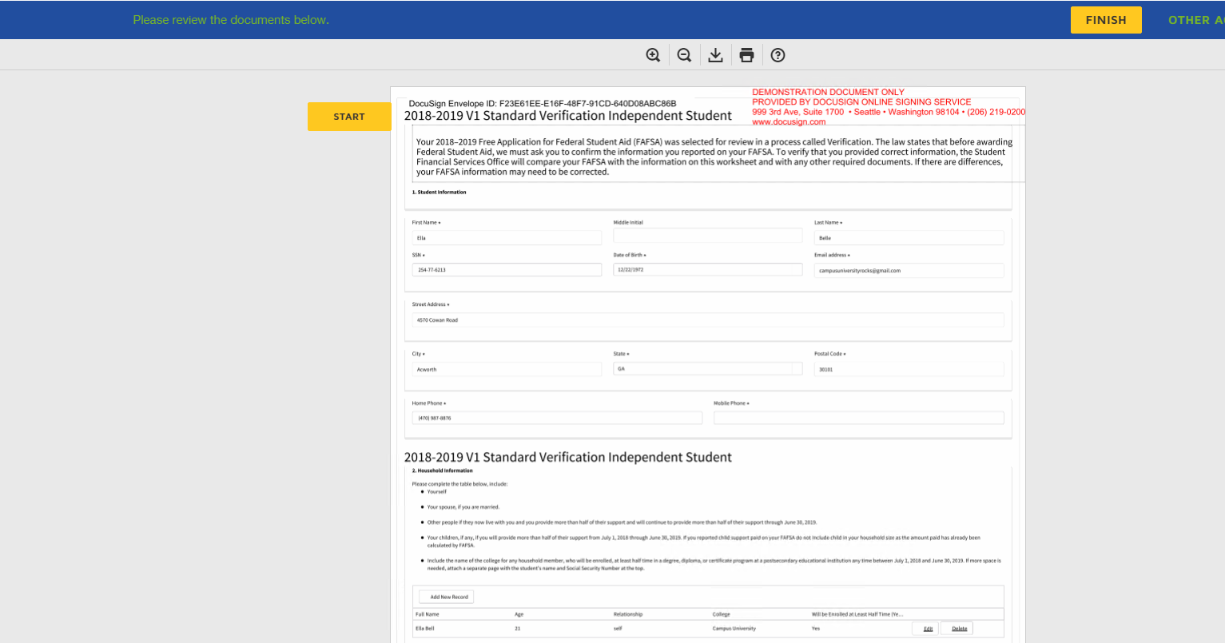

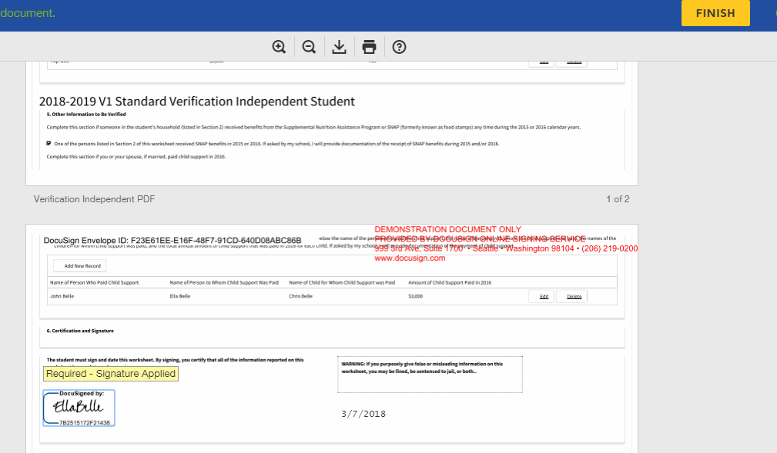

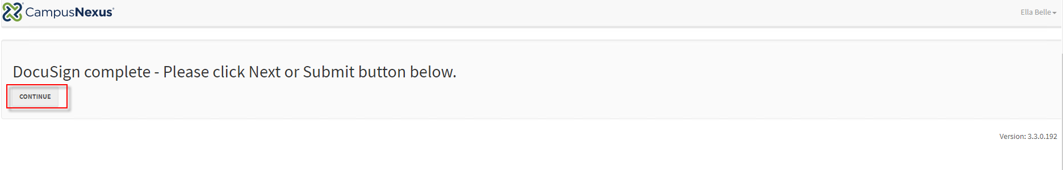

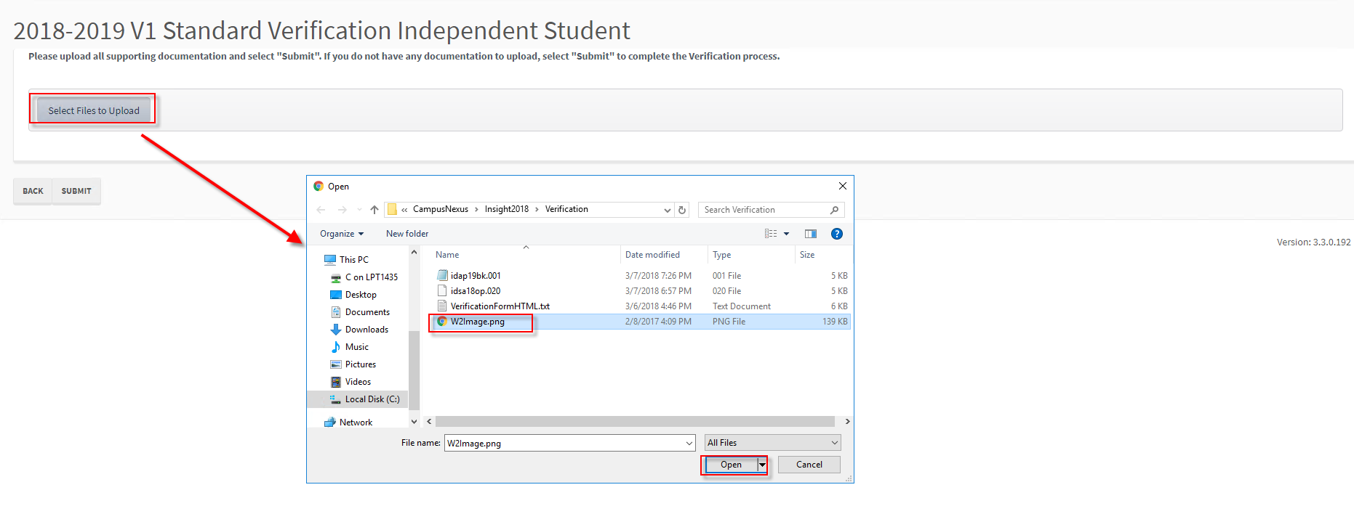

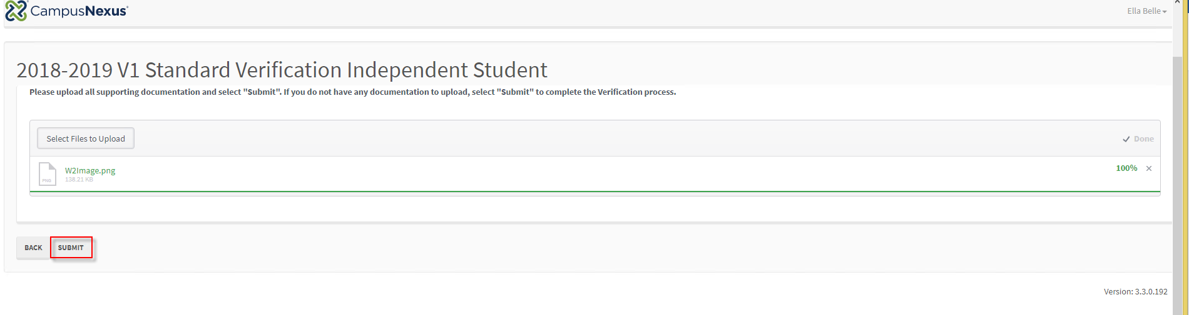

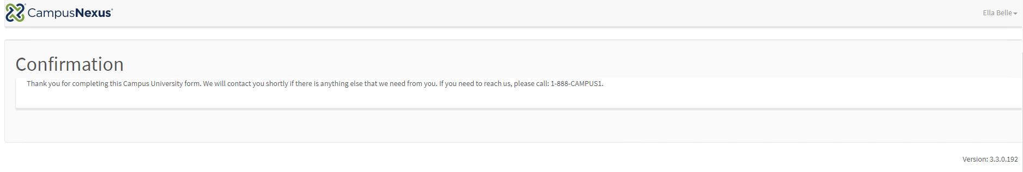

1. In ***CampusNexus Student, v***erify the staff member was notified to complete the Verification Process.

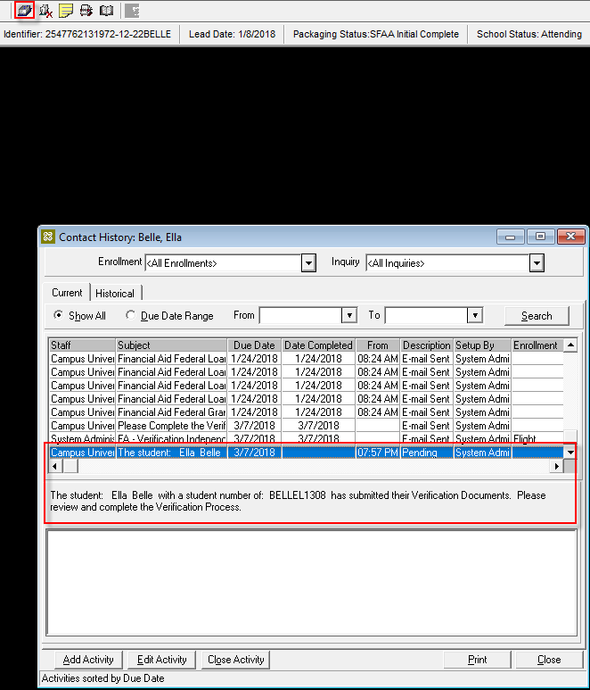

1. View the documents and attachments in the student's Document Center. Update the status to ***On File*** for each document.

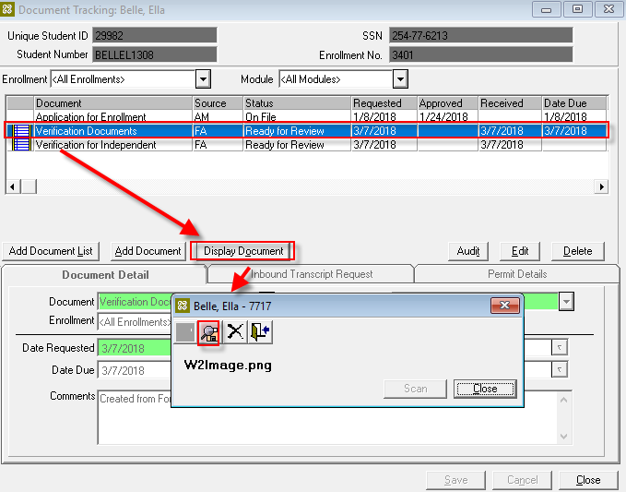

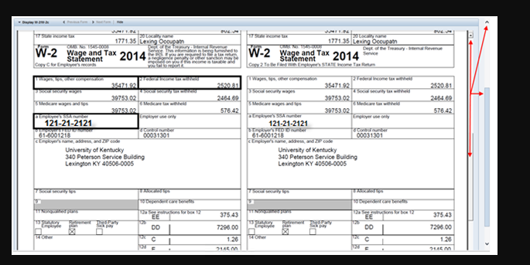

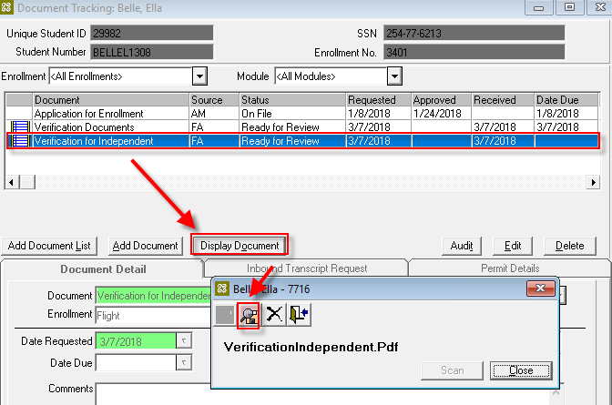

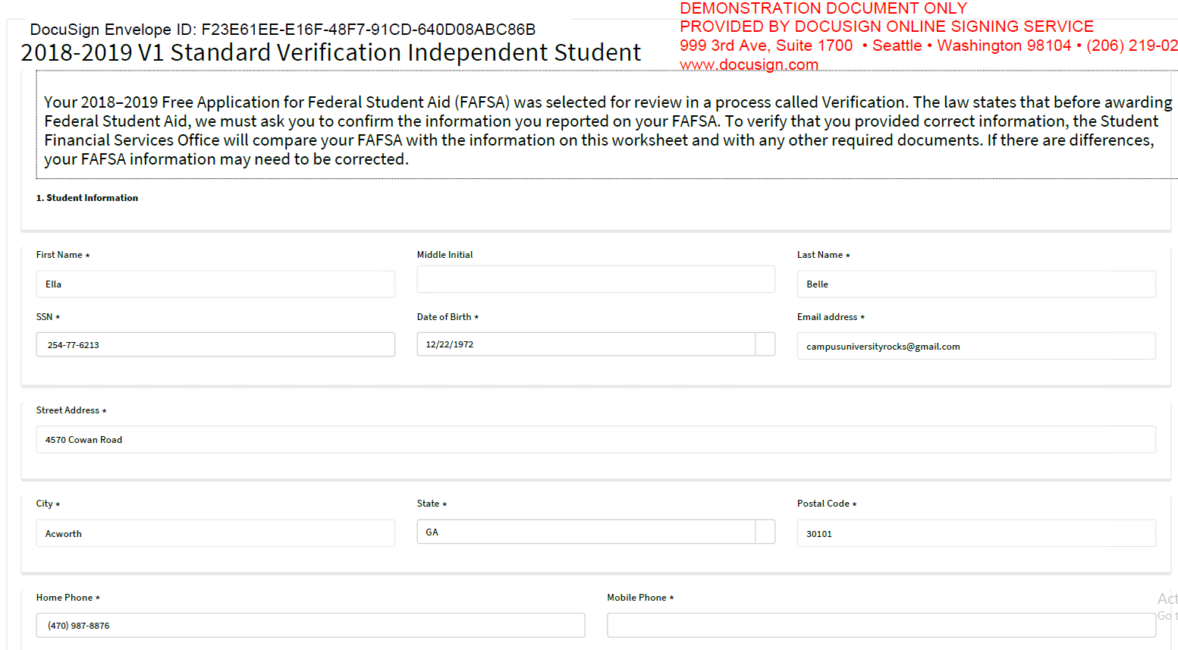

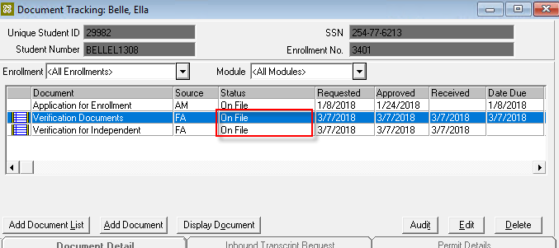

1. Go to the ***ISIR*** and select the ***ISIR, Award Year,*** and ***Verification***.

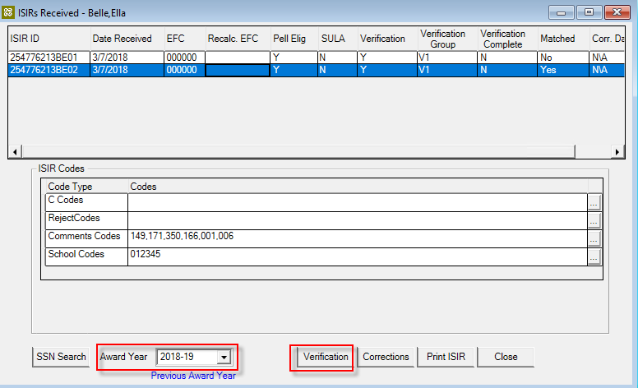

1. Click ***Finish.***

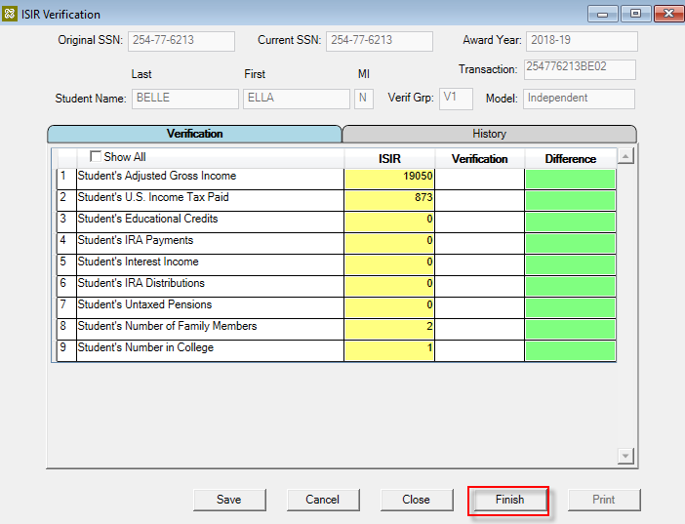

1. Click ***Accept as Verified***.

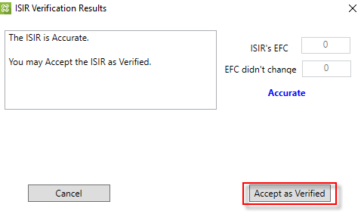

1. Click ***Yes*** to remove the student from the ***Verification Group.***

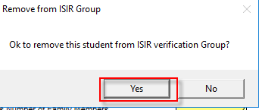

1. Verify the ***ISIR*** is now ***Verification Complete***.

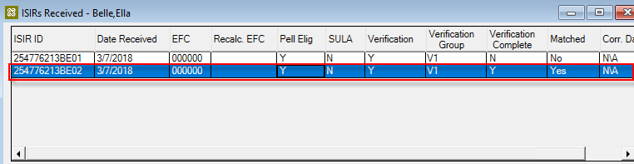

1. Verify the student was removed from the ***Verification Group.***

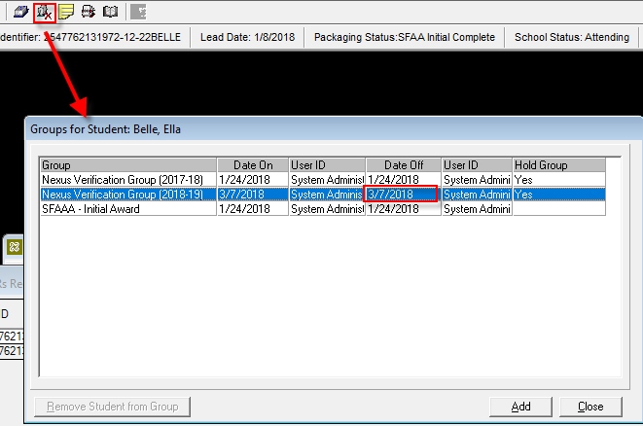

1. Verify the student was sent a notification for ***Verification Complete.***

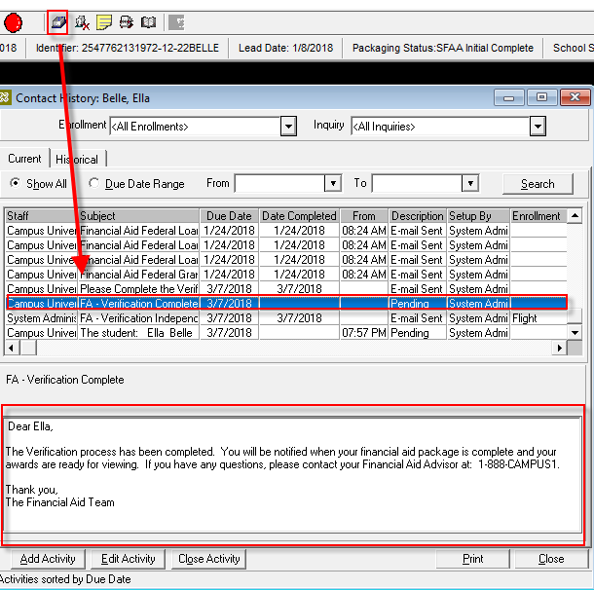

1. Verify the student received the ***Verification Complete*** email.

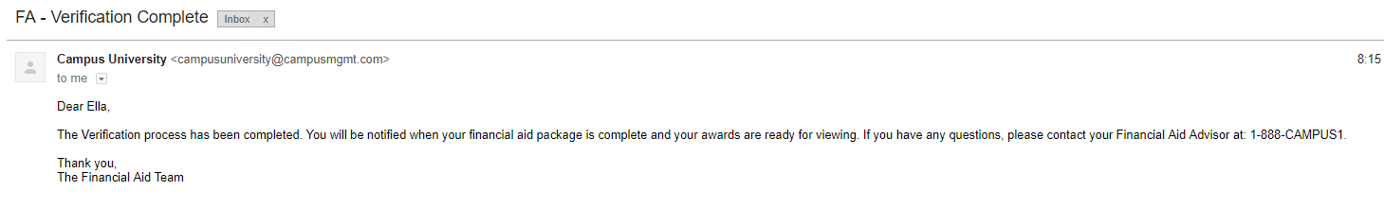

1. Verify the student's ***Verification Status*** updated on the ***Awards*** screen to ***Verified.***

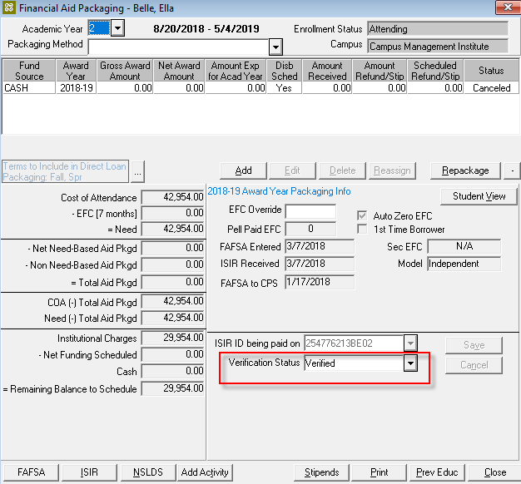

1. The instructor will now walk you through reviewing the student information in the ***CampusNexus Web Client.***